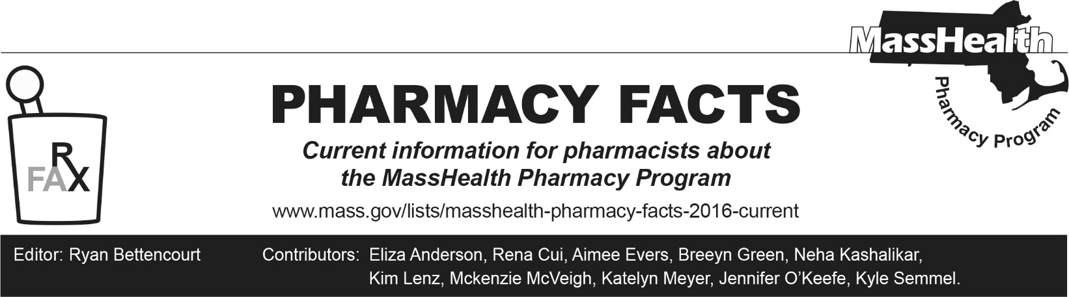
Number 277, May 15, 2026

Upcoming Changes to MassHealth Management of Ustekinumab Biosimilars
Effective July 1, 2026, MassHealth will update its preferred ustekinumab biosimilars. Biosimilars are Food and Drug Administration (FDA) approved biologic medications with no clinically meaningful differences in safety or efficacy compared to the reference product.

Imuldosa® (ustekinumab-srlf), Pyzchiva® (ustekinumab-ttwe), and Steqeyma® (ustekinumab-stba) will no longer be Preferred Biosimilars
Effective July 1, 2026, Imuldosa® (ustekinumab-srlf), Pyzchiva® (ustekinumab-ttwe), and Steqeyma® (ustekinumab-stba) will no longer be preferred drug, and will require a trial of all preferred biosimilars.

Effective July 1, 2026, Starjemza® (ustekinumab-hmny) and unbranded ustekinumab-aekn will be Preferred MassHealth Biosimilars
Starting July 1, 2026, preferred ustekinumab biosimilars will include Starjemza® (ustekinumab-hmny) and unbranded ustekinumab-aekn.
Starjemza® (ustekinumab-hmny) and ustekinumab-aekn are interchangeable biosimilars and can be automatically substituted for Stelara® (ustekinumab), Pyzchiva® (ustekinumab-ttwe), or Steqeyma® (ustekinumab-stba) at the pharmacy.

Patients using Imuldosa® (ustekinumab-srlf) will need a new prescription for either Starjemza® (ustekinumab-hmny) or ustekinumab-aekn. Imuldosa® (ustekinumab-srlf) cannot be automatically substituted.

To aid in transitioning, all MassHealth members approved for Imuldosa® (ustekinumab-srlf), Pyzchiva® (ustekinumab-ttwe), or Steqeyma® (ustekinumab-stba) with an approval duration beyond July 1, 2026, will automatically have an approval put in place to allow a covered biosimilar to pay beginning July 1, 2026. The end date for the new biosimilar PA will match the end date on file for the previous biosimilar.

MassHealth Management of Ustekinumab Biosimilars
Preferred Biosimilars - 1/1/26 to 7/1/26 | Preferred Biosimilars – Effective 7/1/26
Imuldosa® (ustekinumab-srlf)^{PD} 45 mg/0.5 mL syringe  Pyzchiva® (ustekinumab-ttwe)^{PD} 45 mg/0.5 mL syringe  Steqeyma® (ustekinumab-stba) 45 mg/0.5 mL syringe | Starjemza® (ustekinumab-hmny) 45 mg/0.5 mL syringe  unbranded ustekinumab-aekn 45 mg/0.5 mL syringe
Imuldosa® (ustekinumab-srlf)^{PD} 90 mg/1 mL syringe  Pyzchiva® (ustekinumab-ttwe)^{PD} 90 mg/1 mL syringe  Steqeyma® (ustekinumab-stba) 90 mg/1 mL syringe | Starjemza® (ustekinumab-hmny) 90 mg/1 mL syringe  unbranded ustekinumab-aekn 90 mg/1 mL syringe
Pyzchiva® (ustekinumab-ttwe)^{PD} 45 mg/0.5 mL vial | Starjemza® (ustekinumab-hmny) 45 mg/0.5 mL vial
Imuldosa® (ustekinumab-srlf)^{PD} 130 mg/26 mL vial  Pyzchiva® (ustekinumab-ttwe)^{PD} 130 mg/26 mL vial  Steqeyma® (ustekinumab-stba) 130 mg/26 mL vial | Starjemza® (ustekinumab-hmny) 130 mg/26 mL vial
PD=preferred drug
The MassHealth Drug List is on the MassHealth Pharmacy Program website at www.mass.gov/masshealth/pharmacy.

