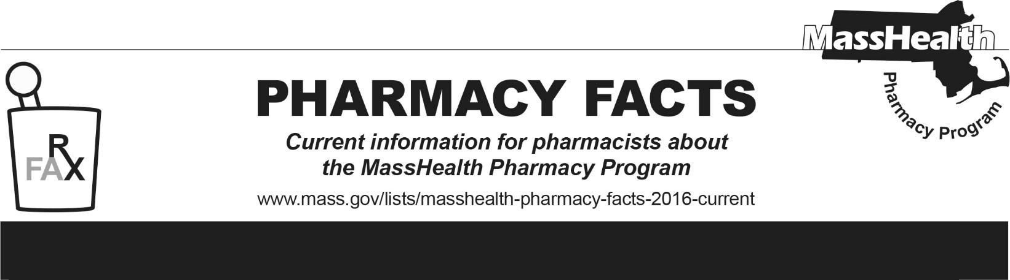
Number 278, June 25, 2026

Editor: Ryan Bettencourt Contributors: Eliza Anderson, Sarah Dube, Aimee Evers, Breeyn Green, Neha Kashalikar,
Kim Lenz, Mckenzie McVeigh, Katelyn Meyer, Kyle Semmel

MassHealth Drug List Update
Below are updates to the MassHealth Drug List (MHDL). See the MHDL for a complete listing of updates.

Additions
Effective July 1, 2026, the following newly marketed drugs have been added to the MassHealth Drug List.
- Avtozma (tocilizumab-anoh vial) – PA; MB
- buspirone capsule – PA; A90
- Enbumyst (bumetanide nasal spray) – PA
- escitalopram capsule – PA; A90
- Exdensur (depemokimab-ulaa) – PA; MB
- Exxua (gepirone) – PA
- Fesilty (fibrinogen, human-chmt)
- Forzinity (elamipretide) – PA
- Hyrnuo (sevabertinib) – PA
- Inluriyo (imlunestrant) – PA
- Javadin (clonidine oral solution) – PA
- Komzifti (ziftomenib) – PA
- Lasix Onyu (furosemide on-body infusor) – PA
- Lopressor (metoprolol immediate-release 12.5 mg tablet) – PA
- Lopressor (metoprolol immediate-release oral solution) – PA
- Pokonza (potassium chloride oral solution) – PA
- potassium chloride 40 mEq powder packet – PA; A90
- Rybrevant Faspro (amivantamab/hyaluronidase-lpuj) – PA; MB
- Starjemza (ustekinumab-hmny prefilled syringe, 45 mg/0.5 mL vial) – PA
- Starjemza (ustekinumab-hmny 130 mg/26 mL vial) – PA; MB
- Unloxcyt (cosibelimab-ipdl) – PA; MB
- ustekinumab-aauz, unbranded – PA
- Veltassa (patiromer 1 g packet) – PA ≥ 18 years and PA > 4 unit/day
- Voyxact (sibeprenlimab-szsi) – PA

Change in Prior Authorization Status
- Effective July 1, 2026, the following antitubercular agent will require PA.
cycloserine – PA; A90
- Effective July 1, 2026, the following hematinic agent will require PA.
Velphoro (sucroferric oxyhydroxide) – PA
- Effective July 1, 2026, the following hormone agent will require PA.
desmopressin acetate 1.5 mg/mL nasal spray – PA
- Effective July 1, 2026, the following cardiovascular agent will no longer require PA within established quantity limits.
Entresto (sacubitril/valsartan tablet) – PA > 2 units/day
- Effective July 1, 2026, the following cardiovascular agent will no longer require PA. Pediatric Behavioral Health Medication Initiative criteria will apply. For additional information, please see the Pediatric Behavioral Health Initiative.
clonidine patch – PA < 3 years; A90
- Effective July 1, 2026, the following cardiovascular agent will no longer require PA within updated age limits.
Inzirqo (hydrochlorothiazide suspension) – PA ≥ 13 years
- Effective July 1, 2026, the following cardiovascular agents will require PA.
Exforge HCT (amlodipine/valsartan/hydrochlorothiazide) – PA; M90
Inspra (eplerenone) – PA; M90
quinidine sulfate – PA; M90
- Effective July 1, 2026, the following insulin agent will no longer require PA.
Humulin N (insulin NPH)
- Effective July 1, 2026, the following insulin agent will require PA.
Novolin N (insulin NPH) – PA

Change in Coverage Status
Effective July 3, 2026, the following anti-obesity agents are excluded per MassHealth regulation 130 CMR 406.413(B)(7) and will no longer be covered.
- Adipex-P (phentermine 37.5 mg capsule, tablet) – PA < 12 years; #
- benzphetamine – PA
- diethylpropion – PA
- diethylpropion extended-release – PA
- phendimetrazine – PA
- phendimetrazine extended-release – PA
- phentermine 15 mg, 30 mg capsule – PA < 12 years
- phentermine 8 mg tablet – PA < 12 years or ≥ 18 years
- phentermine/topiramate extended-release – PA
- Saxenda (liraglutide) – PA
- Xenical (orlistat) – PA

Updated MassHealth Brand Name Preferred Over Generic Drug List
The MassHealth Brand Name Preferred Over Generic Drug List has been updated to reflect recent changes to the MassHealth Drug List.
- Effective July 1, 2026, the following agents will be added to the MassHealth Brand Name Preferred Over Generic Drug List.
Belbuca (buprenorphine buccal film) – PA; BP
Endometrin (progesterone vaginal insert) – PA; BP
Humulin N (insulin NPH); BP
Incruse (umeclidinium); BP, A90
Lumigan (bimatoprost 0.01% ophthalmic solution); BP, M90
- Effective July 1, 2026, the following agents will be removed from the MassHealth Brand Name Preferred Over Generic Drug List.
Fabior (tazarotene foam) – PA
Xenical (orlistat) – PA

Updated MassHealth 90-day Initiative
- Effective July 1, 2026, the following agents may be allowed or mandated to be dispensed in up to a 90-day supply, as indicated below.
Astagraf XL (tacrolimus extended-release capsule); #, A90
Incruse (umeclidinium); BP, A90
Lumigan (bimatoprost 0.01% ophthalmic solution); BP, M90
- Effective July 1, 2026, the following agents will no longer be allowed or mandated to be dispensed in up to a 90-day supply, as indicated below.
Revlimid (lenalidomide) – PA; BP
Samsca (tolvaptan) – PA
Xenical (orlistat) – PA

Abbreviations, Acronyms, and Symbols
# Designates a brand-name drug with FDA “A”-rated generic equivalents. Prior authorization is required for the brand, unless a particular form of that drug (for example, tablet, capsule, or liquid) does not have an FDA “A”-rated generic equivalent.
MB This drug is available through the healthcare professional who administers the drug or in an outpatient or inpatient hospital setting. MassHealth does not pay for this drug to be dispensed through the retail pharmacy. If listed, PA does not apply through the hospital outpatient and inpatient settings. Please refer to 130 CMR 433.408 for PA requirements for other healthcare professionals. Notwithstanding the above, this drug may be an exception to the unified pharmacy policy; please refer to respective MassHealth Accountable Care Partnership Plans (ACPPs) and Managed Care Organizations (MCOs) for PA status and criteria, if applicable.
PA Prior authorization is required. The prescriber must obtain PA for the drug in order for the provider to receive reimbursement. Note: PA applies to both the brand-name and the FDA “A”-rated generic equivalent of listed product.
A90 Allowable 90-day supply. Dispensing in up to a 90-day supply is allowed. May not include all strengths or formulations. Quantity limits and other restrictions may apply.
BP Brand Preferred over generic equivalents. In general, MassHealth requires a trial of the preferred drug or clinical rationale for prescribing the non-preferred drug generic equivalent.
M90 Mandatory 90-day supply. After dispensing up to a 30-day supply initial fill, dispensing in a 90-day supply is required. May not include all strengths or formulations. Quantity limits and other restrictions may also apply.
PD Preferred Drug. In general, MassHealth requires a trial of the preferred drug or clinical rationale for prescribing a non-preferred drug within a therapeutic class.

