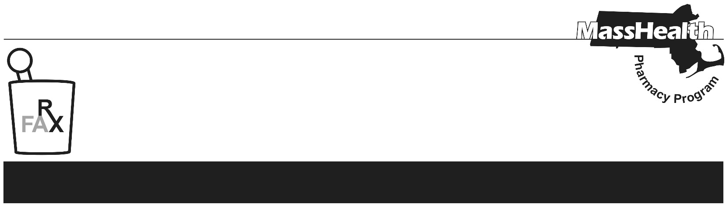
Number 279, June 29, 2026

PHARMACY FACTS
Current information for pharmacists about
the MassHealth Pharmacy Program
www.mass.gov/lists/masshealth-pharmacy-facts-2016-current
Editor: Ryan Bettencourt Contributors: Eliza Anderson, Aimee Evers, Breeyn Green, Neha Kashalikar,
Kim Lenz, Mckenzie McVeigh, Katelyn Meyer, Kyle Semmel

MassHealth Pharmacy Changes Effective July 2026
This Pharmacy Facts describes revisions to pharmacy regulations and provides information on the Centers for Medicare & Medicaid Services (CMS) Medicare GLP-1 Bridge demonstration.

MassHealth Pharmacy Regulation Changes, effective July 3, 2026
The pharmacy regulations at 130 CMR 406.000: Pharmacy Services have been revised, effective July 3, 2026. These revisions allow MassHealth to make changes to how it covers drugs purchase through the 340B Drug Pricing Program. Amendments were made to clarify or update existing policies, including updating language about provider eligibility, allowable refills, and limitations on coverage of drugs. This Pharmacy Facts summarizes selected revisions to 130 CMR 406.000 for convenience. Providers should review the amendments in full to understand all applicable requirements.

Provider Eligibility Changes
- 130 CMR 406.404(B)(2) was updated to clarify that a pharmacy provider that meets all other eligibility requirements and is licensed by the Department of Public Health and dispensing in a clinic or hospital setting may be eligible for enrollment.
- 130 CMR 406.404(D) was revised to indicate that MassHealth does not cover drugs billed through pharmacy point-of-sale adjudication when these drugs are acquired through the 340B Drug Pricing Program. See Pharmacy Facts #274 for detailed information. This change applies to pharmacy claims submitted to POPS to MassHealth FFS, the primary care clinician (PCC) Plan, Primary Care Accountable Care Organization (PCACO-B), or the Children’s Medical Security Plan as a primary payer (Other Coverage Code “00”, “01”, or “03”). This change does not apply to pharmacy claims in which MassHealth FFS, the PCC Plan, PCACO-B, or the Children’s Medical Security Plan is a secondary payer (other Coverage Code “02” or “04”), Health Safety Net pharmacy claims, or Accountable Care Partnership Plan, Managed Care Organization, Senior Care Options, or One Care claims.

Refills Changes
- 130 CMR 406.411(C) was amended to clarify MassHealth refill limits for claims processed through the Pharmacy Online Processing System (POPS).
POPS will no longer reject claims because the fill number (NCPDP field 403-D3) is greater than the number of refills authorized (NCPDP 415-DF). Pharmacies should continue to ensure compliance with refill requirements set forth by the Massachusetts Board of Registration in Pharmacy as outlined in 247 CMR 9.
POPS will reject claims that exceed allowable refills per federal or state law, or where the MassHealth Drug List, Pharmacy Facts, or other written issuance from the MassHealth
agency specifically limits the number of refills, duration of the prescription, or both. For example:
For a CII controlled substance, POPS will reject if the number of refills authorized exceeds “0”, if fill number exceeds “0”, or if the date of service is greater than 30 days after the date the prescription was written
For a CIII through CV controlled substance, POPS will reject if the number of refills authorized exceeds “5”, if fill number exceeds “5”, or if the date of service is greater than 180 days after the date the prescription was written.
For a CVI controlled or non-controlled substance, POPS will reject if the number of refills authorized exceeds “11”, if fill number exceeds “11”, or if the date of service is greater than 365 days after the date the prescription was written.

Limitations on Coverage of Drugs Changes
- 130 CMR 406.413(B)(2) was amended to clarify that the MassHealth agency does not pay for any drug used solely for the symptomatic relief of cough and colds, including but not limited to, those that contain an antitussive or expectorant as a major ingredient.
- 130 CMR 406.413(B)(7) was added. The MassHealth agency does not pay for any drug used for the treatment of obesity or overweight.

Centers for Medicare & Medicaid Services Medicare GLP-1 Bridge
Beginning July 1, 2026, CMS will begin a short-term demonstration, called the Medicare GLP-1 Bridge, that will provide eligible Medicare Part D beneficiaries with access to certain GLP-1 drugs. CMS will use a single central processor (Humana; BIN 028918; PCN MEDDGLP1BR) to manage prior authorization, claims adjudication, and payment to pharmacies for the Medicare GLP-1 Bridge. Providers should review the Medicare GLP-1 Bridge for more information, including Bridge eligibility criteria, covered products, and claims-processing instructions.

Eligible Medicare Part D beneficiaries will have a $50 copay through the Medicare GLP-1 Bridge. Eligible GLP-1 drugs furnished under the Medicare GLP-1 Bridge are provided outside of the Part D benefit. This means that the Part D deductible will not apply, no part of the $50 copay counts towards the beneficiary’s True Out-of-Pocket (TrOOP) costs, and there is no low-income subsidy (LIS) provided for LIS beneficiaries.

For dual-eligible members, the $50 copayment associated with the Medicare GLP-1 Bridge, or any other costs associated with the Medicare GLP-1 Bridge, is not payable by MassHealth. The member will be responsible for the $50 copay.

