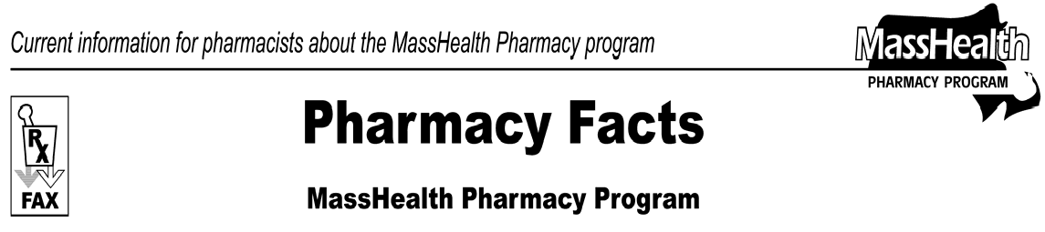
Number 28
July 2, 2007
www.mass.gov/masshealth/pharmacy
- Editor: Vic Vangel • Contributors: Chris Burke, Gary Gilmore, Paul Jeffrey, James Monahan, Chuck Young •
 | MHDL Updates  - Additions  The following newly marketed drugs have been added to the MassHealth Drug List.  Brovana (arformoterol) – PA Desonate (desonide) – PA Fexmid (cyclobenzaprine) – PA  Janumet (sitagliptin/metformin) – PA  Lialda (mesalamine) – PA  Liquicet (hydrocodone/acetaminophen) – PA Magnacet (oxycodone/acetaminophen) – PA Omnitrope (somatropin) – PA  Pataday (olopatadine) – PA  Pylera (bismuth subcitrate/metronidazole/tetracycline) –  PA  Qualaquin (quinine) – PA Soliris (eculizumab) – PA Tekturna (aliskiren) – PA Tykerb (lapatinib)  - New FDA “A” – Rated Generics  The following FDA “A”- rated generic drugs have been added to the MassHealth Drug List. The brand name is listed with a # symbol, to indicate that prior authorization is required for the brand.  New FDA “A” - Rated  Generic Drug Generic Equivalent of  amlodipine Norvasc #  moexipril/ Uniretic # hydrochlorothiazide  polyethylene glycol- NuLytely # electrolyte solution  trandolapril Mavik #  zolpidem – Ambien # –  PA > 10 units/month PA > 10 units/month  - Change in Prior-Authorization Status  - The prior-authorization requirements for the atypical antipsychotics medications will be changing. MassHealth will be adding the following quantity limits to the atypical antipsychotics, effective October 1, 2007. Where applicable, dose consolidation should be considered. | For example, if the member is on two olanzapine (Zyprexa) 5 mg tablets once daily or one olanzapine (Zyprexa) 5 mg tablet twice daily, the dose can be consolidated to one olanzapine (Zyprexa) 10 mg tablet once daily. Updated versions of the Antipsychotic Prior Authorization Request Form, Antipsychotic Initiative, and Atypical Antipsychotic Table will be posted with the September MassHealth Drug List. Prior authorizations for greater than the quantity limit will be considered in August, two months before the start of the requirements.  Abilify (aripiprazole) tablet – PA > 30 units/month Abilify (aripiprazole) solution – PA > 750 ml/month Geodon (ziprasidone) – PA > 60 units/month Invega (paliperidone) – PA > 30 units/month Risperdal (risperidone) tablet – PA > 60 units/month Risperdal (risperidone) solution – PA > 480 ml/  month  Seroquel (quetiapine) – PA > 90 units/month  Zyprexa (olanzapine) – PA > 30 units/month  - The prior-authorization requirements for fenofibrate medications have changed. The following drugs will require prior authorization effective July 16, 2007.  Tricor (fenofibrate) – PA  Triglide (fenofibrate) – PA  - The prior-authorization requirements for gastro- intestinal drugs have changed. The following drugs will require prior authorization effective July 16, 2007.  Helidac (bismuth subsalicylate/metronidazole/ tetracycline) – PA  Prevpac (lansoprazole/amoxicillin/clarithromycin) –  PA  - The following drugs will require prior authorization effective July 16, 2007.  Kerol Redi-cloths (urea) – PA Palgic (carbinoxamine) – PA trazodone 300 mg tablet – PA  - The following drugs no longer require prior authorization.  Arixtra (fondaparinux) Keppra (levetiracetam)

Please direct any questions or comments (or to be taken off of this fax distribution) to
Victor Moquin of ACS at 617-423-9830.

