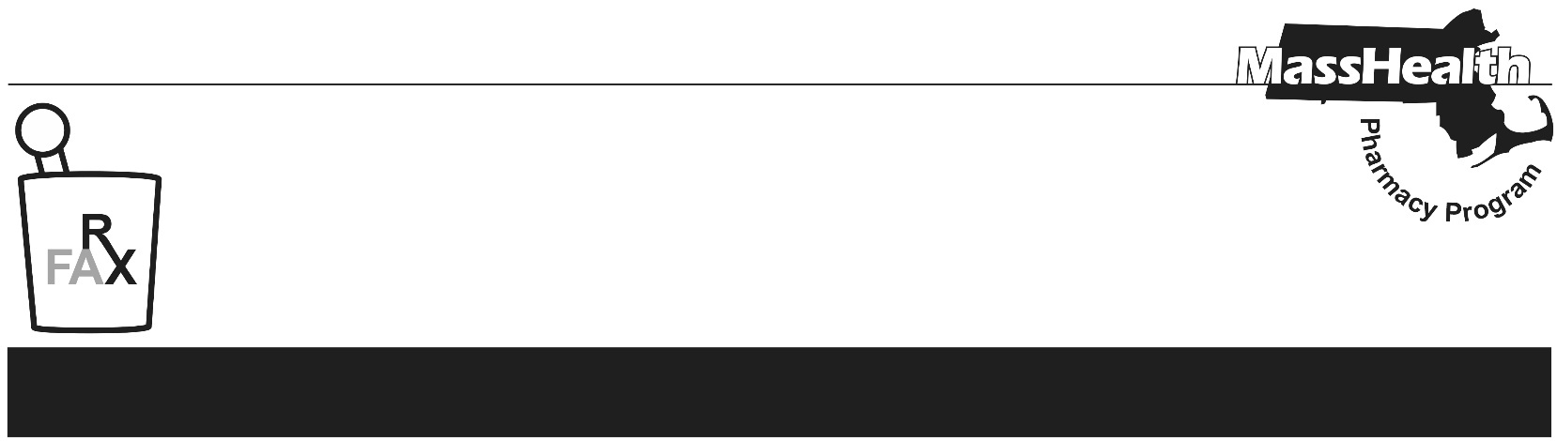
Number 280, July 21, 2026

PHARMACY FACTS
Current information for pharmacists about
the MassHealth Pharmacy Program
www.mass.gov/lists/masshealth-pharmacy-facts-2016-current
Editor: Ryan Bettencourt Contributors: Eliza Anderson, Aimee Evers, Breeyn Green, Neha Kashalikar,
Kim Lenz, Mckenzie McVeigh, Katelyn Meyer, Kyle Semmel

Emergency Override Reminder and Usual and Customary Charge Clarification
This Pharmacy Facts serves as a reminder that emergency overrides are not available for products excluded from MassHealth coverage and clarifies that MassHealth does not treat discounts related to charity care or sliding fee discount programs as the pharmacy’s usual and customary charge.

Emergency Overrides Not Permitted for Products Excluded from Coverage
Effective July 3, 2026, as outlined in 130 CMR 406.413(B)(7), the MassHealth agency does not pay for any drug used for the treatment of obesity or overweight. For MassHealth Standard and CommonHealth members under age 21, MassHealth may cover medically necessary drug therapy in accordance with Early and Periodic Screening, Diagnostic, and Treatment (EPSDT) requirements and any applicable prior-authorization requirements.

Pharmacies are reminded that, due to exclusion from coverage, emergency overrides are not available for any medications excluded from coverage per 130 CMR 406.413(B): Drug Exclusions. This includes medications when used for obesity or overweight. For anti-obesity medications with other medically accepted indications, emergency overrides may be available when appropriate.

If an emergency override is required, pharmacies should contact the Drug Utilization Review Unit at (800) 745-7318 during normal business hours. Pharmacies must attest to the indication for which the medication is being used before an override will be provided. Emergency overrides are valid for at least a 72-hour, non-refillable supply of the drug.

Outside of business hours, pharmacies may submit an emergency override claim with a value of “03” for Level of Service (field 418). After the prescription is adjudicated, the pharmacy should remove the “03” from the level of service field before the next fill. The use of the Level of Service Code “03” will be limited to once per year per member and drug. If the medication is used for treatment of obesity or overweight, and not for another medically accepted indication, pharmacies must not use this override. Pharmacy providers are advised that the use of Level of Service “03” will be closely monitored and may be subject to audit.

Usual and Customary Clarification
The Usual and Customary Charge, as noted in 101 CMR 331.02, requires that MassHealth is charged no more than the lowest price that a provider charges or accepts from any payer for the same quantity of a drug on the same date of service, in Massachusetts, including but not limited to the shelf price, sale price, or advertised price, for any drug including an over-the-counter drug.

Some pharmacy providers may have a sliding fee discount schedule, or other charity care programs. These programs are meant to apply a discount to services based on specific income brackets for uninsured or underinsured patients. MassHealth does not treat a price available only through such a program as the pharmacy’s Usual and Customary Charge. This does not apply to generally available cash prices, discount-card prices, membership prices, or other discounts that are not based on the patient’s financial need.

