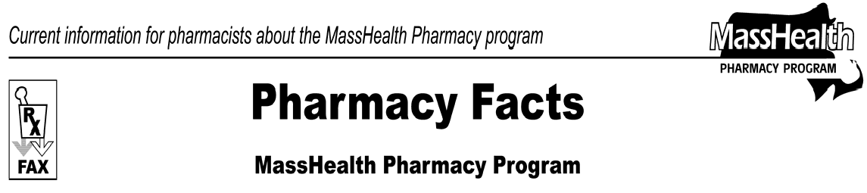
Number 29
August 28, 2007
www.mass.gov/masshealth/pharmacy

 | - Editor: Vic Vangel • Contributors: Chris Burke, Gary Gilmore, Paul Jeffrey, James Monahan, Chuck Young •
 | Medicare Part D Reminders  For dual-eligible members enrolled in Medicare Part D drug plans  MassHealth is required to pay for a one-time 72-hour supply if the pharmacy is unable to bill a Part D plan or the Wellpoint/Anthem point of sale facilitator. After an unsuccessful attempt to bill the member’s Part D plan and Wellpoint/Anthem, pharmacists should use the standard NCPDP other payer reject codes to override a denied claim when a Part D plan and/or Wellpoint will not pay a claim for a Part D drug. A level-of-service code of “03” must also be entered on the claim.  MassHealth also provides assistance with Part D plan copayments. The pharmacy should collect from the member the copayment the member would have paid under MassHealth ($0 to $3) and send a claim to MassHealth for the remainder, using Other Coverage Code 2, 4, or 8.  Note: Drugs excluded from the Medicare Part D program (benzodiazepines, barbiturates, and certain OTCs) are a regular MassHealth benefit for dual-eligible members. Bill MassHealth directly for these drugs and charge the usual MassHealth copayment.  For dual-eligible members that have “opted out” of a Medicare Part D drug plan  Members who choose to receive their drugs through a non-Part D plan (i.e., commercial insurance or “creditable coverage”) do not receive MassHealth assistance with drug costs or drug copayments for any Part D covered drugs when they are provided by a non-Part D plan.  Note: Certain drugs excluded from the Medicare Part D program (benzodiazepines, barbiturates, certain OTCs) are a regular MassHealth benefit for dual-eligible members. Bill MassHealth directly for these drugs and charge the usual MassHealth copayment. | Dose Consolidation — Atypical Antipsychotics  As previously stated, the atypical antipsychotics will have quantity limits as of 10/1/07. Pharmacists will be able to execute most dose consolidations (e.g., a prescription for Zyprexa 5 mg, 2 tablets daily, converted to Zyprexa 10 mg, 1 tablet daily). Other prescriptions may require the prescriber to write two prescriptions (e.g., Zyprexa 2.5 mg, 5 tablets daily, being converted to Zyprexa 10 mg, 1 tablet daily, and Zyprexa 2.5 mg, 1 tablet daily).  When a second prescription is needed to accommodate this dose consolidation, the MassHealth member is not charged a copayment for the second prescription, as long as both prescriptions are processed by the same pharmacy on the same day. MassHealth intends to expand this dose consolidation initiative to other drugs in the future.  Prescriber DEA numbers  MassHealth continues to adopt measures to ensure that the proper prescriber DEA number appears on a prescription claim. Currently, a delay exists between the time a newly licensed prescriber receives a DEA number and when MassHealth receives an updated list of these numbers from the Drug Enforcement Administration.  There is a 90-day grace period beginning from the first time the Pharmacy Online Processing System (POPS) receives a claim with an unrecognized DEA. If, after 90 days, POPS does not receive updated information on this DEA number, it will deny subsequent claims submitted with the unrecognized DEA number. During the 90-day grace period, the pharmacy will receive a message stating that “Prescriber ID on file but will expire at end of 90 day grace period.” After the 90-day grace period, any claim submitted with the unrecognized DEA number will deny with NCPDP Reject Code 25 (Invalid Prescriber ID).
Please direct any questions or comments (or to be taken off of this fax distribution) to
Victor Moquin of ACS at 617-423-9830.

