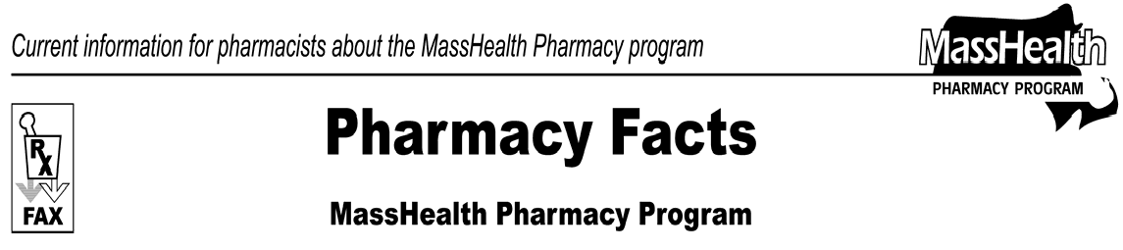
Number 30
September 7, 2007
www.mass.gov/masshealth/pharmacy

- Editor: Vic Vangel • Contributors: Chris Burke, Gary Gilmore, Paul Jeffrey, Vic Vangel, Chuck Young •
Requirement for Tamper-Resistant, Written Prescriptions  Recently, Congress enacted a law mandating the use of tamper-resistant prescription pads for prescriptions for Medicaid members. The law states that payment shall not be made for ". . . amounts expended for medical assistance for covered outpatient drugs (as defined in section 1927(k)(2)) for which the prescription was executed in written (and non-electronic) form unless the prescription was executed on a tamper-resistant pad."  The intent of this law is to reduce forged and altered prescriptions and to deter drug abuse. MassHealth stresses the importance of ensuring that MassHealth members receive appropriate care, and urges prescribers to use alternatives to paper prescriptions where possible while awaiting tamper- resistant prescriptions.  This document is intended to clarify MassHealth’s interpretation and implementation of the new federal requirements that non-electronic prescriptions for Medicaid-covered outpatient drugs be issued using a tamper-resistant prescription. This new requirement is effective for dates of service on and after October 1, 2007.  The new requirement applies to both prescription drugs and over-the-counter drugs prescribed for MassHealth members. The requirement is applicable when MassHealth is the primary or secondary payor of the prescription being filled. It includes drugs prescribed for MassHealth members in nursing facilities if MassHealth will be making any payment for the drugs.  Drug Enforcement Administration regulations, Board of Registration in Pharmacy regulations, DPH regulations, MassHealth regulations, and Massachusetts Controlled Substances laws at  M.G.L. c. 94C still apply.  MassHealth does not endorse specific suppliers of tamper-resistant pads. The federal law exempts | from the tamper-resistant prescription pad requirement MassHealth prescriptions that are:  - e-prescribed, faxed to the pharmacy from the provider’s office, or telephoned to the pharmacy by the provider;  - paid by MassHealth managed care organizations (MCOs);  - provided in institutional and clinical settings for which the drug is not separately reimbursed, but is reimbursed as part of a bundled payment rate; or  - refills for which the original prescription was filled before October 1, 2007.  Emergency fills, where allowed, for prescriptions written on non-tamper-resistant pads are permitted as long as the prescriber provides a verbal, faxed, electronic, or compliant written prescription within 72 hours after the date on which the prescription was filled. This allows a pharmacy, in an emergency situation, to telephone a prescriber to obtain a verbal order for a prescription written on a noncompliant prescription pad.  Effective for dates of service on and after October 1, 2007, a prescription pad must contain at least one of the characteristics listed on the table on page two of this Pharmacy Facts.  Effective for dates of service on and after October 1, 2008, a prescription pad must contain all three characteristics listed on the table on page two of this Pharmacy Facts.  The authorizing federal law is the Troop Readiness, Veterans’ Care, Katrina Recovery, and Iraq Accountability Appropriations Act of 2007 (H.R.  2206) section 7002(b).  For more information, please see Centers for Medicare & Medicaid Services (CMS) Letter to State Medicaid Director (SMDL #07-012,8/17/2007). The full letter is available at: http://www.cms.hhs.gov/SMDL/downloads/SMD081 707.pdf.  (continued on next page)

Pharmacy Facts Number 30, September 7, 2007, page 2 Required Tamper-Resistant Characteristics
One or more industry-recognized features designed to: | Examples include, but are not limited to:
1. prevent unauthorized copying of a completed or blank prescription form | - high security watermark on reverse side of blank  - thermochromic ink (for example, a latent “void” pattern printed across the entire width of the front of the prescription blank, such that if it is photocopied the word “void” will appear in a pattern across the entire front of the  prescription.)
2. prevent erasure or modification of information written on the prescription by the prescriber | - tamper-resistant background ink showing erasures or attempts to change written  information
3. prevent the use of counterfeit prescription forms | - sequentially numbered blanks  - duplicate or triplicate blanks

Please direct any questions or comments (or to be taken off of this fax distribution) to
Victor Moquin of ACS at 617-423-9830.

