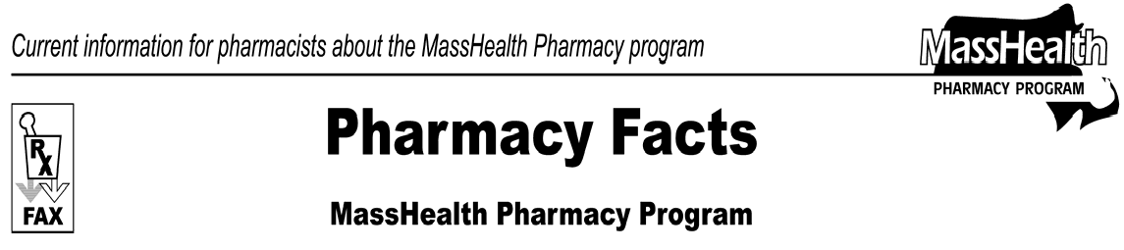
Number 32
December 13, 2007
www.mass.gov/masshealth/pharmacy

- Editor: Vic Vangel • Contributors: Chris Burke, Gary Gilmore, Paul Jeffrey, James Monahan, Chuck Young •
 | Health Safety Net (HSN) Claims  As of 10/1/07 the Pharmacy Online Processing System (POPS) has accepted claims from Health Safety Net (HSN) at in-network pharmacies. This program was formerly known as the Uncompensated Care Pool. HSN is a fund set up to help pay for health services at participating hospitals and community health centers for certain individuals. Health Safety Net is not a MassHealth coverage type, but MassHealth determines an applicant’s eligibility for HSN services. Eligible applicants may receive HSN services at participating hospitals and community health centers only, including hospitals and community health centers that are federally designated “340-B” entities. If a non-participating pharmacy tries to submit a claim for a HSN member it will receive the following message:  40- Contact Health Safety Net Help Desk (877-910-2100) for assistance. Claim must be processed by HSN-designated provider.  MHDL Update  The following newly marketed drugs have been added to the MassHealth Drug List.  Amrix (cyclobenzaprine extended-release) – PA  AzaSite (azithromycin, ophthalmic) – PA Azor (amlodipine/olmesartan) – PA CaloMist (cyanocobalamin) – PA Centany Kit (mupirocin) – PA  Divigel (estradiol) Elestrin (estradiol)  Extina (ketoconazole) – PA Inova (benzoyl peroxide) – PA Isentress (raltegravir)  Lipofen (fenofibrate) – PA  Peranex HC (hydrocortisone/lidocaine) – PA  Perforomist (formoterol) – PA  Selzentry (maraviroc) – PA 1  Tamiflu 30 mg (oseltamivir) – PA all quantities (June 1st to September 30th); PA > 20 capsules/month and PA > 40 capsules/season (October 1st to May 31st) | Tersi (selenium sulfide) – PA  Xyralid (hydrocortisone/lidocaine) – PA  Xyzal (levocetirizine) – PA  Zytopic (triamcinolone) – PA  1 The Trofile assay test, which predicts response to Selzentry, requires PA. Please use the Selzentry PA Request form and send request to the MassHealth Drug Utilization Review Program.  Change in PA Status  The PA requirements for Subutex and Suboxone are changing. The following PA requirements are effective January 2, 2008.  Subutex (buprenorphine) – PA  Suboxone (buprenorphine/naloxone) > 32 mg/day – PA  Suboxone (buprenorphine/naloxone) > 24 and < 32 mg/day  - PA is required after 90 days duration of therapy  Suboxone (buprenorphine/naloxone) > 16 and < 24 mg/day  - PA is required after 180 days duration of therapy  Suboxone (buprenorphine/naloxone) < 16 mg/day – PA is required after 365 days duration of therapy  The PA requirements for ocular antibiotics are changing. The following PA requirements are effective January 2, 2008.  Ciloxan Ointment (ciprofloxacin, ophthalmic ointment) – PA  Iquix (levofloxacin, ophthalmic) – PA  Quixin (levofloxacin, ophthalmic) – PA  Tobrex Ointment (tobramycin, ophthalmic ointment) – PA  Vigamox (moxifloxacin, ophthalmic) – PA  Zymar (gatifloxacin, ophthalmic) – PA  The following PA requirements are effective January 2, 2008.  Restasis (cyclosporine, ophthalmic) – PA > 64 units/month  The PA requirements for the following Triptans are changing. Please refer to Table 14 for the complete list of prior authorization requirements for the Triptans.  Axert (almotriptan) – PA > 8 units/month  Imitrex (sumatriptan), injection – PA > 4 units (8 injections/month)  Zomig (zolmitriptan) – PA > 8 units/month  The following drug requires PA.  Acthar (corticotropin) – PA

Please direct any questions or comments (or to be taken off of this fax distribution) to
Victor Moquin of ACS at 617-423-9830.

