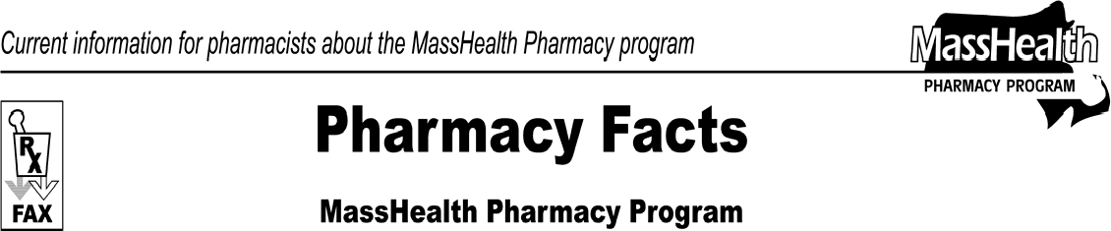www.mass.gov/masshealth/pharmacy
Number 34
March 21, 2008
- Editor: Vic Vangel • Contributors: Chris Burke, Gary Gilmore, Paul Jeffrey, James Monahan, Chuck Young •
Tamper-Resistant Prescription Requirements  Tamper-resistant prescription requirements are being phased in over the next seven months.  Effective April 1, 2008, the Centers for Medicare & Medicaid Services (CMS) will require that all Medicaid prescription blanks incorporate at least one of the characteristics listed below. To be considered tamper resistant after October 1, 2008, prescription blanks must include all three of the following characteristics:  - one or more industry-recognized features designed to prevent unauthorized copying of a completed or blank prescription form;  - one or more industry-recognized features designed to prevent the erasure or modification of information written on the prescription by the prescriber; and  - one or more industry-recognized features designed to prevent the use of counterfeit prescription forms.  For more information about tamper-resistant requirements, go to the CMS Web site at http://www.cms.hhs.gov The CMS Web site also includes recently updated information that may be of value to health facilities using tamper-resistant paper.  MassHealth has met with representatives from pharmacy and medical organizations to develop the characteristics of a tamper-resistant blank that would meet the federal requirements and be easily used by all providers. Prescription blanks must satisfy  tamper-resistant requirements before MassHealth is able to pay the corresponding claim. | To help determine whether a prescription complies with tamper-resistant requirements, three examples are listed below. Note that these are only some examples of tamper-resistant features. Pharmacies should fill prescriptions that are compliant under the CMS rules.  - a heat sensitive feature that will either change color or disappear and then reappear when rubbed (e.g., sensing imprint or thermochromic ink);  - erasure protection, such that the prescription has a background that resists alteration and erasure (e.g., special security paper);  - use of a latent, repetitive, printed word “Void” that will appear across the front of the prescription if it is scanned or photocopied. This feature must be patterned in such a way as not to obscure prescribing information.  Exceptions to the tamper-resistant requirements include prescriptions that are  - electronic, verbal, or faxed;  - reimbursed through a MassHealth managed care organization (MCO);  - for drugs reimbursed as part of a bundled rate; and  - Refilled when the original prescription was filled before April 1, 2008.  Emergency fills are allowed as long as a prescriber provides a verbal, faxed, electronic, or compliant written prescription within 72 hours.  MassHealth does not plan to endorse specific suppliers of tamper-resistant blanks. The Massachusetts Medical Society, however, has posted some Web sites to help providers find vendors for tamper-resistant blanks. For more information, go to their Web site at www.massmed.org/rx.
Please direct any questions or comments (or to be taken off of this fax distribution) to
Victor Moquin of ACS at 617-423-9830.

