www.mass.gov/masshealth/pharmacy
- Editor: Vic Vangel • Contributors: Chris Burke, Gary Gilmore, Paul Jeffrey, James Monahan, Chuck Young •

MHDL Updates

Additions

The following newly marketed drugs have been added to the MassHealth Drug List.
Allegra ODT (fexofenadine orally disintegrating tablet) – PA
Bystolic (nebivolol) – PA
Combigan (brimonidine/timolol, ophthalmic) Doribax (doripenem)
Flector Patch (diclofenac topical patch) – PA Hyper RAB (rabies immune globulin IM, human) Intelence (etravirine)
Ixempra (ixabepilone) Kuvan (sapropterin) Renvela (sevelamer)
Sanctura XR (trospium extended-release) Somatuline (lanreotide)
Tasigna (nilotinib)
Tekturna HCT (aliskiren/hydrochlorothiazide) – PA
Valstar (valrubicin)
Veregen (sinecatechins) – PA
Zyflo CR (zileuton extended-release) – PA

New FDA “A”-Rated Generics

The following FDA “A”-rated generic drugs have been added to the MassHealth Drug List. The brand name is listed with a # symbol, to indicate that prior authorization is required for the brand.

New FDA “A” - Rated
Generic Drug Generic Equivalent of

albuterol/ipratopium Duoneb #
alendronate Fosamax #
balsalazide Colazal #
ethinyl estradiol/ Estrostep FE # norethindrone
granisetron tablet – Kytril # – PA > 15 units/

PA > 15 units/month month

- Change in PA Status

  - The PA requirements for Prevacid capsules and solutabs are changing. The following PA requirements are effective April 15, 2008. Please see Table 3 for a complete list of PA requirements for the Proton Pump Inhibitors.
Prevacid (lansoprazole) capsule – PA ≥ 2 years
Prevacid SoluTab (lansoprazole, orally disintegrating tablet)

– PA≥ 2 years
  - The following PA requirements are effective April 15, 2008.

clindamycin 300 mg – PA Zyvox (linezolid), oral – PA Zyflo (zileuton) – PA

Updated MassHealth Nonlegend (OTC) Drug List

The MassHealth Nonlegend (OTC) Drug List has been updated to include the following drug.
cetirizine tablet

Deletions

- The following drugs have been deleted from the MassHealth Drug List because they are now over-the- counter.

Zyrtec (cetirizine)
Zyrtec-D (cetirizine/pseudoephedrine)

- The following medications have been deleted from the MassHealth Drug List. MassHealth does not pay for legend or nonlegend preparations for cosmetic purposes.

Drysol (aluminum chloride) Xerac AC (aluminum chloride)

- The following drugs have been deleted from the MassHealth Drug List because they were discontinued by the manufacturer.

Estrostep 21 (ethinyl estradiol/norethindrone) Prevacid (lansoprazole) suspension

Corrections

- The age restrictions for the following drugs have been added to the MassHealth Drug List. They were omitted in error.

Zostavax (herpes zoster vaccine) – PA < 60 years
Gardasil (human papillomavirus vaccine) – PA < 9 years and > 26 years

- The following drugs have been added to the MassHealth Drug List. They were omitted in error.

HalfLytely (polyethylene glycol-electrolyte solution/bisacodyl) - PA
Supprelin LA (histrelin) – PA
Vantas (histrelin) – PA

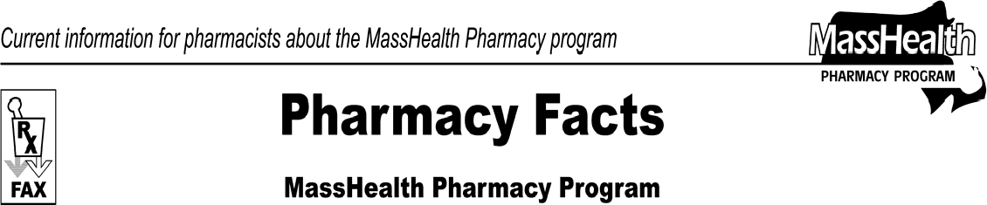
Number 35
March 28, 2008

Please direct any questions or comments (or to be taken off of this fax distribution) to
Victor Moquin of ACS at 617-423-9830.

