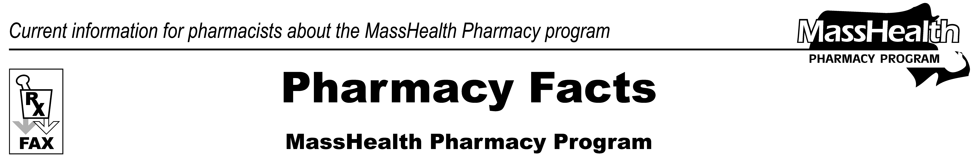
www.mass.gov/masshealth/pharmacy
Number 42
June 25, 2008
• Editor: Vic Vangel • Contributors: Chris Burke, Gary Gilmore, Paul Jeffrey, James Monahan, Nancy Schiff, Chuck Young •
MHDL Updates  1. Additions  The following newly marketed drugs have been added to the MassHealth Drug List.  Arcalyst (rilonacept) – PA  Dazidox (oxycodone immediate release) – PA  Emend IV (fosaprepitant injection)  Evamist (estradiol transdermal spray)  Fenoglide (fenofibrate) – PA  Lamisil Granules (terbinafine granules) – PA  Luvox CR (fluvoxamine extended-release) – PA  Millipred (prednisolone) – PA  Omnaris AQ (ciclesonide nasal spray) – PA  Pristiq (desvenlafaxine) – PA  Simcor (niacin extended-release/simvastatin) – PA  Treanda (bendamustine)  Voltaren Gel (diclofenac topical gel) – PA  2. New FDA “A”-Rated Generics  The following FDA “A”-rated generic drugs have been added to the MassHealth Drug List. The brand name is listed with a # symbol, to indicate that prior authorization is required for the brand.  New FDA “A” - Rated  Generic Drug Generic Equivalent of  epoprostenol Flolan #  irinotecan Camptosar #  3. Change in PA Status  - The PA requirements for the intranasal corticosteroids are changing. The following PA requirements are effective on July 15, 2008.  Beconase AQ (beclomethasone nasal spray) – PA  Nasacort AQ (triamcinolone nasal spray) – PA  Nasarel (flunisolide nasal spray) – PA  Nasonex (mometasone nasal spray) – PA > 4 years and  > 1 inhaler/month  Rhinocort Aqua (budesonide nasal spray) – PA  b. The following PA requirements for bisphosphonates are changing. The following PA requirements are effective July 15, 2008.  Actonel (risedronate) – PA  Boniva (ibandronate) – PA  Reclast (zoledronic acid) – PA  Skelid (tiludronate) – PA | c. The PA requirements for benzodiazepines are changing. The following PA requirements are effective July 15, 2008.  alprazolam powder – PA  Diastat (diazepam rectal gel) – PA > 5 kits (10 syringes/1  month)  diazepam powder – PA  lorazepam powder – PA  Tranxene SD (clorazepate) – PA  d. The following drugs will require prior authorization effective July 15, 2008.  Aldara (imiquimod) – PA  Flagyl ER 750 mg (metronidanole extended-release) – PA  metronidazole 375 mg – PA  e. The PA requirements for pseudoephedrine are changing. The following PA requirements are effective July 15, 2008.  pseudoephedrine – PA > 240 mg/day  f. The following drug will no longer require prior authorization.  Neumega (oprelvekin)  4. Updated MassHealth Nonlegend (OTC) Drug List  The MassHealth Nonlegend (OTC) Drug List has been updated to include the following drugs.  cetirizine syrup  Culturelle (lactobacillus rhamnosus GG) < 18 years  glycerin  5. Corrections  The following drugs have been added to the MassHealth Drug List. They were omitted in error. These changes do not reflect any change in MassHealth policy.  Fansidar (sulfadoxine/pyrimethamine)  Maxaquin (lomefloxacin)  ProAir HFA (albuterol HFA)  ranitidine syrup
Please direct any questions or comments (or to be taken off of this fax distribution) to
Victor Moquin of ACS at 617-423-9830.

