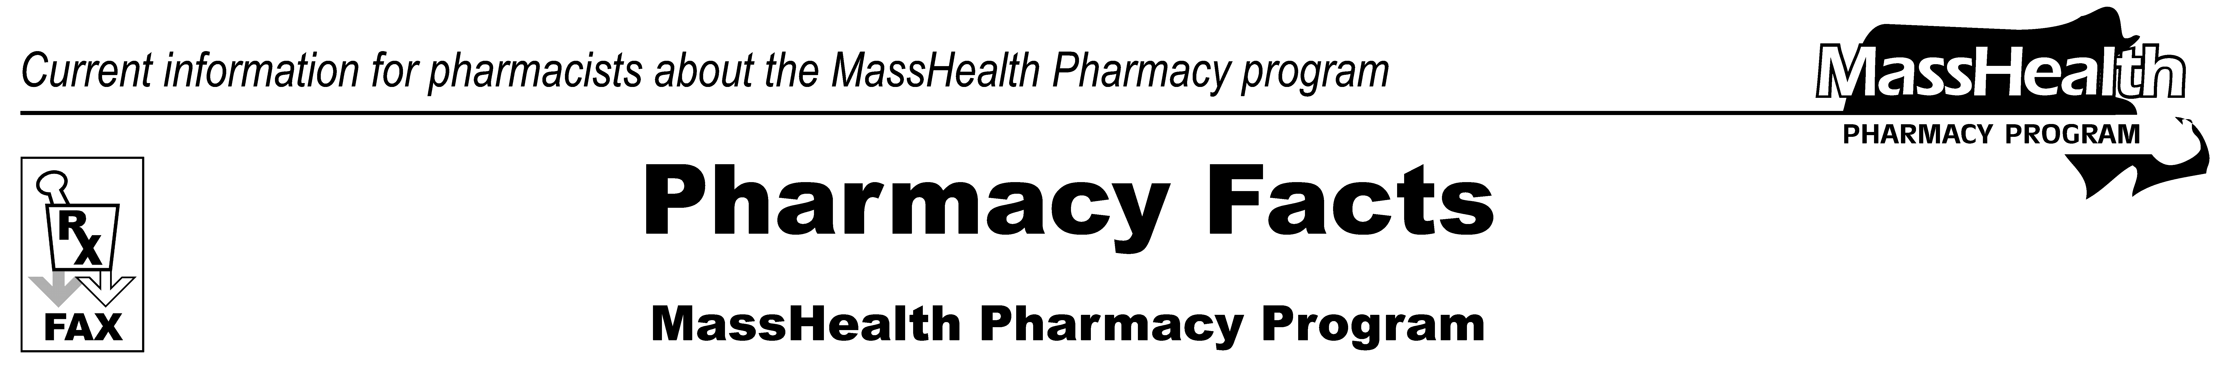
www.mass.gov/masshealth/pharmacy
Number 43
September 9, 2008
• Editor: Vic Vangel • Contributors: Chris Burke, Gary Gilmore, Paul Jeffrey, James Monahan, Chuck Young •
Pharmacy Program Regulations  MassHealth has updated the Pharmacy Manual with changes detailed in Transmittal Letter PHM-58. It was mailed last month and can be found at www.mass.gov/masshealthpubs. Click on “Provider Library,” then “Transmittal Letters,” then “2008 Transmittal Letters,” then “PHM-58.”  Changes to regulations transmitted by Transmittal Letter PHM-58 will become effective September 15, 2008. The following changes may be of particular interest to pharmacists.  - MassHealth will allow the following additional exceptions to the 30-day quantity limit to allow 90-day supplies:  - for all family-planning drugs; and  - when MassHealth is the secondary payer and the primary payer allows a 90-day supply.  - The MassHealth Drug List (MHDL) will be used to:  - specify refill limitations; and  - specify all medical supplies and devices that are paid through POPS, in a section called the MassHealth Non-Drug Product List.  - MassHealth is revising the definition of “usual and customary charge” to require pharmacies to include cash-paying customers and advertised prices for OTC drugs when determining the lowest price.  MHDL Reminders  In some instances MassHealth requires prior authorization (PA) for specific formulations or strengths of certain prescribed drugs. This does not mean that all formulations and strengths of that drug will require PA. MassHealth encourages the pharmacy, when clinically appropriate, to obtain a new prescription for a formulation or strength of that drug that does not require PA.  Examples of drugs that require PA for certain formulations or strengths (indicated in italics) include the following: | ranitidine capsules  fluoxetine 20 mg. tablets and fluoxetine 40mg.  trazodone 300 mg.  clindamycin 300 mg.  metronidazole 375 mg and Flagyl ER 750 mg.  Keflex 750 mg.  Additionally, the MHDL therapeutic tables are undergoing revisions. The tables provide a view of drugs within their respective therapeutic classes along with PA requirements, clinical information about the drug, and evaluation criteria for PA for select therapeutic classes. The tables may not include all medications, dosage forms, and combination products within that therapeutic class. The criteria for PA identify the clinical information MassHealth considers when determining medical necessity for selected medications. These criteria are based upon generally accepted standards of practice, review of the medical literature, federal and state policies, as well as laws applicable to the Massachusetts Medicaid Program (MassHealth). The clinical information included in the criteria is not intended to serve as a source of comprehensive prescribing information.  NewMMIS Update  The NewMMIS implementation date has been changed from September 29, 2008 to January 5, 2009. The additional time will enable MassHealth to continue internal testing and ensure that the new system functions as intended. It will also give MassHealth providers some additional time to prepare for the transition to NewMMIS.  All MassHealth providers will receive a bulletin explaining the delayed implementation date of NewMMIS in more detail.
Please direct any questions or comments (or to be taken off of this fax distribution) to
Victor Moquin of ACS at 617-423-9830.

