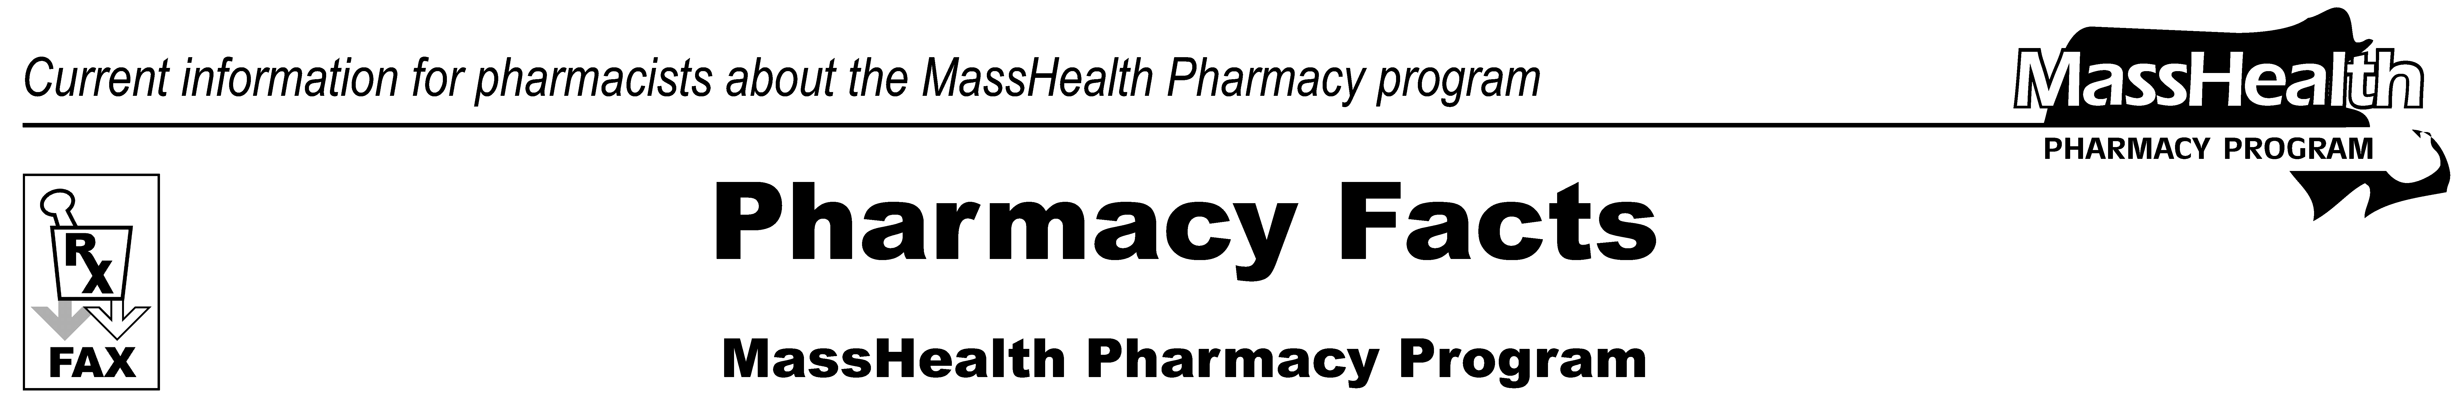
www.mass.gov/masshealth/pharmacy
Number 46
October 8, 2008
Page 1 of 2
• Editor: Vic Vangel • Contributors: Chris Burke, Gary Gilmore, Paul Jeffrey, James Monahan, Nancy Schiff, Chuck Young •
Update to MassHealth All Provider Bulletin 173 (March 2008)  NewMMIS will be implemented January 5, 2009  The Medicaid Management Information System (MMIS) processes and pays pharmacy claims that are adjudicated in the Pharmacy Online Processing System (POPS). MMIS interacts daily with POPS concerning claims, member files, provider enrollment, and payment information. MassHealth has previously issued other Pharmacy Facts that gave some general information about NewMMIS. MassHealth encourages providers to refer to the NewMMIS materials and begin to make modifications to their practice management systems and databases before the January implementation date.  • Final versions of HIPAA companion guides for the 835 and 837P transactions are accessible on the MassHealth Web site at www.mass.gov/masshealth/newmmis. The POPS Billing Guide will be updated before implementation, with minimal changes relating to NewMMIS. The 835 companion guides for pharmacy and DME have been changed drastically.  • The billing guide for the CMS-1500 will replace the billing instructions for MassHealth claim form no. 9 for DME services.  Implementation Timeline  90 – 75 Days Before Implementation —  New Member ID Cards  - MassHealth began issuing new, individual MassHealth ID cards to all members beginning October 7, 2008. The MassHealth ID cards will contain a new 12-digit member ID number.  - Pharmacies will be able to process claims through POPS using either the new or the old legacy member ID number until the January 5, 2009, implementation date when the use of the new member ID number becomes mandatory. The Recipient Eligibility Verification System (REVS) will show both the new and old member ID number until the January 5, 2009, implementation date. | - The MassHealth card will display the member’s name and a new 12-digit identification number. The new member ID number will not be based on the member’s social security number. The new member ID number will remain the same no matter how many times the member receives a replacement card, has a change in address, name, or marital status, or has a gap in MassHealth coverage.  - Following the practice of other health insurance plans, MassHealth cards will no longer be issued at the head-of-household level. MassHealth cards will list only one member per card.  60 – 45 Days Before Implementation —  New Provider ID Numbers  • MassHealth will issue new 10-character provider IDs to all providers. Providers will continue to use a national provider identifier (NPI) to submit claims to MassHealth, as appropriate.  • MassHealth will send the last paper provider enrollment application to providers.  30 Days Before Implementation  • MassHealth will accept the last paper claim adjustments and voids for processing.  • MassHealth will accept the last Medicare/Medicaid crossover claims (i.e., claim form no. 2) for processing in the current system.  • The NewMMIS Provider Online Service Center will be available to providers.  20 – 10 Days Before Implementation  • MassHealth will accept the last MassHealth-proprietary claim form no. 9.  • MassHealth will begin accepting the industry-standard paper claim form CMS-1500 (for DME).  Seven Days Before Implementation  • MassHealth will accept the first electronic batch claims in NewMMIS.  Implementation Day  • The current system will be shut down.  • The Recipient Eligibility Verification System (REVS) will be shut down and replaced by verification via direct data entry (DDE) and batch submissions in the Provider Online Service Center. However, EVSpc and the automated voice response (AVR) will continue to be available.  • MassHealth will issue the last remittance advices (i.e., for claim form nos. 2, 6, and 9).

NewMMIS Web Page
MassHealth continues to post essential information about NewMMIS on a dedicated Web page, located at www.mass.gov/masshealth/newmmis. Refer to this resource to access and download copies of relevant MassHealth publications, such as All Provider Bulletin 173 (March 2008), and draft publications, including billing guides, companion guides, Appendix C, and an Automated Voice Response (AVR) User Guide. Updated information will also be posted on the NewMMIS Implementation Schedules for Member, Provider, and Claim Functions.
NewMMIS E-Learning Training Courses
Beginning in October 2008, the NewMMIS E-Learning courses will be made available. This tool is accessible from any location with an Internet connection and will play an important role in helping your office prepare for the transition to NewMMIS, which is effective beginning January 5, 2009. The link to access the E-Learning training tool will be posted to the dedicated NewMMIS Web page. Be sure to visit for more information.

Please direct any questions or comments (or to be taken off of this fax distribution) to
Victor Moquin of ACS at 617-423-9830.
Page 2 of 2
Pharmacy Facts, Number 46

