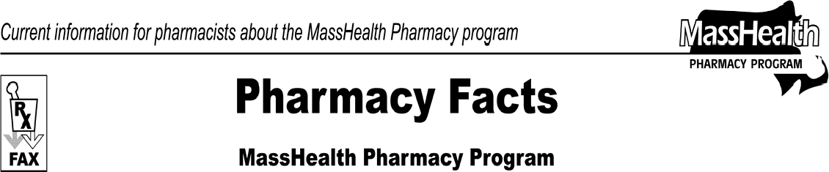www.mass.gov/masshealth/pharmacy
Number 47
December 18, 2008
- Editor: Vic Vangel • Contributors: Chris Burke, Gary Gilmore, Paul Jeffrey, James Monahan, Chuck Young, Nancy Schiff •
NewMMIS Update  The NewMMIS Project and Executive Team recently reviewed the status of the project, resulting in the decision to delay implementation. You will be informed of the new implementation date as soon as it is confirmed. Please refer to the MassHealth NewMMIS Web page at www.mass.gov/masshealth/newmmis for updated timelines and reference materials.  Please remember that MassHealth members are receiving new member ID cards and pharmacy providers may use these new member ID numbers on claims processed through the Pharmacy Online Processing System (POPS). Claims submitted to the legacy MMIS, such as those for DME services, require the legacy member ID (10 digits).  Medicare Part-D Prescription Drug Coverage Update  MassHealth continues to provide assistance with Medicare Part D prescription drug plan copayments to ensure that the member does not pay a copayment that is greater than the standard MassHealth copayment.  Currently the maximum amount that a Part D plan is permitted to charge a dually eligible member is $5.60. Effective January 1, 2009, this maximum amount will increase to $6.00. Beginning Monday, December 22, POPS will deny a claim for a Part D copayment that is greater than these allowed maximums for dually eligible members. The pharmacy will receive a denial that states “Submitted Med-D copay exceeds MassHealth’s maximum limit.” If the Part D plan assesses a copayment in excess of these maximum amounts, pharmacy staff will need to contact the Part D plan in order for the plan to correct the copayment amount. Part D plans are required to accept best available evidence (BAE) as proof that an individual has MassHealth and should therefore be charged the low-income-subsidy level copayments. For detailed information on what constitutes BAE, refer to the Centers for Medicare & Medicaid Services (CMS) Web site at www.cms.hhs.gov. Click first on the link for Medicare, then on Prescription Drug Coverage Contracting, in the right column. Next, click on the link for Best Available Evidence (BAE), and then on the link to the Clarified BAE Guidance memo (v08.04.08). | If a Part D plan is unwilling or unable to correct the copayment amount at the time the prescription is filled, the MassHealth denial can be overridden by placing a “99” in the Submission Clarification field (NCPDP field 420-DK). By using this override, the pharmacy is certifying that an attempt was made to contact and correct the copayment amount with the Part D plan. The use of these overrides will be closely monitored.  Please note that dually eligible members who choose to receive their prescription drugs through a non-Part D plan (i.e. commercial insurance or “creditable coverage”), and have no Part D coverage, will not receive MassHealth assistance with drug copayments for any Part D covered drugs when provided by a non-Part D plan. For dually eligible members who have both a Part D plan and commercial insurance, both plans must be billed before sending the claim to MassHealth. MassHealth provides copayment assistance only if the Part D plan pays a portion of the claim, and the remaining balance exceeds the MassHealth copayment. If you are unsure of the correct billing order, send the claim to the Part D plan and you will receive an online message about the correct order of billing.  Please note that some classes of drugs could be covered by Medicare B or by Medicare D, depending on the circumstances. A table explaining these coverage issues can be found on the pharmacy pages of the CMS Web site at www.cms.hhs.gov/pharmacy. Click first on the link for Parts B and D Information and then on Medicare Parts B and D Coverage Issues Table.  An example of a drug class where some confusion exists is the immunosuppressants. Medicare Part B would be responsible for paying for these prescriptions if the member was eligible for Medicare at the time of transplant. Medicare Part D would assume responsibility for payment if the service is not Medicare Part B covered. If a Part D plan requires a prior authorization (PA) for an immunosuppressant, the pharmacy must attempt to obtain that PA from the Part D plan. MassHealth should never be the primary payer for this class of drugs for a dually eligible member. Other examples of drugs that could be covered under Part B or Part D depending on the circumstance, are oral anti-cancer agents, oral anti- emetics, and erythropoietin.

Please direct any questions or comments (or to be taken off of this fax distribution) to
Victor Moquin of ACS at 617-423-9830.

