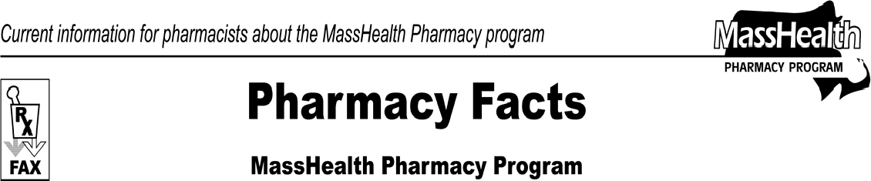www.mass.gov/masshealth/pharmacy
Number 48
January 28, 2009
- Editor: Vic Vangel • Contributors: Chris Burke, Gary Gilmore, Paul Jeffrey, James Monahan, Chuck Young, Nancy Schiff •
Copayment Changes  Effective February 1, 2009, the pharmacy copayments will be as follows.  - $1 for each prescription and refill for each generic drug and over-the-counter drug covered by MassHealth in the following drug classes: antihyperglycemics, antihypertensives, and antihyperlipidemics;  - $2 for each prescription and refill for other generic drugs and over-the-counter drugs covered by MassHealth;  - $3 for each prescription and refill for brand-name drugs covered by MassHealth.  All other copayment rules remain unchanged. Please see 130 CMR 450.130 for regulations about copayments.  MHDL Updates  - Additions  The following newly marketed drugs have been added to the MassHealth Drug List.  Akten (lidocaine ophthalmic gel) Alvesco (ciclesonide)  Durezol (difluprednate) – PA  Enterg ^{H} (alvimopan)  Fusilev (levoleucovorin) – PA  Keppra XR (levetiracetam extended-release) – PA  Nplate (romiplostim) – PA  Nucort (hydrocortisone/aloe vera) – PA  NutreStore (L-glutamine) – PA  Sancuso (granisetron transdermal system) – PA  venlafaxine extended-release tablet Veripred (prednisolone) – PA  H This drug is available only in an inpatient hospital setting.  MassHealth does not pay for this drug to be dispensed through the retail pharmacy or physician’s office.  - Change in Prior-Authorization (PA) Status  - The following prior-authorization requirement is effective February 16, 2009.  Doryx (doxycycline) – PA  - The following drug will no longer require prior authorization.  gabapentin  3. Deletions  The following drugs have been deleted from the MassHealth Drug List. | MassHealth does not pay for drug products (including identical, similar, or related drug products) that the U.S. Food and Drug Administration has proposed, in a Notice of Opportunity for Hearing (NOOH), to withdraw from the market because they lack substantial evidence of effectiveness for all labeled indications.  Accuzyme (papain/urea) Auralgan (antipyrine/benzocaine) Ethezyme (papain/urea)  Granul-derm (castor oil/peru balsam/trypsin) Granulex (castor oil/peru balsam/trypsin) Kovia (papain/urea)  Panafil (papain/urea/chlorophyllin/copper complex) TBC (trypsin/balsam peru/castor oil)  Ziox (papain/urea/chlorophyllin)  4. Corrections  The following drugs have been added to the MassHealth Drug List. They were omitted in error. These additions do not reflect any change in MassHealth policy.  Coraz (hydrocortisone/salicylic acid/sulfur) – PA  Halotin (haloprogin) – PA  salicylic acid °  Xyntha (antihemophilic factor, recombinant)  ° PA status depends on the drug’s formulation.  Important Updates about NewMMIS  Steps you need to take now include:  - Coordinate with software vendors for 835 viewing.  - Prepare your operations for the provider registration process.  - Designate staff in your organization who will require access to the Provider Online Service Center.  - Identify the functions designated staff will perform within the Provider Online Service Center.  - Revisit any e-Learning courses to increase proficiency on difficult or often-used tasks.  Provider PIN Registration Letters for NewMMIS  MassHealth will mail the provider PIN (personal identification number) registration letters soon. Once you receive your PIN registration letter, you should prepare your operations as directed in the letter. Both the job aid and e-Learning courses can be accessed at: www.mass.gov/masshealth/newmmis.

Please direct any questions or comments (or to be taken off of this fax distribution) to
Victor Moquin of ACS at 617-423-9830.

