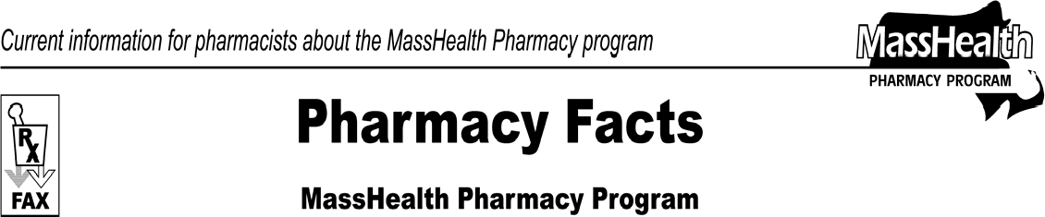www.mass.gov/masshealth/pharmacy
Number 50
May 6, 2009
Page 1 of 2
- Editor: Vic Vangel • Contributors: Chris Burke, Gary Gilmore, Paul Jeffrey, James Monahan, Nancy Schiff •
Claims for Secondary Payment for Medicare Part B Covered Items  In Pharmacy Facts No. 49 MassHealth announced revised procedures to follow when submitting claims to MassHealth for secondary payment for Medicare-B covered items when Medicare B is the primary payer. The implementation date of this revised procedure will now be July 1, 2009.  Beginning July 1, 2009, any claim for a Medicare-B covered drug, durable medical equipment, or supply that is payable through the Pharmacy Online Processing System (POPS) for when MassHealth is being billed as the secondary payer and Medicare B is the primary payer, must be processed through POPS.  Pharmacy Copayment Poster Updated  The sample Pharmacy Copayment poster on the MassHealth Web site has been updated to reflect the latest copayment information. Pharmacies are required by MassHealth regulations at 130 CMR 450.130(F) to post a notice about MassHealth copayments in areas where copayments are collected. The notice must be visible to the public and easily readable, must specify the exclusions from the copayment requirement listed in 130 CMR 450.130(D) and (E), and must instruct members to inform providers if members believe they are excluded from the copayment requirement. The poster can be downloaded by going to www.mass.gov/masshealth and clicking on the link for Provider, then for Insurance (including MassHealth), then for MassHealth, then for Training and Resources and then for MassHealth Poster Requirements.  Invoice Type 9 Adjustments  MassHealth is adjusting some claims to pharmacies that may have paid incorrectly for dates of service | from July 2007 to October 2007 on Claim Form No. 9 for DME products or supplies. This correction is to incorporate the July 2007 rate changes issued by the Division of Health Care Finance and Policy. The retro adjustment is expected to be in run 2085. Providers may contact MassHealth Customer Service at 1-800- 841-2900 with any questions or concerns.  MHDL Update  1. Additions  The following newly marketed drugs have been added to the MassHealth Drug List.  Aczone (dapsone gel) – PA Astepro (azelastine) – PA Banzel (rufinamide) – PA  Cinryze (C1 inhibitor, human) – PA  Epiduo (adapalene/benzoyl peroxide) – PA Moxatag (amoxicillin, extended-release) – PA Mozobil (plerixafor)  Prandimet (repaglinide/metformin) – PA  Promacta (eltrombopag) – PA  Seroquel XR 50 mg (quetiapine extended-release)  – PA > 60 units/month  Seroquel XR 150 mg (quetiapine extended- release) – PA > 30 units/month  Trilipix (fenofibric acid) – PA  Xenazine (tetrabenazine) – PA  2. New FDA “A”-Rated Generics  The following FDA “A”-rated generic drugs have been added to the MassHealth Drug List. The brand name is listed with a # symbol to indicate that prior authorization is required for the brand.

Pharmacy Facts, Number 50 Page 2 of 2
 | - New FDA “A” – Rated Generics (cont.)  New FDA “A”-Rated Generic Drug: calcium acetate Generic Equivalent of: Phoslo #  New FDA “A”-Rated Generic Drug: stavudine Generic Equivalent of: Zerit #  - Change in Prior-Authorization Status  - The following drugs will require prior authorization effective May 18, 2009.  Lumigan (bimatoprost) – PA Travatan (travoprost) – PA Xalatan (latanoprost) – PA Xifaxan (rifaximin) – PA  - The PA requirement for Nasacort AQ is changing. The following PA requirement is effective May 18, 2009. Please see Table 25 for a complete list of the PA requirements for intranasal corticosteroids.  Nasacort AQ (triamcinolone nasal spray) – PA  > 4 years or > 1 inhaler/month  - The following drugs will no longer require prior authorization.  Eurax (crotamiton) Ovide (malathion)  - Updated MassHealth Over-the-Counter (OTC) Drug List  The MassHealth (OTC) Drug List has been updated to include the following.  hydrophilic ointment  - Updated MassHealth Non-Drug Product List  The MassHealth Non-Drug List has been updated to include the following.  Hyper-Sal (sodium chloride 7% for inhalation)  - Deletions  The following drugs have been deleted from the MassHealth Drug List. MassHealth does not pay for | drugs that are manufactured by companies that have not signed rebate agreements with the U.S. Secretary of Health and Human Services.  Aphthasol 5% (amlexanox)  Coraz (hydrocortisone/salicylic acid/sulfur)  7. Corrections  The following drugs have been added to the MassHealth Drug List. They were omitted in error. These additions do not reflect any changes in MassHealth policy.  Anzemet (dolasetron) injection coal tar °  Kytril # (granisetron) injection Zofran # (ondansetron) injection  ° PA status depends on the drug’s formulation.

Please direct any questions or comments (or to be taken off of this fax distribution) to
Victor Moquin of ACS at 617-423-9830.

