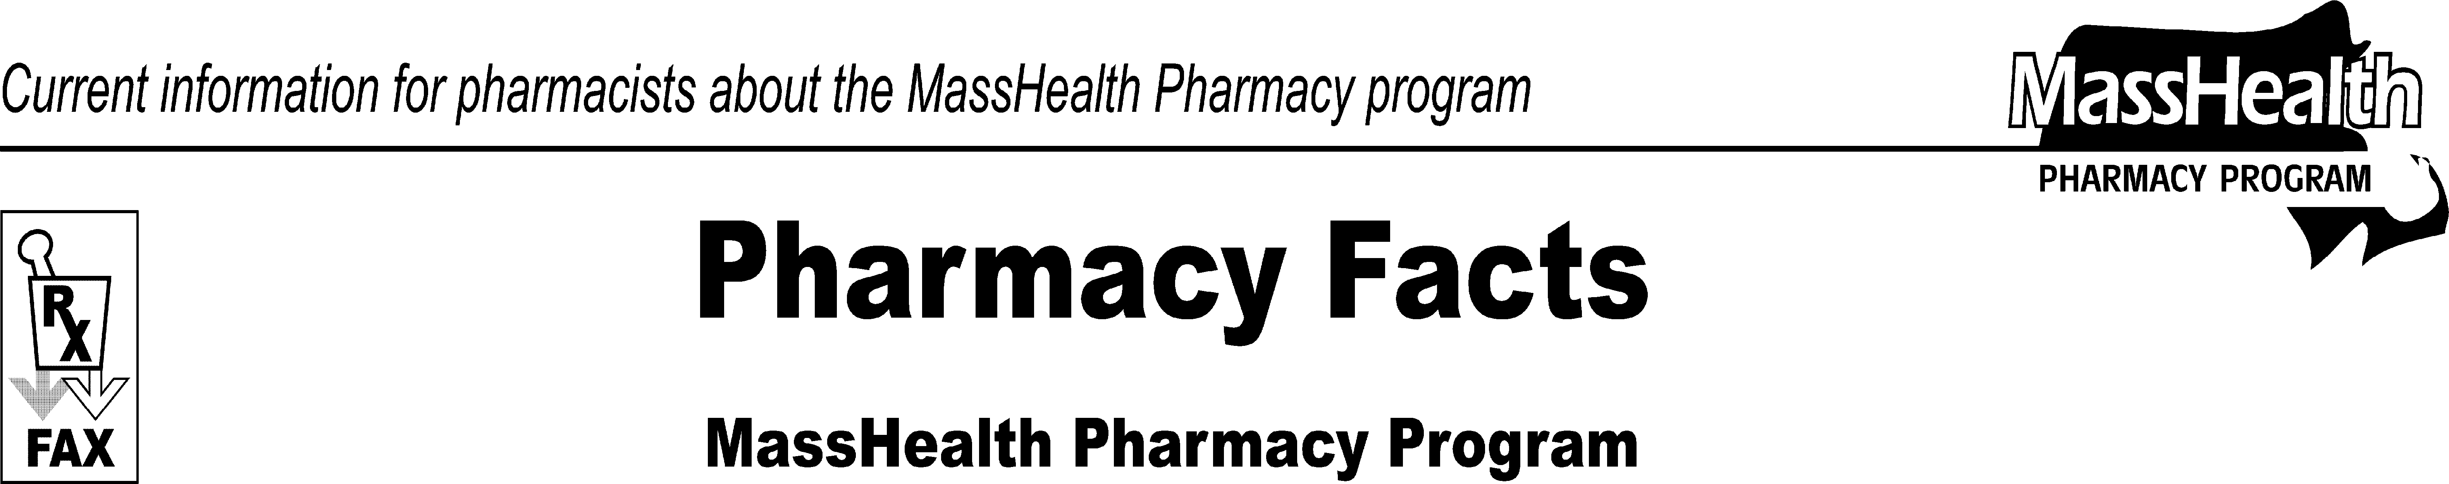www.mass.gov/masshealth/pharmacy
Number 51
May 14, 2009
Page 1 of 2

- Editor: Vic Vangel • Contributors: Chris Burke, Gary Gilmore, Paul Jeffrey, James Monahan, Nancy Schiff •
POPS Scheduled Downtime  Due to the implementation of NewMMIS, the POPS system will undergo major maintenance on the weekend of May 16-17, 2009. The POPS system will be unavailable to process claims from approximately 11:55 P.M. on Saturday, May 16, through 3:00 P.M. Sunday, May 17. The changes made will not affect how pharmacies will process claims after the maintenance is applied. |  | To use the POSC, you must have Internet access, designate a primary user to be responsible for security access, and have that person register as the primary user. Once registered, the primary user can set up user IDs for others who will need to use the POSC in, or associated with, your organization, including other site locations and billing intermediaries. A provider's primary user will have a manage subordinate accounts role that will not be available to subordinate users. This guide will instruct the primary user on tasks such as assigning and removing subordinate user roles. The user guide is available on www.mass.gov/masshealth/newmmis.  Please Note: The primary user ID and password cannot be used as a shared ID. One person must be assigned as the primary because that person will be responsible for assigning subordinate IDs.  Additionally, the application does not allow for the same user ID and password to be logged on at the same time.  Information about the POSC was mailed to providers two months ago in the MassHealth Provider Identification Number (PIN) letter. One letter was mailed to the “doing business as” locations of all providers. A second letter was mailed on May 4, 2009, to those providers who had not registered as of April 19th. If you did not receive this letter, please contact the MassHealth Customer Service Team (CST) at 1- 800-841-2900 for the necessary information.  Many MassHealth pharmacy providers who are eligible to use the POSC have not yet registered. Please carry out this important task for your pharmacy business.  Paper Claim Form Changes for Pharmacies Providing DME Services  Effective May 4, 2009, all paper claims and paper claim adjustments must be submitted on the industry- standard CMS-1500 or UB-04 claim forms, as applicable.  The MassHealth claim form no. 9 is no longer accepted. In addition, all claims must contain a national provider identifier (NPI), except for claims submitted by “atypical providers,” that is, providers who are not required to obtain an NPI.
Pharmacy Payment Cycle
Claims processed through POPS on May 17 and May 18 will not appear on the usual, expected remittance. Payment for claims processed on these days will be slightly delayed and will appear on the following week’s remittance.

Update on NewMMIS Implementation on May 26, 2009
The NewMMIS implementation date is May 26, 2009. Providers should complete preparation activities for implementation, including e-learning, PIN registration, and review of the all-provider bulletins.
For more information on the latest development and communications, go to www.mass.gov/masshealth/newmmis. This Web site is updated regularly. Some of the training materials here include past NewMMIS Provider Education Forums, MassHealth NewMMIS Preparation, and provider questions and answers.
You should have already informed your software vendors to make any necessary changes to accommodate the NewMMIS system. This is especially important for nonpharmacy claims submitted outside of POPS, and all 835 remittance advices used by a provider. Providers currently submitting POPS claims do not need to complete another Trading Partner Agreement (TPA) with MassHealth to retrieve the new 835 at the new Web location.

NewMMIS POSC Guide for Primary Users
MassHealth has issued a new Primary User Guide to help primary users understand how to manage user security access to the Provider Online Service Center (POSC).

Pharmacy Facts, Number 51 Page 2 of 2
 | See All Provider Bulletin 181 for more information about the NPI requirement for NewMMIS and exceptions to it.  Effective May 4, 2009, paper claims must contain the new 12-digit member identification (ID) number. See the applicable MassHealth billing guides on the MassHealth Web site at www.mass.gov/masshealth/newmmis for more information about completing and submitting claims.  Please see the NewMMIS Web site for item-by-item billing instructions for this claim form.  REVS Member Eligibility Changes  The current Recipient Eligibility Verification System (REVS) will shut down on 5/23/09, three days before NewMMIS implementation. The NewMMIS Eligibility Verification System (EVS) will begin on the same day (5/23/09). Providers who check member eligibility via this method should prepare for a smooth transition between the two systems.  There will be a delay in updating member eligibility in POPS from May 21 through May 24. For any inquiries concerning member eligibility, pharmacies should use REVS on May 21st and May 22nd, and the NewMMIS EVS that will be available through the POSC, on May 23rd and May 24th, during this time.  Pharmacies will also be able to check member eligibility by telephone using an Automated Voice Response (AVR) System that is available by calling  1-800-554-0042. On May 23rd, a new AVR system will begin taking member eligibility calls. The phone number for the AVR (1-800-554-0042) is the same number as the AVR system used under the current system.  Providers will be required to register with the POSC before they can use the new AVR. A pharmacy will be able to check eligibility by using either member ID, social security number, or name with gender and D.O.B.  Durable Medical Equipment (DME) Prior Authorization (PA) Changes in May 2009  PA requests cannot be accepted by the existing Automated Prior Authorization System (APAS) after close of business on May 8, 2009. APAS will be replaced by a service-authorization function in the NewMMIS POSC. Providers will be able to submit their PAs via the POSC starting May 18th. If a provider needs to submit a PA request during the period between May 8th and May 18th, the request must be submitted on paper. | While MassHealth will review and adjudicate the paper request, a PA number will not be available until the POSC goes live on May 18th.  Please Note: The PA process for medications and DME products that are processed by POPS will remain unchanged.  Changes to the CMS-1500 Billing Guide  This is important for DME providers The CMS-1500 Billing Guide has been updated. The CMS-1500 claim form will replace the MassHealth proprietary claim form no. 9 effective May 4, 2009.  Electronic Remittance Advice (835 Transactions)  Pharmacy 835s will no longer be separately provided by ACS as of the NewMMIS implementation date.  Pharmacy providers must log into the current EDI Web location (www.masspharmacy-edi.com) and download their remaining 835s before July 7, 2009. 835s will be available through the POSC after the NewMMIS implementation date.

Please direct any questions or comments (or to be taken off of this fax distribution) to
Victor Moquin of ACS at 617-423-9830.

