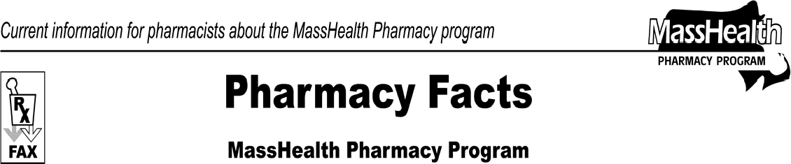www.mass.gov/masshealth/pharmacy
Number 52
July 21, 2009
Page 1 of 2
- Editor: Vic Vangel • Contributors: Chris Burke, Gary Gilmore, Paul Jeffrey, James Monahan, Nancy Schiff •
Proposed Regulation Changes - Payment Methodology  The Division of Health Care Finance and Policy will hold a public hearing on Tuesday, July 28, 2009 at 10:00 A.M. at the Division, 2 Boylston Street, Boston, MA, about proposed amendments to:  114.3 CMR 31.00: Prescribed Drugs  The proposed amendments, effective August 1, 2009, alter the usual and customary charge to ensure that payment for MassHealth does not exceed prices that a pharmacist has agreed to accept from any other payer.  The amendment also redefines how MassHealth will reimburse pharmacies for blood clotting factors by including the Medicare B rate as follows  Payment for Blood Clotting Factor shall not exceed the lowest of:  - the federal upper limit of the drug, if any, plus the appropriate dispensing fee as listed in 114.3 CMR 31.06;  - the Massachusetts upper limit of the drug, if any, plus the appropriate dispensing fee as listed in  114.3 CMR 31.06;  - the estimated acquisition cost, plus the appropriate dispensing fee as listed in 114.3 CMR 31.06;  - the Medicare Part B rate; or  - the usual and customary charge.  Reminder About Claims Processing When MassHealth is Secondary Insurer  When a pharmacy is not a participating provider for a MassHealth member’s primary insurance or the pharmacy receives a message from the primary insurer that a product is covered only at certain network pharmacies, the pharmacy cannot appropriately bill MassHealth as the primary payer using Other Coverage Code 3. In these instances, the pharmacy needs to instruct the member that they need to use a participating pharmacy of the primary insurer. | MHDL Updates  - Additions  - The following newly marketed drugs will be added to the MassHealth Drug List effective August 3, 2009.  Acanya (clindamycin/benzoyl peroxide) – PA Aplenzin (bupropion extended-release) – PA Apriso (mesalamine extended-release) degarelix – PA  Exforge HCT (amlodipine/valsartan/hydrochlorothiazide)  – PA  Gelnique (oxybutynin gel) – PA Kapidex (dexlansoprazole) – PA Lamictal ODT (lamotrigine, orally disintegrating tablet) – PA  Lamictal ODT Start Kit (lamotrigine, orally disintegrating tablet) – PA  LoSeasonique (ethinyl estradiol/levonorgestrel)  Naprelan CR 750 mg (naproxen controlled- release) – PA  Prilosec (omeprazole suspension) – PA  Rapaflo (silodosin) – PA  Ryzolt (tramadol extended-release) – PA  Toviaz 4 mg (fesoterodine) – PA > 30 units/month  Toviaz 8 mg (fesoterodine) Uloric (febuxostat) – PA  Vectical (calcitrol ointment) – PA  Vimpat injection (lacosamide)  Vimpat tablet (lacosamide) – PA  - The following drugs will be added to the MassHealth Drug List effective August 3, 2009.  Carmol HC (hydrocortisone/urea) U-Cort (hydrocortisone/urea)  - Change in Prior-Authorization Status  - The PA requirement for Risperdal Consta is changing. The following PA requirement is effective August 17, 2009.  Risperdal Consta (risperidone injection) – PA  >2 units (2 syringes)/month

Pharmacy Facts, Number 52 Page 2 of 2
 | MHDL Updates (cont.)  - The PA requirements for the 5-HT₃ Receptor Antagonists are changing. The following PA requirements are effective August 17, 2009. Please see Table 27 of the MassHealth Drug List for a complete list of the PA requirements for the 5-HT₃ Receptor Antagonists.  Anzemet (dolasetron) tablet – PA  granisetron tablet – PA  Kytril 2 mg/10 ml (granisetron) solution – PA  - The following drugs will require prior authorization effective August 17, 2009.  Detrol LA 2 mg (tolterodine extended-release) –  PA > 30 units/month  DexPak (dexamethasone) – PA  Enablex 7.5 mg (darifenacin) – PA > 30 units/month  Nalfon 200 mg (fenoprofen) – PA  Naprelan CR 375 mg, 500 mg (naproxen controlled-release) – PA  naproxen controlled-release – PA  VESIcare 5 mg (solifenacin) – PA > 30 units/month  - The following drugs will require prior authorization effective August 17, 2009.  buprenorphine powder – PA codeine powder – PA fentanyl powder – PA hydrocodone powder – PA  methylphenidate powder – PA propoxyphene powder – PA sufentanil powder – PA  - The PA requirement for Alinia suspension is changing. The following PA requirement is effective August 17, 2009.  Alinia suspension (nitazoxanide) – PA | - Deletions  - The following drugs have been removed from the MassHealth Drug List. There are no products containing urea as the sole active ingredient that are approved by the FDA.  Carmol (urea) Kerol (urea) Umecta (urea) urea  - The following drug has been removed from the MassHealth Drug List because it has been withdrawn from the market.  Raptiva (efalizumab)  - The following drug has been removed from the MassHealth Drug List. MassHealth does not pay for drug products (including identical, similar, or related drug products) that the U.S. Food and Drug Administration has proposed, in a Notice of Opportunity for Hearing (NOOH) to withdraw from the market because they lack substantial evidence of effectiveness for all labeled indications.  Vanoxide-HC (benzoyl peroxide/hydrocortisone)  - Corrections  The following drugs have been added to the MassHealth Drug List. They were omitted in error. These additions do not reflect any changes in MassHealth policy.  Amnesteem (isotretinoin) – PA > 21 years Benzac W (benzoyl peroxide) – PA Claravis (isotretinoin) – PA > 21 years Ery Pad (erythromycin) – PA  Sotret (isotretinoin) – PA > 21 years  Testopel Pellet (testosterone)

Please direct any questions or comments (or to be taken off of this fax distribution) to
Victor Moquin of ACS at 617-423-9830.

