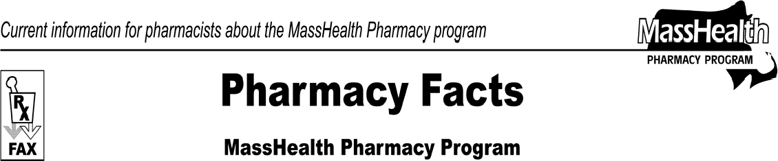www.mass.gov/masshealth/pharmacy
Number 53
September 24, 2009
- Editor: Vic Vangel • Contributors: Chris Burke, Gary Gilmore, Paul Jeffrey, James Monahan, Chuck Young, Nancy Schiff •
DMEPOS Supplier Accreditation and Surety Bond Requirements  Medicare laws and rules were changed to require non- exempt suppliers of durable medical equipment, prosthetics, orthotics, and supplies (DMEPOS), including pharmacies, to  - obtain and submit proof of accreditation by September 30, 2009; and  - post a surety bond by October 2, 2009.  Covered suppliers of DMEPOS failing to comply with these Medicare requirements may lose their Medicare billing privileges for DMEPOS. Please check with the Centers for Medicare & Medicaid Services (CMS) with any questions about your responsibilities and the consequences for not complying with these requirements.  If you choose not to comply with the accreditation and surety bond requirements at this time, contact CMS about voluntary termination from Medicare enrollment.  MassHealth DME regulations will soon require most DME providers, including pharmacies, to participate in Medicare as a DME provider and obtain accreditation by an organization acceptable to CMS. These requirements will be a condition of MassHealth participation.  MassHealth regulations at 130 CMR 450.316 require providers, with limited exceptions, to make diligent efforts to obtain payment from other resources first so that MassHealth is the payer of last resort. If you voluntarily terminate from Medicare enrollment or become unable to bill Medicare because you failed to meet the Medicare accreditation or surety bond requirements, you must contact MassHealth Customer Service at 1-800-841- 2900 to inform them that you are no longer able to bill Medicare as a DMEPOS supplier.  Under MassHealth regulations at 130 CMR 450.316(D), you are not entitled to receive or keep any payment from MassHealth if, on the date of service, you did not participate in a MassHealth member’s other insurance plan (including Medicare) which may have covered the service.  For more information on the CMS accreditation requirements go to the CMS Web site at http://www.cms.hhs.gov/MLNMattersArticles/downloads/s e0903.pdf. | For more information on surety bond requirements go to www.palmettogba.com/nsc.  The MassHealth Pharmacy program provides links to sites that are believed to be useful. The inclusion of such links is for convenience only and does not constitute an endorsement of the programs by either EOHHS or the Commonwealth of Massachusetts.  MassHealth can not be responsible for the accuracy of the information contained on the linked Web sites.

Please direct any questions or comments (or to be taken off of this fax distribution) to
Victor Moquin of ACS at 617-423-9830.

