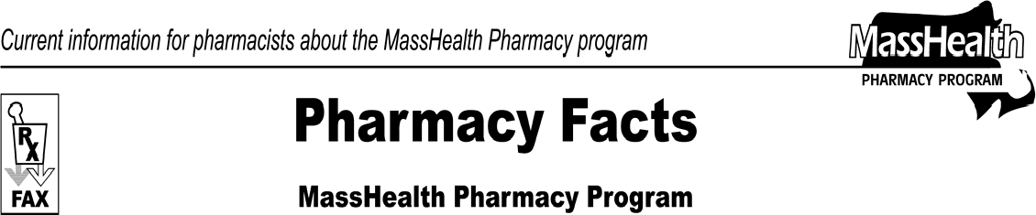www.mass.gov/masshealth/pharmacy
Number 54
October 30, 2009
Page 1 of 2
- Editor: Vic Vangel • Contributors: Chris Burke, Gary Gilmore, Paul Jeffrey, James Monahan, Nancy Schiff •
 | Flu Vaccine Update  Effective November 1, 2009, MassHealth will pay pharmacies for the administration of the H1N1 and seasonal flu vaccines to MassHealth-eligible members. Vaccinations must be administered by properly trained and certified pharmacists and other health care professionals in accordance with Massachusetts Department of Public Health regulations at 105 CMR 700.000. When MassHealth pays for these vaccines, pharmacies may not charge MassHealth members a copayment for the vaccine administration or flu vaccine serum.  For the 2009-2010 flu season, MassHealth will pay pharmacies for seasonal flu vaccine serum without prior authorization if the vaccine is not available free of cost.  Pharmacies should bill for H1N1 and seasonal flu vaccine administration through the Pharmacy Online Processing System (POPS) as follows.  - Bill with separate claims for each vaccine administered.  - When billing for both H1N1 and seasonal flu vaccines for a member at the same time, bill for the H1N1 vaccine as the first claim.  - Include the NDC of the vaccine serum.  - If the vaccine was obtained at no cost to the pharmacy, enter a zero amount as the submitted ingredient cost.  - Enter a zero amount in the dispensing fee field. (MassHealth will pay pharmacies an administration fee instead of a dispensing fee.).  - Enter the value of “MA” in the field called “Professional Service” (440-E5).  - Enter the appropriate administration fee (see chart below) in the field called “Incentive Amount Submitted” (438-E8).  - If the pharmacy incurred a cost to obtain the vaccine, include the cost of the vaccine serum plus the administration fee as the Gross Amount Due.  MassHealth will pay pharmacies according to the following table.  Vaccine Service Description Admin. Fee  H1N1 vaccine, by injection or intranasal $13.76  Seasonal flu vaccine only, by injection $13.76  Seasonal flu vaccine only, by intranasal $9.06 route  Seasonal flu vaccine, by injection, given $7.23 at the same time as H1N1 vaccine  Seasonal flu vaccine, by intranasal route,  given at the same time as H1N1 vaccine $6.13 by injection | MHDL Updates  - Additions  - The following newly marketed drugs have been added to the MassHealth Drug List, effective November 9, 2009.  Adcirca (tadalafil) – PA  Afinitor 5 mg (everolimus)  – PA> 30 units/month  Afinitor 10 mg (everolimus)  Asacol HD (mesalamine, delayed-release tablet) Besivance (besifloxacin) – PA  Caldolor (ibuprofen injection)  Cetraxal (ciprofloxacin OTIC solution) – PA  Coartem (artemether/lumefantrine)  – PA > 24 units/year  Edluar (zolpidem sublingual) – PA  Effient (prasugrel) Feraheme (ferumoxytol)  Influenza H1N1 Vaccine (influenza virus vaccine, H1N1)  Ixiaro (Japanese encephalitis vaccine) Lamictal XR (lamotrigine extended-release)  – PA  Lamictal XR Start Kit (lamotrigine extended- release) – PA  Multaq (dronedarone) Nucynta (tapentadol) – PA Nuvigil (armodafanil) – PA Onglyza (saxagliptin) – PA  Plan B One Step (levonorgestrel) Quinzyme ODT (ubiquinone, orally disintegrating tablet) – PA RiaSTAP (fibrinogen concentrate)  Samsca (tolvaptan) – PA Savella (milnacipran) – PA Simponi (golimumab) – PA Ulesfia (benzyl alcohol lotion)  b. The following drugs have been added to the MassHealth Drug List.  Firmagon (degarelix) – PA  Xyrem (sodium oxybate) – PA

Pharmacy Facts, Number 54 Page 2 of 2
 | - New FDA “A”-Rated Generics  The following FDA “A”-rated generic drugs (listed on the next page) have been added to the MassHealth Drug List. The brand name is listed with a # symbol, to indicate that PA is required for the brand.  New FDA “A”-Rated  Generic Drug Generic Equivalent  bicalutamide Casodex #  levonorgestrel Plan B #  tacrolimus Prograf #  - Change in Prior-Authorization (PA) Status  - The PA requirement for Suboxone is changing. Maintenance doses less than or equal to 16 mg/day will no longer require prior authorization, effective November 2, 2009.  - The PA requirement for Flumist has been changed to the following.  Flumist (influenza virus vaccine live, intra- nasal) – PA > 1 dose/season  - The PA requirement for Adderall XR is changing. The following PA requirement is effective November 23, 2009.  Adderall XR (amphetamine salts extended- release) – PA  The PA requirement for amphetamine salts extended-release will remain:  amphetamine salts extended-release  – PA > 60 units/month  d. The following drugs will require prior authorization effective November 23, 2009.  Acetasol HC (acetic acid/hydrocortisone) – PA CiproDex Otic suspension (ciprofloxacin/dexamethasone) – PA  Cipro HC Otic suspension (ciprofloxacin/hydrocortisone) – PA Floxin Otic Singles (ofloxacin) – PA  - Updated MassHealth Over-the-Counter Drug List  The following newly marketed drug has been added to the MassHealth Drug List.  Plan B One Step (levonorgestrel)  - Deletions  - The following drug has been deleted from the MassHealth Drug List. MassHealth does not pay for drugs that are manufactured by companies that have not signed rebate agreements with the  U.S. Secretary of Health and Human Services. EstroGel (estradiol) | b. The following drugs have been removed from the MassHealth Drug List because they are not approved by the FDA.  A/B Otic drops (antipyrine/benzocaine) Allergen (antipyrine/benzocaine) antipyrine/benzocaine  Aurodex (antipyrine/benzocaine) Auroto # (antipyrine/benzocaine)

Please direct any questions or comments (or to be taken off of this fax distribution) to
Victor Moquin of ACS at 617-423-9830.

