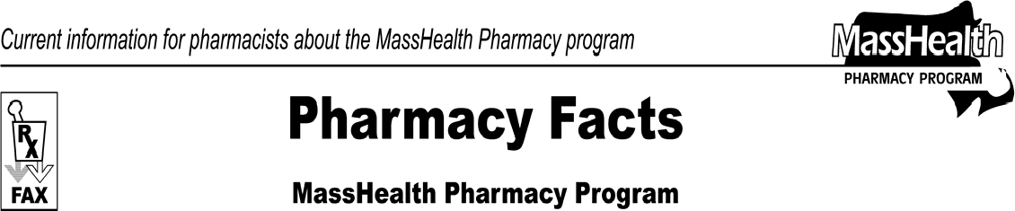www.mass.gov/masshealth/pharmacy
Number 55
December 28, 2009
- Editor: Vic Vangel • Contributors: Chris Burke, Gary Gilmore, Paul Jeffrey, James Monahan, Nancy Schiff •
 | Medicare Part D Prescription Drug Coverage Update  MassHealth continues to provide assistance with Medicare Part D prescription drug plan copayments. Member copayments must not be greater than the standard MassHealth copayment. The maximum amount that a Part D plan is currently permitted to charge a dually eligible member is $6.00. Effective January 1, 2010, this maximum amount will increase to $6.30.  Wellpoint Point-of-Sale Facilitated Enrollment Process to Be Replaced  Effective January 1, 2010, the Centers for Medicare & Medicaid Services (CMS) will replace the Wellpoint Point-of-Sale Facilitated Enrollment process with a new Medicare Limited Income Newly Eligible Transition (LI NET) program. LI NET will be administered by Humana.  According to Humana’s Web site, this program allows MassHealth members with Medicare (dual-eligibles) to receive immediate need coverage at the point-of-sale if they are not already enrolled in a Part D plan.  Additionally, CMS will temporarily enroll all newly identified dual-eligibles into LI NET (contract number X0001). This allows for a smoother transition as CMS auto-enrolls them into standard Medicare prescription drug plans. Pharmacists will find a detailed payer sheet, FAQs, and a tip sheet at www.humana.com/pharmacists/resources/li_net.asp.  Please review this information to assist dual-eligible MassHealth members that are now eligible to receive Medicare-D drug coverage, but have yet to enroll in a specific Medicare-D plan.  MassHealth pays for a one-time 72-hour supply if the pharmacy is unable to bill a Part D plan or the LI NET program. After unsuccessfully attempting to bill | the member’s Part D plan and the LI NET program, pharmacists should override a denied claim using the standard NCPDP other payer reject codes. A level-of- service code of “03” must also be entered on the claim.  Early Refill Denials  Effective January 4, 2010, when MassHealth denies a claim for an early refill, a message will be returned notifying the pharmacist of the earliest date that the next fill will be allowed. For drugs in Schedules III-VI, MassHealth will not allow a refill until the date where 80% of the current supply, as measured from the date of the most recent refill, should have been consumed. For Schedule II controlled substances, the early refill threshold will remain unchanged at 85% of current supply.  Prescriber NPI  It is extremely important that you submit only the NPI of the individual prescriber issuing the prescription. When entering a prescriber NPI on a claim, never use an organizational NPI.  Pharmacy Facts on the Web  Previous editions of Pharmacy Facts can be found on the MassHealth Pharmacy Program home page. Go to www.mass.gov/masshealth/pharmacy and click the link for Pharmacy Facts. Also on this page, interested parties have an opportunity to sign up for an e-mail notification whenever a new edition of the Pharmacy Facts is posted on the MassHealth Web site.
Please direct any questions or comments (or to be taken off of this fax distribution) to
Victor Moquin of ACS at 617-423-9830.

