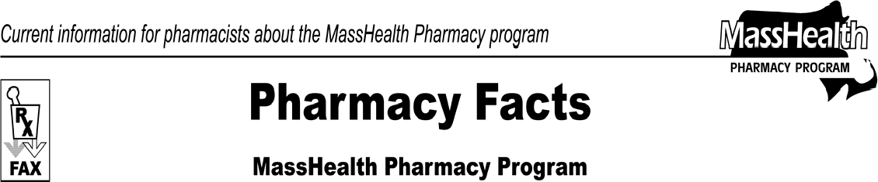www.mass.gov/masshealth/pharmacy
Number 56
February 11, 2010
Page 1 of 2
 | - Editor: Vic Vangel • Contributors: Chris Burke, Gary Gilmore, Paul Jeffrey, James Monahan, Nancy Schiff •
 | MHDL Updates  Below are certain updates to the MassHealth Drug List (MHDL). See the MHDL for a complete listing of updates.  - Additions  - The following newly marketed drugs have been added to the MassHealth Drug List.  Acuvail (ketorolac ophthalmic solution) –  PA  Benzefoam (benzoyl peroxide foam) – PA Bepreve (bepotastine besilate) – PA Cervarix (human papillomavirus bivalent  vaccine) – PA < 10 years and > 25 years  Embeda (morphine/naloxone) – PA Fibricor (fenofibric acid) – PA Folotyn ^{H} (pralatrexate)  Ilaris (canakinumab) – PA  Intuniv (guanfacine extended-release) – PA  Metozolv ODT (metoclopramide, orally disintegrating tablet) – PA  Onsolis (fentanyl buccal film) – PA  Ozurdex (dexamethasone intravitreal implant) ^  peramavir ^{H}  Sabril (vigabatrin) – PA Stelara (ustekinumab) – PA Tyvaso (treprostinil)  Twynsta (amlodipine/telmisartan) – PA Valturna (aliskiren/valsartan) – PA Zipsor (diclofenac) – PA  - The following newly marketed drugs have been added to the MassHealth Drug List and will require prior authorization March 1, 2010.  Invega Sustenna (paliperidone injection) – PA > 2 units/mo. in the first 30 days; PA > 1 unit/month after 30 days  Saphris (asenapine) – PA  ^ This drug is available through the health-care professional who administers the drug. Masshealth does not pay for this drug to be dispensed through a retail pharmacy.  H This drug is available only in an inpatient hospital setting. MassHealth does not pay for this drug to be dispensed through the retail pharmacy or the physician’s office. | - New FDA “A”-Rated Generics  The following FDA “A”-rated generic drugs have been added to the MassHealth Drug List. The brand name is listed with a # symbol, to indicate that PA is required for the brand.  New FDA “A”-Rated  Generic Drug Generic Equivalent  apraclonidine Iopidine #  brimonidine Alphagan P # ethinyl estradiol /  norgestimate Ortho Tri-Cyclen Lo # ketorolac ophthalmic  solution Acular #  lansoprazole –  PA > 2 years Prevacid # – PA > 2 years  - Change in Prior-Authorization (PA) Status  - The PA requirements for hypnotics are changing. The following PA requirements are effective February 15, 2010. Please see Table 15 of the MHDL for a complete list of the PA requirements for hypnotics.  Ambien # (zolpidem) 5 mg – PA > 45 units/ month  Ambien # (zolpidem) 10 mg – PA > 30 units/ month  Dalmane # (flurazepam) – PA > 30 units/month  estazolam – PA > 30 units/month flurazepam – PA > 30 units/month ProSom # – PA > 30 units/month  Restoril # 15 mg, 30 mg (temazepam) – PA > 30 units/month  temazepam – PA > 30 units/month triazolam – PA > 30 units/month zolpidem 5 mg – PA > 45 units/month zolpidem 10 mg – PA > 30 units/month  - The PA requirement for triptans are changing. The following PA requirements are effective February 15, 2010. Please see Table 14 of the MHDL for a complete list of the PA requirements for triptans.  Axert (almotriptan) – PA  sumatriptan injection – PA  sumatriptan tablet – PA > 9 units/month  Zomig (zolmitriptan) – PA

Pharmacy Facts, Number 56 Page 2 of 2
 | - The PA requirement for the following brand name medications are changing. The following PA requirements are effective February 15, 2010.  Dilantin # (phenytoin) capsule, kapseal, suspension  Neoral # (cyclosporine) Phenytek # (phenytoin) Sandimmune # (cyclosporine)  # This is a brand-name drug with FDA “A”-rated generic equivalents. PA is required for the brand, unless a particular form of that drug (for example, tablet, capsule, or liquid) does not have an FDA “A”-rated generic equivalent.  - The following will require prior authorization effective February 15, 2010.  Blood glucose testing reagent strips used for the management of diabetes – PA > 100 units/month  - The following will require prior authorization effective February 15, 2010.  Bactroban (mupirocin) nasal ointment – PA  Comtan (entacapone) – PA diclofenac extended-release – PA etodolac extended-release – PA indomethacin extended-release – PA ketoprofen extended-release – PA Migranal (dihydroergotamine) – PA  phenytoin 100 mg/4 ml unit dose suspension – PA  Solaraze (diclofenac) – PA Zovirax (acyclovir) cream – PA Zovirax (acyclovir) ointment – PA  - The following will no longer require prior authorization.  ramipril capsule  - The following drug will require prior authorization effective March 1, 2010. Please see Table 24 of the MHDL for a complete list of the PA requirements for the atypicial antipsychotics.  Invega (paliperidone) – PA  - Updated MassHealth Non-Drug Product List  The MassHealth Non-Drug Product List has been updated to reflect the following change, effective February 15, 2010.  Blood glucose testing reagent strips used for the management of diabetes – PA > 100 units/month  - MassHealth Over-the-Counter (OTC) Drug List  The MassHealth OTC Drug List has been updated to include the following.  ketotifen | - Deletions  The following drugs have been removed from the MassHealth Drug List. MassHealth does not pay for drugs that are manufactured by companies that have not signed rebate agreements with the U.S. Secretary of Health and Human Services.  Liquadd (dextroamphetamine) Tersi (selenium sulfide) Zegerid (omeprazole)  - Corrections  The following drugs have been added to the MassHealth Drug List. They were omitted in error. These changes do not reflect any change in MassHealth policy.  Campath (alemtuzumab) Cyklokapron (tranexamic acid) ^{H}  Procentra (dextroamphetamine) – PA > 450 ml/ month  H This drug is available only in an inpatient hospital setting.  MassHealth does not pay for this drug to be dispensed through the retail pharmacy or the physician’s office.

Please direct any questions or comments (or to be taken off of this fax distribution) to
Victor Moquin of ACS at 617-423-9830.

