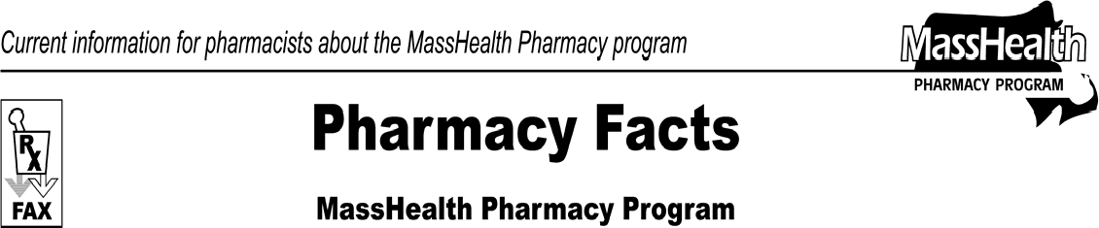www.mass.gov/masshealth/pharmacy
Number 57
March 5, 2010
- Editor: Vic Vangel • Contributors: Chris Burke, Gary Gilmore, Paul Jeffrey, James Monahan, Nancy Schiff •
Blood Glucose Test Strip Update  Effective April 1, 2010, FreeStyle, FreeStyle Lite, and Precision Xtra test strips will be the preferred diabetes blood glucose test strips of the MassHealth Pharmacy Program.  Claims for new prescriptions of any other product will require prior authorization (PA). Keep in mind that any claim for any diabetes blood glucose test strip with a quantity > 100/month will also require prior authorization. Current prescriptions for nonpreferred products will be honored and will not require prior authorization until existing refills have been exhausted.  Abbott Diabetes Care is required to provide replacement meters for MassHealth members requiring a new blood glucose monitor. Abbott ensures that members will receive their replacement meters either through direct delivery to the member or by the member picking up the monitor from their prescriber or pharmacy. Abbott will be providing these meters to prescribers and pharmacies at no cost to MassHealth, providers, or members. MassHealth strives to ensure a smooth implementation. Abbott Diabetes Care will soon be in touch with you about all conversion issues. Pharmacists can call Abbott at 866-216-5747 to ask questions about Abbott diabetes products or this conversion.  MHDL Update  Below are certain updates to the MassHealth Drug List (MHDL). The MHDL has a complete listing of updates.  - Additions  - The following newly marketed drugs have been added to the MassHealth Drug List.  Fanapt (iloperidone) – PA  Invega Sustenna (paliperidone injection) –  PA > 2 units/mo. within the first 30 days of therapy;  PA > 1 unit/mo. after 30 days of therapy  Saphris (asenapine) – PA  Zenpep (pancrelipase) | - Change in Prior-Authorization Status  - The following drug will require PA effective March 1, 2010, as announced in the February 4, 2010, MassHealth Drug List rollout. Please see Table 24 of the MHDL and applicable PA request forms for PA requirements for the atypical antipsychotics.  Invega (paliperidone) – PA  - The following change in prior-authorization status will be effective March 1, 2010.  Methylin (methylphenidate oral solution) –  PA > 900 ml/month  - The following will require prior authorization effective April 1, 2010.  FreeStyle, FreeStyle Light, and Precision Xtra brand blood glucose testing reagent strips used for the management of diabetes – PA > 100 units/month  All other brands of blood glucose testing reagent strips used for the management of diabetes will require prior authorization for all quantities.  - The following drug will no longer require prior authorization.  Zyprexa IM (olanzapine injection)

Please direct any questions or comments (or to be taken off of this fax distribution) to
Victor Moquin of ACS at 617-423-9830.

