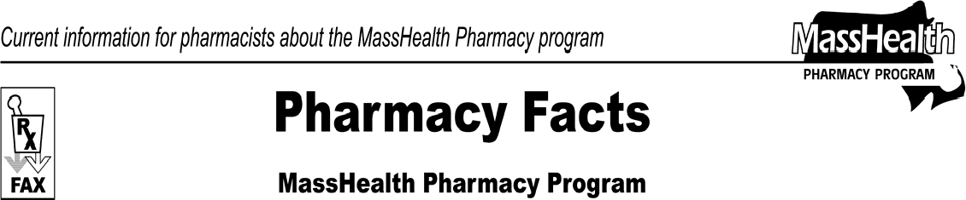www.mass.gov/masshealth/pharmacy
Number 58
April 28, 2010
- Editor: Vic Vangel • Contributors: Chris Burke, Gary Gilmore, Paul Jeffrey, James Monahan, Nancy Schiff •
MHDL Update  Below are certain updates to the MassHealth Drug List (MHDL). The MHDL has a complete listing of updates.  1. Additions  The following newly marketed drugs have been added to the MassHealth Drug List effective May 3, 2010.  Actemra (toclizumab) – PA Ampyra (dalfampridine) – PA Arzerra (ofatumumab) – PA  Dysport (abobotulinumtoxin A) – PA  Enemeez enema (docusate)  Fluzone HD (influenza virus vaccine, high dose)  – PA < 65 years  Menveo–A/C/Y/W-135 (meningococcal quadrivalent vaccine)  Nalfon 400 mg (fenoprofen) – PA Norvir (ritonavir) tablet – PA Oforta (fludaribine)  Prevnar 13 (pneumococcal 13-valent conjugate vaccine)  Urocit-K (potassium citrate) 15 meq – PA  Victoza (liraglutide) – PA  Votrient (pazopanib)  Welchol (colesevelam) powder for suspension –  PA  Wilate (von Willebrand Factor/Coagulation Factor VIII Complex)  Zyprexa Relprevv (olanzapine pamoate) 210 mg, 300 mg – PA > 2 injections/month  Zyprexa Relprevv (olanzapine pamoate) 405 mg  – PA > 1 injection/month  2. New FDA “A”-Rated Generic Drug  The following FDA “A”-rated generic drugs have been added to the MassHealth Drug List. The brand name is listed with a # symbol to indicate that prior authorization is required for the brand.  New FDA “A”-Rated  Generic Drug Generic Equivalent of  calcitonin, salmon Miacalcin #  ursodiol Urso # | - Change in Prior-Authorization (PA) Status  - The PA requirements for Hepatitis antiviral agents are changing. The following PA requirements are effective May 17, 2010. Please see Table 44 and applicable PA request forms for PA requirements for the Hepatitis antiviral agents.  Pegasys (peginterfereon alfa-2a) – PA  PEG-Intron (peginterfereon alfa-2b) – PA  - The following drug will require PA effective May 17, 2010. Please see Table 13 and applicable PA request forms for PA requirements for the lipid lowering agents.  Welchol (colesevelam) tablet – PA  - The following PA requirements are effective May 17, 2010. Please see Table 40 for the PA requirements for Leukotriene modifiers.  Accolate (zafirlukast) – PA  Singulair (montelukast) – PA  - The following will require PA effective May 17, 2010.  Cerezyme (imiglucerase) – PA Fosamax (alendronate) solution – PA Kristalose (lactulose) – PA  Vancocin (vancomycin) tablet – PA  Viread (tenofovir) – PA > 30 units/month  - The following agent was previously restricted to inpatient hospital use. MassHealth will now pay for this drug to be dispensed through the retail pharmacy or physician’s office.  Folotyn (pralatrexate)  - The following drugs will no longer require PA. Angeliq (drospirenone/estradiol)  Femtrace (estradiol)

Pharmacy Facts, Number 58 Page 2 of 2

Deletions

The following “A”-rated generic has been discontinued by the manufacturer. PA will no longer be required for the brand name formulation.
ethinyl estradiol/norgestimate Ortho Tri-Cyclen Lo #

Name Change

The manufacturer of the following drug is now marketing the product under a new trade name. The MassHealth Drug List has been updated to reflect this change.

Previous Trade Name New Trade name
Kapidex (deslansoprazole) Dexilant
(deslansoprazole)

Corrections

  - The following drugs have been added to the MassHealth Drug List. They were omitted in error. These changes do not reflect any change in MassHealth policy.
Pancrease MT (amylase/lipase/protease) Urso Forte (ursodiol)

  - The following drug has been added to the MassHealth OTC List. It was omitted in error. This change does not reflect any change in MassHealth policy.
triple antibiotic ointment

Please direct any questions or comments (or to be taken off of this fax distribution) to
Victor Moquin of ACS at 617-423-9830.

