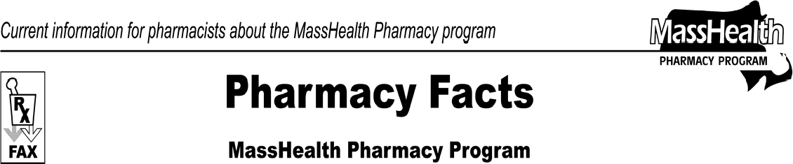www.mass.gov/masshealth/pharmacy
Number 59
June 24, 2010
- Editor: Vic Vangel • Contributors: Chris Burke, Gary Gilmore, Paul Jeffrey, James Monahan, Nancy Schiff •
Copayment Changes  Effective July 1, 2010, the pharmacy copayments will be as follows.  - $1 for each prescription and refill for each generic drug and over-the-counter drug covered by MassHealth in the following drug classes: antihyperglycemics, antihypertensives, and antihyperlipidemics;  - $3 for each prescription and refill for all other generic, brand-name, and over-the-counter drugs covered by MassHealth.  All other copayment rules remain unchanged. Please see 130 CMR 450.130 for regulations about copayments.  Pharmacy Copayment Poster Updated  The pharmacy copayment poster has been updated to reflect this new information and is on the MassHealth Pharmacy Web page. To download the poster, go to www.mass.gov/masshealth/pharmacy and click on the link for MassHealth Pharmacy Publications and Notices for Pharmacy Providers, then Sample Pharmacy Copayment Poster.  Pharmacies are required by MassHealth regulations at 130 CMR 450.130(F) to post a notice about MassHealth copayments in areas where copayments are collected. The notice must be visible to the public and easily readable; specify the exclusions from the copayment requirement listed in 130 CMR 450.130(D) and (E); and instruct members to inform providers if they believe they are excluded from the copayment requirement. | Member Identification (ID) Numbers  Before starting NewMMIS in May 2009, MassHealth issued new 12-digit identification (ID) cards to all members. To ease the transition to these longer ID numbers, MassHealth allows providers to use either the new 12-digit number or the older 10-digit member IDs on pharmacy claim submissions. In the future, MassHealth will require the 12-digit number on all pharmacy claims. Pharmacies are encouraged to collect and use the new 12-digit member IDs on pharmacy claims whenever possible. This will help avoid disruption in the future.  MassHealth providers can verify necessary information about a member’s eligibility using the MassHealth Eligibility Verification System (EVS) and the Automated Voice Response (AVR) system applications. EVS provides the most current member information from MassHealth, 24 hours a day, 7 days a week. This method is very useful to pharmacies verifying members’ NewMMIS IDs.  The AVR phone system allows you to verify eligibility by member ID, social security number, or other agency ID. A member’s eligibility can also be verified by supplying the member’s name, gender, and date of birth. You must have a valid user name and password combination associated with a MassHealth provider or national provider identifier (NPI) number in order to access AVR. It is recommended to use AVR only when you do not have access to the Provider Online Service Center (POSC) or the EVSpc software. For further information, contact MassHealth Customer Service at 1-800-841-2900, or e-mail your inquiry to providersupport@mahealth.net.

Please direct any questions or comments (or to be taken off of this fax distribution) to
Victor Moquin of ACS at 617-423-9830.

