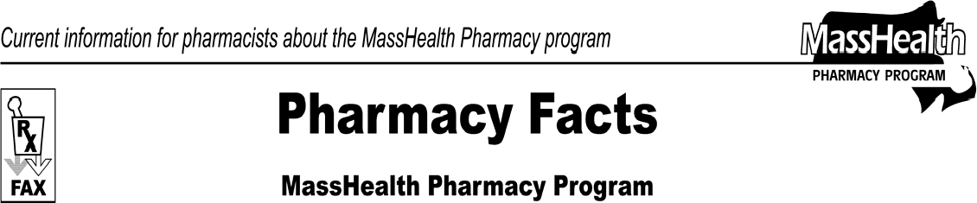www.mass.gov/masshealth/pharmacy
Number 60
July 30, 2010
Page 1 of 2
- Editor: Vic Vangel • Contributors: Chris Burke, Gary Gilmore, Paul Jeffrey, James Monahan, Nancy Schiff •
MHDL Updates  Below are certain updates to the MassHealth Drug List (MHDL). See the MHDL for a complete listing of updates.  - Additions  - The following newly marketed drugs have been added to the MassHealth Drug List.  ActoPlus Met XR (pioglitazone/metformin extended-release) – PA  Berinert (C1 inhibitor, human) ^  Exalgo (hydromorphone, extended release)  - PA  Hizentra (immune globulin, subcutaneous)  - PA  Kalbitor (encallatide) ^  Metvixia (methyl aminolevulinate) ^ Mirapex ER (pramipexole extended-  release) – PA  Pennsaid (diclofenac topical solution) – PA Qutenza (capsaicin, high dose patch) – PA Revatio IV (sildenafil) ^{H}  ` Rybix ODT (tramadol, orally disintegrating tablet) – PA  Tirosint (levothyroxine) – PA  Vibativ (televancin) – PA  Vpriv (velaglucerase alfa) – PA  Xiaflex (collagenase clostridium histolyticum) – PA  Zirgan (ganciclovir) Zyclara (imiquimod) – PA  ^ This drug is available through the health-care professional who administers the drug. Masshealth does not pay for this drug to be dispensed through a retail pharmacy.  H This drug is available only in an inpatient hospital setting. MassHealth does not pay for this drug to be dispensed through the retail pharmacy or the physician’s office.  2. New FDA “A”-Rated Generics  The following FDA “A”-rated generic drugs have been added to the MassHealth Drug List. The brand name is listed with a # symbol, to indicate that PA is required for the brand.  New FDA “A”-Rated  Generic Drug Generic Equivalent  pramipexole Mirapex # | - Change in Prior-Authorization (PA) Status  - The PA requirements for butalbital containing medications are changing. The following will require PA effective August 16, 2010.  Anolor-300 (butalbital/acetaminophen/caffeine) – PA > 60 units/month  Ascomp/codeine (butalbital/aspirin/codeine/ caffeine) – PA > 60 units/month  butalbital/acetaminophen – PA > 60 units/month  butalbital/acetaminophen/caffeine – PA > 60 units/month  butalbital/acetaminophen/codeine/caffeine – PA  > 60 units/month  butalbital/aspirin/caffeine – PA > 60 units/month  butalbital/aspirin/codeine/caffeine – PA > 60 units/month  Esgic # (butalbital/acetaminophen/caffeine) – PA > 60 units/month  Fioricet # (butalbital/acetaminophen/caffeine) – PA > 60 units/month  Fioricet/codeine # (butalbital/acetaminophen/codeine/caffeine) – PA > 60 units/month  Fiorinal # (butalbital/aspirin/caffeine) – PA > 60 units/month  Fiorinal/codeine # (butalbital/aspirin/codeine/ caffeine) – PA > 60 units/month  Marten-tab # (butalbital/acetaminophen) – PA > 60 units/month  Phrenilin # (butalbital/acetaminophen) – PA > 60 units/month  Repan # (butalbital/acetaminophen/caffeine) – PA > 60 units/month  Zebutal # (butalbital/acetaminophen/caffeine) –  PA > 60 units/month  - The following intravenous antibiotics will require PA effective August 16, 2010.  Cubicin (daptomycin) – PA  Synercid (dalfopristin/quinpristin) – PA  Tygacil (tigecycline) – PA  Zyvox (linezolid), injection – PA  - The following drugs will require PA effective August 16, 2010.  Lotemax (loteprednol) – PA Ontak (denileukin diftitox) – PA Zmax (azithromycin) – PA

Pharmacy Facts, Number 60 Page 2 of 2

- The following agent previously required prior authorization (PA). Effective August 16, 2010, this agent will be available only through a provider who administers the drug.
Cinryze (C1 inhibitor, human) ^
^ This drug is available through the health-care professional who administers the drug. Masshealth does not pay for this drug to be dispensed through a retail pharmacy.
- The following agent previously required PA for all quantities. Effective August 4, 2010, the following quantity limits will be effective.
Voltaren Gel (diclofenac) – PA>100 grams/ month
- The following agent previously required PA for quantities greater than one tube/month and three tubes/lifetime. Effective August 16, 2010, this agent will require PA for all quantities.
Regranex (becaplermin) – PA

- The following agent previously required prior authorization for quantities greater than 64 units/month. The following quantity limits will be effective August 16, 2010.
Restasis (cyclosporine, ophthalmic) – PA > 60 units/month
- The following drugs will no longer require prior authorization:
Lialda (mesalamine)
Percocet # (oxycodone/acetaminophen)
Topiramate

- The following quantity limits for cerebral stimulant solutions are effective August 4, 2010.
Methylin 5mg/5ml (methylphenidate oral solution) – PA > 1800 ml/month
Methylin 10mg/5ml (methylphenidate oral solution) – PA > 900 ml/month
Procentra (dextroamphetamine oral solution) – PA > 900 ml/month

Please direct any questions or comments (or to be taken off of this fax distribution) to
Victor Moquin of ACS at 617-423-9830.

