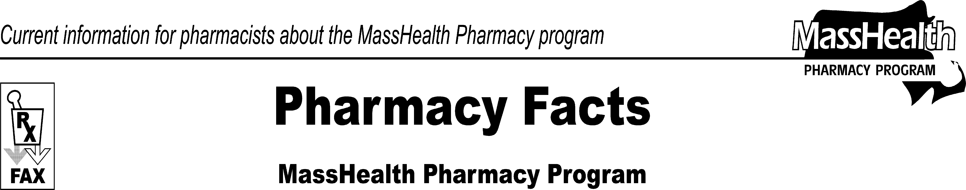www.mass.gov/masshealth/pharmacy
Number 62
October 29, 2010
Page 1 of 2
 | - Editor: Vic Vangel • Contributors: Chris Burke, Gary Gilmore, Paul Jeffrey, James Monahan, Nancy Schiff •
 | MHDL Update  Below are certain updates to the MassHealth Drug List (MHDL). See the MHDL (www.mass.gov/druglist) for a complete listing of updates.  - Additions  The following newly marketed drugs have been added to the MassHealth Drug List.  Afinitor 2.5 mg (everolimus) – PA > 30 units/month  Afluria (influenza virus vaccine) Agriflu (influenza virus vaccine)  Cambia (diclofenac powder for solution) – PA  Cayston (aztreonam) Chenodal (chenodiol) – PA  Clobeta Plus Kit (clobetasol/coal tar) – PA Dulera (mometasone/formoterol) – PA Istodax (romidepsin) – PA  Jalyn (dutasteride/tamsulosin) – PA  Jevtana (cabazitaxel) Livalo (pitavastatin) – PA Lysteda (tranexamic acid)  Oleptro (trazodone ER) – PA omeprazole/sodium bicarbonate – PA Oravig (miconazole) – PA  Prolia (denosumab) – PA  Tribenzor (olmesartan/amlodipine/hydrochlorothiazide) – PA  Veltin (clindamycin/tretinoin) – PA  Vimovo (naproxen/esomeprazole) – PA < 60 years  Vimpat (lacosamide) solution – PA Xerese (acyclovir/hydrocortisone) – PA Zortress (everolimus)  Zuplenz (ondansetron) oral soluble film – PA  Zymaxid (gatifloxacin) – PA  - Change in Prior-Authorization Status  - The prior authorization requirements for the following drugs are changing. Please refer to Table 31 and applicable PA request forms for the complete list of prior authorization requirements for the cerebral stimulants.  Daytrana (methylphenidate transdermal system) – PA < 6 or > 12 years and PA > 30 units/month  Vyvanse (lisdexamfetamine) – PA > 60 units/month | - The prior authorization requirement for the following drug is changing.  Zovirax (acyclovir) cream – PA > 12 years and PA > 5 grams/month  - The following oral nonsteroidal anti-inflammatory agents will require prior authorization effective November 15, 2010.  Cataflam (diclofenac potassium) – PA Feldene (piroxicam) – PA meclofenamate – PA  Naprosyn (naproxen) suspension – PA > 12 years  Naprosyn EC (naproxen EC) – PA  Tolectin (tolmetin) – PA  - The following pulmonary hypertension agents will require prior authorization effective November 15, 2010.  Letairis (ambrisentan) – PA Remodulin (treprostinil) injection – PA Tracleer (bosentan) – PA  Tyvaso (treprostinil) inhalation solution – PA  Ventavis (iloprost) – PA  - The following drugs will require prior authorization effective November 15, 2010.  Aloxi (palonosetron) – PA  Catapres-TTS Patch (clonidine) – PA Sucraid (sacrosidase) – PA Transderm Scop (scopolamine) – PA  - The following drug will require prior authorization for all quantities effective November 15, 2010.  Zofran (ondansetron) solution – PA  - The following drugs will require prior authorization effective January 1, 2011.  Actos (pioglitazone) – PA  Avandia (rosiglitazone) – PA  - The following drug will require prior authorization for members older than 12 years, effective November 15, 2010.  Riomet (metformin solution) – PA > 12 years  - The following drugs will no longer require prior authorization for < 15 units/month.  Zofran ODT 4 mg (odansetron, orally disintegrating tablet) – PA > 15 units/month

Pharmacy Facts, Number 62 Page 2 of 2

 | - The following drugs will no longer require prior authorization.  Aricept ODT (donepezil, orally disintegrating tablet)  glipizide/metformin glyburide/metformin  venlafaxine extended-release capsule  - The following drug has been added to the MassHealth OTC Drug List as covered for members aged 18 and younger, effective November 1, 2010.  Melatonin tablet and solution < 18 years  - The following quantity limits are effective November 15, 2010.  Methylin 5mg/5mL (methylphenidate oral solution) – PA > 900 mL/month  - Corrections  - The following prior authorization requirements have been clarified. These changes do not reflect any changes in MassHealth policy.  Betopic # (betaxolol)  Commit (nicotine) lozenge – PA > 180 days treatment/year  nicotine gum – PA > 180 days treatment/year  nicotine lozenge – PA > 180 days treatment/year  nicotine transdermal patch (generics) – PA > 180 days treatment/year  propoxyphene/acetaminophen  Relenza (zanamivir) – PA all quantities (June 1st to September 30th); PA < 5 years and > 20 inhalations/month or 40 inhalations/season (October 1st to May 31st) | - The PA requirements for the following drug have been clarified on the OTC drug list. This change does not reflect any changes in MassHealth policy.  Coenzyme Q10 < 18 years  - The following drugs have been added to the MassHealth Drug List. They were omitted in error. These changes do not reflect any changes in MassHealth policy.  Adoxa Kit (doxycycline) – PA  Angiomax (bivalirudin)  Climara Pro (estradiol/levonorgestrel) fluoxetine solution  Innohep (tinzaparin)  Isopto-Carbachol (carbachol) Lumizyme (alglucosidase) – PA Miochol (acetylcholine chloride) Miostat (carbachol)  Norvir (ritonavir) solution Rowasa Kit (mesalamine) – PA

Please direct any questions or comments (or to be taken off of this fax distribution) to
Victor Moquin of ACS at 617-423-9830.

