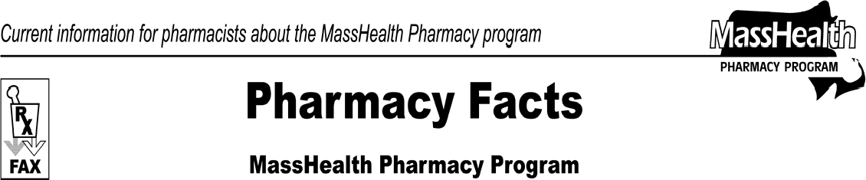www.mass.gov/masshealth/pharmacy
Number 63
February 10, 2011
- Editor: Vic Vangel • Contributors: Chris Burke, Gary Gilmore, Paul Jeffrey, James Monahan, Nancy Schiff •
MHDL Update  Below are certain updates to the MassHealth Drug List (MHDL). See the MHDL for a complete listing of updates.  - Additions  The following newly marketed drugs have been added to the MassHealth Drug List effective February 14, 2011.  Atelvia (risedronate) delayed release – PA  Beyaz (drospirenone/ethinyl estradiol/levomefolate) Bromday (bromfenac) – PA  Gilenya (fingolimod) – PA  Glassia (alpha 1-proteinase inhibitor, human) Kombiglyze XR (saxagliptin/metformin ER) – PA Lo Loestrin Fe (norethindrone/ethinyl estradiol/  ferrous fumarate)  Natazia (estradiol valerate and estradiol valerate/ dienogest)  Pacnex Cleansing Pads (benzoyl peroxide) – PA  Pradaxa (dabigatran) – PA  Silenor (doxepin) – PA  Suboxone (buprenorphine/naloxone) film – PA  Suprep Bowel Kit (sodium sulfate/potassium sulfate/magnesium sulfate) – PA  Tachosil (fibrinogen/thrombin) patch Tekamlo (aliskiren/amlodipine) – PA  Tobradex ST (tobramycin 0.3%/dexamethasone 0.05%) – PA  Xeomin (incobotulinum toxinA) – PA  - Change in Prior-Authorization Status  - The prior authorization requirement for the following drug is changing. Please refer to Table 31 and applicable PA request form for PA requirements for this drug.  Daytrana (methylphenidate transdermal system) – PA < 6 years or > 17 years and PA > 30 units/month  - The following drugs will no longer require prior authorization.  Aceon # (perindopril) ephedrine injection  Sandimmune (cyclosporine) capsules | - The following agent will no longer require prior authorization for ≤ 30 units/month.  Wellbutrin XL # (bupropion XL) – PA > 30 units/month  - The following drugs will be restricted to inpatient hospital use effective February 28, 2011.  Angiomax (bivalirudin) argatroban  Refludan (lepirudin)  - The following ophthalmic antibiotic/ corticosteroid combination drugs will require prior authorization effective February 28, 2011.  Blephamide (sulfacetamide/prednisolone) – PA  Poly-Pred (neomycin/polymyxin B/ prednisolone) – PA  Pred-G (prednisolone/gentamycin) – PA  Tobradex (tobramycin 0.3%/dexamethasone, ophthalmic ointment 0.1%) – PA  Zylet (loteprednol/tobramycin) – PA  - The prior authorization requirements for the following drugs are changing effective February 28, 2011. Please refer to Table 3 and applicable PA request forms for PA requirements for these drugs.  Prilosec # (omeprazole) 10 mg – PA > 30 units/month  Prilosec # (omeprazole) 20 mg – PA > 120 units/month  Prevacid # (lansoprazole) capsule – PA > 2 years and > 30 units/month  Prevacid SoluTab (lansoprazole, orally disintegrating tablet) – PA > 2 years and > 30 units/month  - The following drug will require prior authorization effective February 28, 2011.  doxepin 150 mg – PA  - The following prior authorization requirement for acetaminophen-containing products are effective February 28, 2011.  acetaminophen – PA > 4 grams/day

Please direct any questions or comments (or to be taken off of this fax distribution) to
Victor Moquin of ACS at 617-423-9830.

