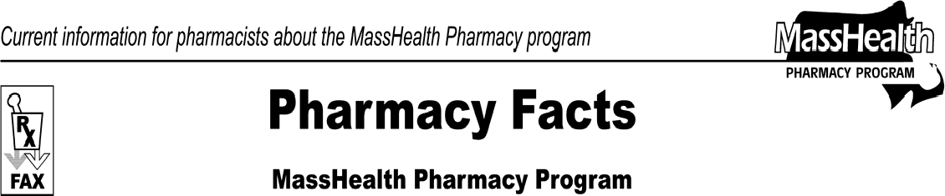www.mass.gov/masshealth/pharmacy
Number 68
December 15, 2011
Page 1 of 2

- Editor: Vic Vangel • Contributors: Chris Burke, Gary Gilmore, Paul Jeffrey, James Monahan, Nancy Schiff •

National Council for Prescription Drug Programs (NCPDP) Version D.0
This is another reminder that, effective January 1, 2012, the National Council for Prescription Drug Programs (NCPDP) Version D.0 transaction standards will become mandatory for all MassHealth pharmacy claims. D.0 is an updated version of the HIPAA standard for pharmacy claims transactions. All pharmacy software vendors must be upgrading their products in order to support D.0.
MassHealth has posted a draft of the D.0 version of the POPS Billing Guide on the MassHealth Pharmacy Program Web site. Please ensure your software vendor has been notified. To view the draft billing guide go to www.mass.gov/masshealth/pharmacy and click on the link for MassHealth Pharmacy Publications and Notices for Pharmacy Providers, then Draft POPS Billing Guide Standard D.0.
Please Note: The final version of the billing guide will be posted by January 1, 2012, and the Draft POPS Billing Guide Standard D.0 will no longer exist.

Changes for D.0 Claims Submissions
Some of the changes are described below.

Other Coverage Code (NCPDP Field 308-C8)
Accepted values are:
00=Not specified by patient
01=No other coverage has been identified 02=Other coverage exists. Payment was collected.
03=Other coverage exists. This claim is not covered. 04=Other coverage exists. Payment not collected.
Please Note: “04” is replacing “08” and must only be used when the other payer has paid $0.00 because 100% of the allowed amount was applied to the patient responsibility.

Submission Clarification Code (NCPDP Field 420-DK)
This field will now allow up to three entries.

Prescription Origin (NCPDP Field 419-DJ)
Accepted values are:
1=Written on tamper resistant prescription pad 2=Telephone
3=Electronic 4=Facsimile 5=Pharmacy

Patient Residence (NCPDP Field 384-4X)
This field will be used in place of Patient Location (NCPDP Field 307-C7).
Accepted values are:
1=Home
2=Skilled nursing facility 3=Nursing facility 4=Assisted living facility 5=Custodial care facility 6=Group home 11=Hospice 14=Homeless shelter

Prescription Number (NCPDP Field 402-D2)
This field is expanding from seven digits to 12 digits.

Testing D.0 Claims Submissions
MassHealth pharmacies interested in testing claim submissions for D.0 before the January 1, 2012, go- live date should contact the ACS Technical Helpdesk for instructions (available 24/7) at 1-866-246-8503.

Pharmacy Facts, Number 68

Member Identification Number
Reminder to All MassHealth Pharmacies: Effective January 1, 2012, all MassHealth pharmacy claims must contain the 12-digit member identification number that was introduced in May 2009. The older 10-digit member identification numbers will no longer be accepted. Any claims containing the 10-digit number will be denied. MassHealth is still seeing many claims being submitted with the older identification numbers.

Usual and Customary Charge
MassHealth pharmacy providers are reminded that they must report an accurate usual and customary charge for each drug included on all pharmacy claims. The Division of Health Care Finance and Policy defines usual and customary charge at 114.3 CMR 31.00 as:
Usual and Customary Charge. The lowest price that a Provider charges or accepts from any payer for the same quantity of a drug on the same date of service, in Massachusetts, including but not limited to the shelf price, sale price, or advertised price for any drug including an over-the-counter drug. If an insurer and the Eligible Provider have a contract that specifies that the insurer will pay an average or similarly computed fixed amount for multiple therapeutic categories of drugs with different acquisition costs, the fixed amount will not be the Provider’s usual and customary charge.
This usual and customary charge provision applies broadly to any payer, including without limitation, payers that are MassHealth and other managed care organizations (MCOs). If the lowest price the MassHealth pharmacy provider charges or accepts for the same quantity of drug on the same date of service is the price that it charges or accepts from an MCO, the provider must report that price on the MassHealth pharmacy claim as its usual and customary charge.
Page 2 of 2

Failure to do so constitutes a violation of MassHealth requirements and is subject to sanctions including those specified in the MassHealth regulations at 130 CMR 450.000 et seq. MassHealth intends to audit pharmacies for compliance with the usual and customary charge regulation.

New MassHealth Web Site
The MassHealth Web site has a new, cleaner, more modern look and feel. This is the result of a major restructuring of www.mass.gov, the state Web site. We are aware that the change resulted in some broken links in document files (such as bulletins and transmittal letters), and are working to fix these as soon as possible. The new Web site also has a very different method of constructing URLs from the method used by the previous site. This means any favorites or bookmarks that you have previously created will be broken. To correct this situation, you will need to navigate to the pages that you bookmarked and reset your bookmarks. Please note that this change does not affect the Virtual Gateway or the Provider Online Service Center (POSC) links. Thank you for your patience as we manage this major change.

Medicare Part D Prescription Drug Coverage Update
MassHealth continues to provide assistance with Medicare Part D prescription drug plan copayments for dually eligible members to ensure that the member does not pay a copayment that is greater than the standard MassHealth copayment.
Please Note: Currently, the maximum amount that a Part D plan is permitted to charge a dually eligible member is $6.30. Effective January 1, 2012, this maximum amount will increase to $6.50.

Please direct any questions or comments (or to be taken off of this fax distribution) to
Victor Moquin of ACS at 617-423-9830.

