www.mass.gov/masshealth/pharmacy
Editor: Vic Vangel • Contributors: Chris Burke, Gary Gilmore, Paul Jeffrey, James Monahan, Nancy Schiff

MHDL Updates

Below are certain updates to the MassHealth Drug List (MHDL). See the MHDL for a complete listing of updates.
- Additions
  - The following newly marketed drugs have been added to the MassHealth Drug List as of January 9, 2012.
ADCETRIS (brentuximab) – PA
Amethia (levonorgestrel/ethinyl estradiol) Arcapta (indacaterol) – PA
Biltricide (praziquantel)
BRILINTA (ticagrelor) – PA
chlorzoxazone 375 mg, 750 mg – PA Complera (emtricitabine/rilpivirine/tenofovir) Conzip ER (tramadol ER) – PA
DUEXIS (ibuprofen/famotidine) – PA < 60 years
FIRAZYR (icatibant) – PA
Flo-pred (prednisolone suspension) – PA GRALISE (gabapentin ER) – PA Juvisync (sitagliptin/simvastatin) – PA Nucynta ER (tapentadol ER) – PA Phoslyra (calcium acetate)
Xalkori (crizotinib) – PA
Xarelto (rivaroxaban 10 mg) – PA > 10 mg/day and PA > 35 tablets/365 days
Xarelto (rivaroxaban 15 mg, 20 mg) – PA
Zelboraf (vemurafenib) – PA

The following drug has been added to the MassHealth Drug List as of January 9, 2012, due to the newly approved indication for the signs and symptoms of benign prostatic hyperplasia (BPH).
Cialis (tadalafil) – PA

Change in Prior-Authorization Status
  - The following drug will require prior authorization effective January 23, 2012.
Effient (prasugrel) – PA
  - The following topical antiviral agents will require prior authorization for all quantities effective January 23, 2012.
Denavir (penciclovir) – PA
Zovirax (acyclovir cream) – PA
  - The following antiparkinson agents will require prior authorization effective January 23, 2012.
amantadine tablet – PA selegiline capsule – PA Tasmar (tolcapone) – PA

Deletions

The following drug has been removed from the MassHealth Drug List because it is not approved by the FDA.
LidaMantle HC (lidocaine/hydrocortisone) – PA
  - The following drugs have been removed from the MassHealth Drug List because they have been discontinued by the manufacturer.
Alamast (pemirolast) – PA
Proquin XR (ciprofloxacin XR) – PA Sildec (carbinoxamine/pseudoephedrine) Xibrom (bromfenac) – PA

Corrections

The following drugs have been added to the MassHealth Drug List. They were omitted in error. These changes do not reflect any change in MassHealth policy.
Activase (alteplase)
AquaDEKS (multivitamins/minerals/coenzyme Q10) – PA
AquaDEKS (multivitamins/minerals/folic acid/ coenzyme Q10) – PA
Gammaplex (immune globulin, IV) – PA
Simulect (basiliximab)

The prior-authorization status of the following drugs has been clarified. These changes do not reflect any change in MassHealth policy.
Bactroban # (mupirocin ointment)
EMLA # (lidocaine/prilocaine) – PA >30 grams/ month and PA > 90 days treatment/180 days hydrocortisone/pramoxine cream, lotion, ointment Sandimmune (cyclosporine)

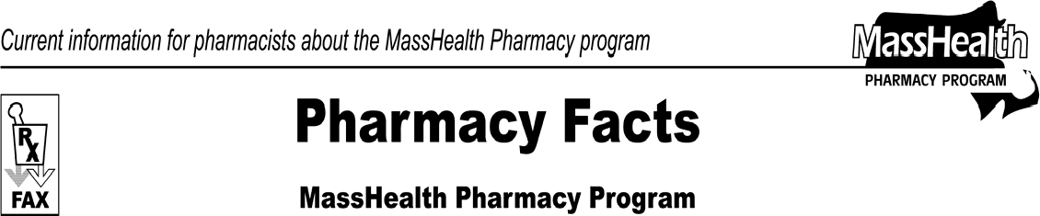
Number 69
January 10, 2012

Please direct any questions or comments (or to be taken off this fax distribution) to Victor Moquin of ACS at 617-423-9830.

