www.mass.gov/masshealth/pharmacy
Editor: Vic Vangel • Contributors: Chris Burke, Gary Gilmore, Paul Jeffrey, James Monahan, Nancy Schiff

MHDL Updates

Below are certain updates to the MassHealth Drug List (MHDL). See the MHDL for a complete listing of updates.
- Additions
The following newly marketed drugs have been added to the MassHealth Drug List as of
March 12, 2012.
Erwinaze (asparaginase Erwinia chrysanthemi) ^

– PA
fluoxetine 60 mg tablet – PA Jakafi (ruxolitinib) – PA ONFI (clobazam) – PA
- New FDA “A”–Rated Generics

The following FDA “A”-rated generic drugs have been added to the MassHealth Drug List as of March 12, 2012. The brand name is listed with a # symbol, to indicate that prior authorization is required for the brand.

New FDA “A”-Rated
Generic Drug Generic Equivalent
methylphenidate 20, 30 or
40 mg – PA > 60
units/month Ritalin LA # fluocinolone oil,
otic drops DermOtic # piperacillin/tazobactam Zosyn #

Change in Prior-Authorization Status
  - The following drug requires prior authorization when exceeding quantity limits effective March 12, 2012.
Aricept # (donepezil 10 mg tablet) – PA > 60 units/ month
  - The following drug is covered without prior authorization effective March 12, 2012.
Vivitrol (naltrexone injection)
  - The following drugs will require prior authorization when exceeding quantity limits effective March 26, 2012.
Spiriva (tiotropium) – PA > 30 units/month
  - The following antidiarrheal agents will require prior authorization effective March 26, 2012.
opium tincture – PA
Motofen (atropine/difenoxin) – PA
# This is a brand-name drug with FDA “A”-rated generic equivalents. Prior authorization is required for the brand, unless a particular form of that drug (i.e., tablet, capsule, or liquid) does not have an FDA “A”-rated generic equivalent.

  - The following drugs will require prior authorization effective March 26, 2012.
Avastin (bevacizumab) – PA
Berinert (c1 esterase inhibitor, human) – PA Cinryze (c1 esterase inhibitor, human) – PA naltrexone powder – PA

Corrections
  - The following drugs have been added to the MassHealth Drug List. They were omitted in error. These changes do not reflect any change in MassHealth policy.
Atralin (tretinoin) – PA chloral hydrate solution Elspar (asparaginase) ^
erythromycin, topical – PA > 22 years fenofibric acid tablet 35 mg and 105 mg Ifex (ifosfamide)
Oncaspar (pegasparaginase) ^
Questran Light # (cholestyramine/aspartame)
  - The prior-authorization status of the following drug has been clarified. These changes do not reflect any change in MassHealth policy.
Evoclin (clindamycin foam) – PA > 22 years
^ This drug is available through the health care professional who administers the drug. Medicaid does not pay for this drug to be dispensed through a retail pharmacy

Reminder about Claims Processing When MassHealth is a Secondary Insurer

When a pharmacy is not a participating provider for a MassHealth member’s primary insurance, or the pharmacy receives a message from the primary insurer that a product is covered only at certain network pharmacies, the pharmacy cannot appropriately bill MassHealth as the primary payer using Other Coverage Code 3.
In these instances, the pharmacy must instruct the member that they need to use a participating pharmacy of the primary insurer.

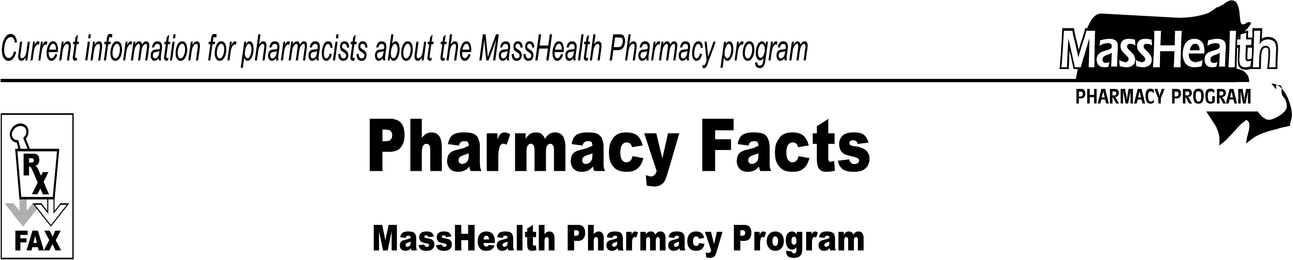
Number 70
March 19, 2012
Please direct any questions or comments (or to be taken off this fax distribution) to Victor Moquin of ACS at 617-423-9830.

