www.mass.gov/masshealth/pharmacy
Editor: Vic Vangel • Contributors: Chris Burke, Gary Gilmore, Paul Jeffrey, James Monahan, Nancy Schiff

MHDL Updates
Below are certain updates to the MassHealth Drug List (MHDL). See the MHDL for a complete listing of updates.

Additions
The following newly marketed drugs have been added to the MassHealth Drug List as of July 16, 2012.
Cosopt PF (dorzolamide/timolol, preservative free)

– PA
Intermezzo (zolpidem, sublingual tablet) – PA
Korlym (mifepristone) – PA Omontys (peginesatide) ^ – PA Picato (ingenol) – PA
Qnasl (beclomethasone nasal aerosol) – PA
Revlimid (lenalidomide 2.5 mg)

– PA > 30 units/month
Subsys (fentanyl sublingual spray) – PA
ZIOPTAN (tafluprost) – PA

New FDA “A” –Rated Generics
The following FDA “A”-rated generic drugs have been added to the MassHealth Drug List as of July 16, 2012. The brand name is listed with a # symbol, to indicate that prior authorization is required for the brand.

New FDA “A”-Rated
Generic Drug Generic Equivalent
clopidogrel Plavix # lamivudine/zidovudine Combivir #

Change in Prior-Authorization Status
  - The following drug no longer requires prior authorization effective July 16, 2012.
Derma-smoothe FS # (fluocinolone body oil, scalp oil)
hydrocortisone acetate/aloe vera cream, gel, lotion
  - The prior-authorization requirements for the following drug have changed. The new prior-authorization requirement is shown below.
Veramyst (fluticasone furoate nasal spray) – PA ≥

4 years and > 1 inhaler/month
  - The following topical corticosteroids will require prior authorization effective July 30, 2012
Apexicon-E (diflorasone cream/emollient) – PA
Kenalog (triamcinolone spray) – PA
Texacort (hydrocortisone solution) – PA
Topicort (desoximetasone cream, gel, ointment)

– PA
Trianex (triamcinolone 0.05% ointment) – PA
# This is a brand-name drug with FDA “A” -rated generic
equivalents. Prior authorization is required for the brand, unless a particular form of that drug (for example, tablet, capsule, or liquid) does not have an FDA “A” -rated generic equivalent.

  - The following otic antibiotics will require prior authorization effective July 30, 2012.
Coly-Mycin S (colistin/neomycin/thonzonium/ hydrocortisone) – PA
Cortisporin-TC (colistin/neomycin/thonzonium/ hydrocortisone) – PA
  - The following laxatives will require prior authorization effective July 30, 2012.
CoLyte with flavor packs (polyethylene glycol- electrolyte solution) – PA
GoLytely packet (polyethylene glycol-electrolyte solution) – PA
  - The following drug is restricted to a health-care professional
ketamine injection ^ – PA

Updated Non-Drug Product List
The MassHealth Non-Drug Product List has been updated to reflect recent changes to the MassHealth Drug List. The following non-drug products have been added to the Non- Drug Product List as covered without prior authorization, effective July 16, 2012.
Hyper-Sal (sodium chloride 3.5% for inhalation) Nebusal (sodium chloride 6% for inhalation) sodium chloride for inhalation

Corrections
  - The following drugs have been added to the MassHealth Drug List. They were omitted in error. These changes do not reflect any change in MassHealth policy.
Busulfex (busulfan injection) Desowen # (desonide cream) Epivir (lamivudine solution) Epivir # (lamivudine tablet) Fludara # (fludarabine)
fluocinolone cream, ointment, solution Hycamtin # (topotecan) hydrocortisone cream, lotion, ointment Myleran (busulfan tablet)
Olux-E (clobetasol propionate foam/emollient) QUADRAMET (samarium SM 153 lexidronam) ^ SSD # (silver sulfadiazine)
Tabloid (thioguanine)
Vitrasert (ganciclovir intravitreal implant) ^
  - The following drugs previously had an “A”-rated generic equivalent that is no longer available on the market. Prior authorization is no longer required for the branded products.
Grifulvin V (griseofulvin 500 mg tablet)
Gris-Peg (griseofulvin 125 mg, 250 mg tablet)
^ This drug is available through the health-care professional who
administers the drug. MassHealth does not pay for this drug to be dispensed through a retail pharmacy.

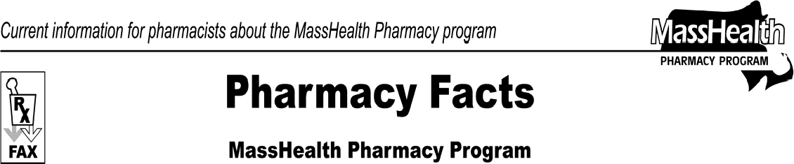
Number 72
July 16, 2012
Please direct any questions or comments (or to be taken off this fax distribution) to Victor Moquin of Xerox at 617-423-9830.

