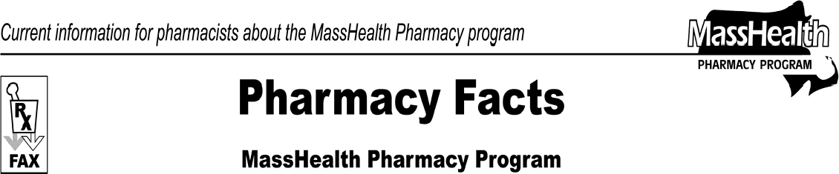www.mass.gov/masshealth/pharmacy
Number 73
October 2, 2012
Page 1 of 2
- Editor: Vic Vangel • Contributors: Chris Burke, Gary Gilmore, Paul Jeffrey, James Monahan, Nancy Schiff •

Upcoming Pharmacy Audits
The Executive Office of Health and Human Services, as the state agency responsible for administering the MassHealth program (“MassHealth”), has retained Health Management System Inc. (“HMS”), as a MassHealth Recovery Audit Contractor (“RAC”), pursuant to Section 6411 of the Patient Protection and Affordable Care Act (“ACA”) of 2010. Accordingly, HMS is authorized to audit provider payments and associated financial records to identify improper payments. These audits are designed to complete a post-payment audit of claims and verify that claims are in compliance with the rules and regulations governing the MassHealth program.
As part of the RAC auditing engagement, HMS will be performing both onsite and desk audits of MassHealth pharmacies, and will be contacting the selected pharmacies via faxed correspondence confirming the date of the audit, audit format, and prescriptions to be audited. We ask that you cooperate with HMS requests and respond accordingly to their outreach.

What to Expect
If your pharmacy is selected for an onsite review, HMS will contact you via fax to schedule a date and time for the visit. Approximately two weeks before the onsite review, you will receive a list of the prescriptions that will be audited. These prescriptions will be randomly selected from the claims paid to your pharmacy by MassHealth.
HMS will review the claims onsite against MassHealth provider and claims regulations.
If your pharmacy is selected for a desk audit, you will receive notification from HMS, via fax, including a list of the prescriptions that you must submit for review. You will have 15 days to submit the requested documentation.
Upon receipt, HMS will review the prescriptions against MassHealth provider and claims regulations.
In accordance with 130 CMR 450.235 through 450.240, findings can result in recovery of overpayments and/or sanctions.
In accordance with 130 CMR 450.238 through 450.240, if you do not comply with the requirements of this audit engagement notice, MassHealth may impose sanctions against you. For example, 130 CMR 450.238(A) states that “Such sanctions may include, but are not limited to, administrative fines and suspension or termination from participation in MassHealth.”
If you have any questions or concerns about the Medicaid RAC Program, you may find the following web page helpful.

https://www.cms.gov/Medicare-Medicaid- Coordination/Fraud- Prevention/MedicaidIntegrityProgram/Downloads/scanne d_document_29-12-2011.pdf
Once the audits have been initiated, the audit letters will contain detailed information about the process, as well as phone numbers to contact HMS during the audit process.

Member Prior-Authorization Inquiries
MassHealth pharmacy providers are reminded that if a MassHealth member cannot pick up a prescription because prior authorization wasn’t requested or the prior authorization request requires additional information, the member should not be referred to MassHealth Customer Service or the MassHealth Drug Utilization Review Program. The pharmacy must instruct the member to contact the prescribing clinician for details about the prior authorization status of the prescription.

Copayments
As a reminder, a pharmacy may not refuse service or fail to fill a prescription as written based on a MassHealth member’s inability to pay a copayment. This is also true for MassHealth members enrolled in MassHealth managed care organizations (MCO). 130 CMR 450.130(G) specifies that providers may not refuse services to any members who are unable to pay the copayment at the time service is provided.

Flu Vaccine Update
MassHealth continues to pay pharmacies for the administration of flu vaccine to MassHealth-eligible members. The current administration fee for flu vaccine administered either by injection or by intranasal route is
$15.50.

Pharmacy Facts, Number 73

MHDL Updates
Below are certain updates to the MassHealth Drug List (MHDL). See the MHDL for a complete listing of updates.

Additions
The following newly marketed drugs have been added to the MassHealth Drug List as of September 10, 2012.
Combivent Respirmat (albuterol/ipratropium inhalation spray)
Elelyso (taliglucerase alfa) – PA
Potiga (ezogabine) – PA
Sorilux (calcipotriene foam) – PA
Zetonna (circlesonide nasal aerosol, 37 mcg) – PA

Change in Prior-Authorization Status
  - The following drugs are available only in an inpatient hospital setting effective September 24, 2012.
Bexxa (tositumomab) ^{H} papaverine ^{H} phentolamine^{H}
Zevalin (ibritumomab) ^{H}
  - The following drugs no longer require prior-authorization effective September 10, 2012.
Keppra XR # (levetiracetam extended-release) Uroxatral # (alfuzosin extended-release)
  - The following agents will require prior authorization effective September 24, 2012
Dovonex (calcipotriene cream) – PA
Equetro (carbamazepine) – PA

# This is a brand-name drug with FDA “A” -rated generic equivalents. Prior authorization is required for the brand, unless a particular form of that drug (for example, tablet, capsule, or liquid) does not have an FDA “A” -rated generic equivalent.
H This drug is available only in the inpatient hospital setting. MassHealth
does not pay for this drug to be dispensed through the retail pharmacy or physician office.
Page 2 of 2

Updated MassHealth Over-the-Counter Drug List
The MassHealth Over-the-Counter Drug List has been updated to reflect recent changes to the MassHealth Drug List.
The following drugs have been added to the Over-the- Counter Drug List as covered without prior authorization effective September 10, 2012.
Pin-X (pyrantel pamoate)
Reese’s Pinworm (pyrantel pamoate)

Corrections
  - The following drugs have been added to the MassHealth Drug List. They were omitted in error. These changes do not reflect any change in MassHealth policy.
calcipotriene scalp solution Calcitrene# (calcipotriene ointment) Centany# (mupirocin ointment) Pancreaze (lipase/protease/amylase)
  - The following listings have been clarified.
diflorasone cream, ointment hydrocortisone solution – PA isotretinoin – PA ≥ 22 years Picato (ingenol gel) – PA
triamcinolone 0.05% ointment – PA
Ziagen (abacavir solution) – PA

Please direct any questions or comments (or to be taken off of this fax distribution) to
Victor Moquin of Xerox at 617-423-9830.

