www.mass.gov/masshealth/pharmacy
- Editor: Vic Vangel • Contributors: Chris Burke, Gary Gilmore, Paul Jeffrey, James Monahan, Nancy Schiff •

Update on Medicare Part-D Prescription Drug Coverage
- Copayments
MassHealth continues to provide assistance with Medicare Part-D prescription drug plan copayments for dually eligible members to ensure that the member does not pay a copayment that is greater than the standard MassHealth copayment for that drug. Currently, the maximum amount that a Part-D plan is permitted to charge a dually eligible member is $6.50. Effective January 1, 2013, this maximum amount will increase to $6.60. If a Part-D plan returns a copayment amount in excess of $6.60, pharmacies are reminded to follow the instructions published in Pharmacy Facts #47 to correct this issue (see www.mass.gov/eohhs/docs/masshealth/pharmacy/ pharmacy-fact-47.pdf).

- Benzodiazepines
Effective January 1, 2013, benzodiazepines will no longer be an excluded drug under Medicare
Part-D. MassHealth will no longer cover this class of drugs for dually eligible members for dates of service beginning January 1, 2013, because Medicare Part-D prescription drug plans will now provide coverage of benzodiazepines.

- Barbiturates
Effective January 1, 2013, Medicare Part-D prescription drug plans will provide coverage of barbiturates when used to treat epilepsy, cancer, or a chronic mental health disorder. Therefore, MassHealth will no longer cover barbiturates for dually eligible members when used to treat those conditions for dates of service on or after January 1, 2013.
3. Barbiturates (cont.)
However, MassHealth will continue to provide coverage of barbiturates for dually eligible members being treated for other conditions, when medically necessary. The pharmacy may use the standard NCPDP Other Coverage Code (NCPDP field 308-C8) and Reject Code (NCPDP field 472- 6E) to override a denied claim from the Medicare Part-D plan for a barbiturate if the barbiturate is not being used to treat epilepsy, cancer, or chronic mental health disorder.

Buprenorphine/Naloxone
MassHealth is aware of Reckitt Benckiser’s planned withdrawal of Suboxone tablets.
MassHealth will continue to pay for available formulations of buprenorphine/naloxone for members, when used only if medically necessary. MassHealth will issue additional advisories on this matter as necessary. MassHealth has also adjusted prior authorization criteria to allow for coverage of the unit-dosed film formulation, upon request, for those members who were prescribed Suboxone and reside in households with children under six years of age.

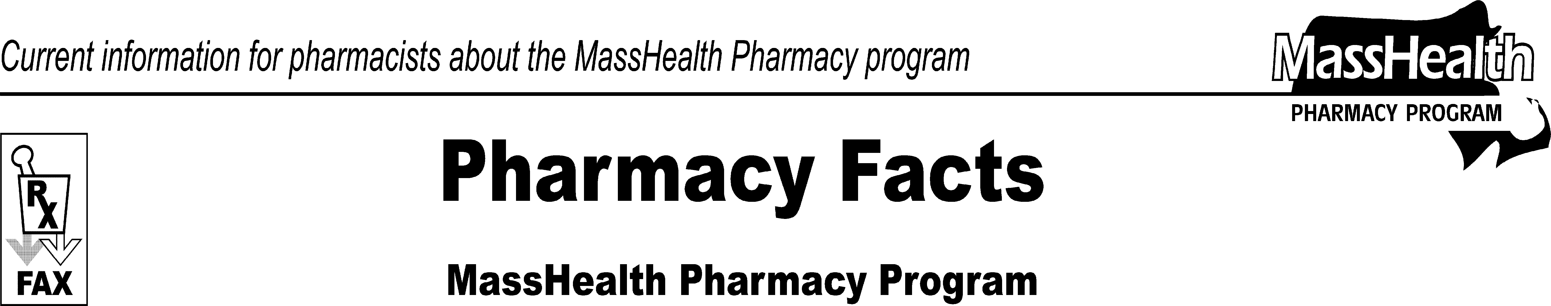
Number 75
December 28, 2012

Please direct any questions or comments (or to be taken off of this fax distribution) to
Victor Moquin of ACS at 617-423-9830.

