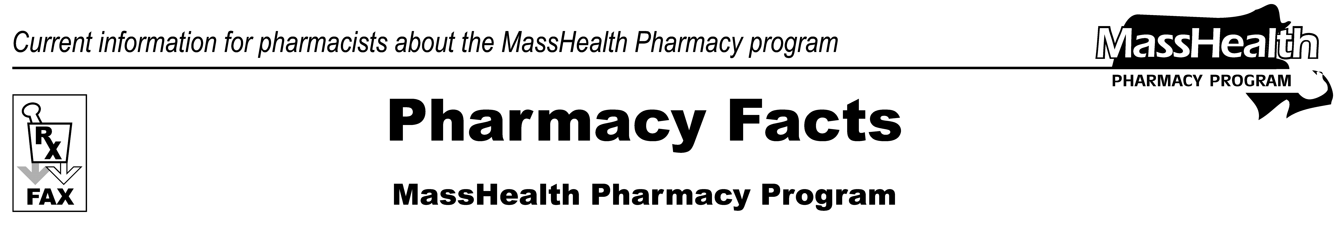
www.mass.gov/masshealth/pharmacy
Number 81
September 30, 2013
Editor: Vic Vangel • Contributors: Chris Burke, Gary Gilmore, Paul Jeffrey, Kim Lenz, James Monahan, Nancy Schiff
MHDL Updates  Below are certain updates to the MassHealth Drug List (MHDL). See the MHDL for a complete list of updates.  - Additions  The following newly marketed drugs have been added to the MassHealth Drug List as of September 30, 2013.  BIVIGAM (immune globulin IV, human) – PA  Cystaran (cysteamine ophthalmic) – PA  dextroamphetamine 2.5 mg and 7.5 mg tablets – PA  Minastrin 24 FE (ethinyl estradiol/norethindrone/ ferrous fumarate chewable)  Namenda XR (memantine ER) – PA  Quartette (levonorgestrel/ethinyl estradiol)  Revlimid (lenalidomide 20 mg) – PA > 21 units / 28 days  Tafinlar (dabrafenib) – PA  Vecamyl (mecamylamine) – PAKyprolis  (carfilzomib) – PA  - Change in Prior Authorization Status  - The following topical anesthetic will be covered without prior authorization regardless of quantity or days of treatment effective September 30, 2013.  Lidocaine/prilocaine  - The following agents will be covered without prior authorization within newly established quantity limits, effective September 30, 2013.  Imitrex # (sumatriptan tablet) – PA > 18 units/month  Maxalt # (rizatriptan tablet) – PA > 18 units/month  - The following vitamin D analogue will require prior authorization above quantity limits as listed below effective October 14, 2013.  Calcitrene (calcipotriene ointment) – PA > 60 grams/month  - The following tricyclic antidepressant will require prior authorization effective October 14, 2013.  Anafranil (clomipramine) – PA | 3. Corrections / Clarifications  - The following drugs have been added to the MassHealth Drug List. They were omitted in error. This does not reflect any change in MassHealth policy.  Alsuma (sumatriptan injection) – PA  Moxatag (amoxicillin extended-release) – PA  Nexplanon (etonogestrel implant))  - The following listings have been clarified. These changes do not reflect any change in MassHealth policy.  desvenlafaxine ER – PA  Dexedrine # (dextroamphetamine 5 mg, 10 mg, 15 mg capsule and tablet) – PA > 90 units/month  dextroamphetamine solution – PA > 900 ml/month  Ferrlecit # (sodium ferric gluconate complex)  Pristiq (desvenlafaxine succinate ER) – PA  Suclear Bowel Prep Kit (polyethylene glycol electrolyte solution) – PA  Travatan Z (travoprost 0.004% eye drop) – PA  travoprost 0.004% eye drop – PA  # This is a brand-name drug with FDA “A” -rated generic equivalents. Prior authorization is required for the brand, unless a particular form of that drug (for example, tablet, capsule, or liquid) does not have an FDA “A” -rated generic equivalent.  ^{PA} Prior authorization is required, The .prescriber must obtain prior authorization for the drug in order for the pharmacy to receive payment.plee
Please direct any questions or comments (or to be taken off this fax distribution) to
Victor Moquin of Xerox at 617-423-9830.

