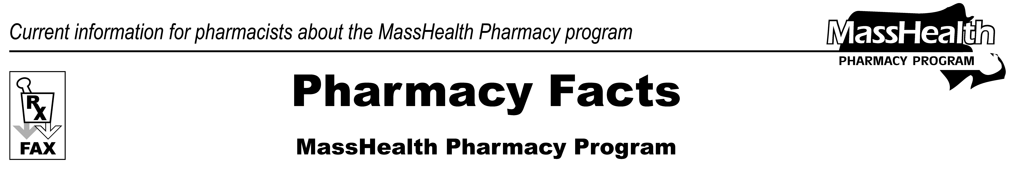
www.mass.gov/masshealth/pharmacy
Number 84
July 10, 2014
• Editor: Vic Vangel • Contributors: Paul Jeffrey, Kim Lenz, James Monahan, Nancy Schiff •
MassHealth Provider Enrollment Revalidation  Most pharmacies will be selected for revalidation of their provider enrollment information this year.  As required by the Affordable Care Act, MassHealth has begun revalidation activity using new enrollment screening criteria. The first step of revalidation must be completed using the Provider Online Service Center (POSC) web page: https://newmmis-portal.ehs.state.ma.us/EHSProviderPortal/appmanager/provider/desktop.  Upon completing the above step, pharmacies must complete and submit an original signed Federally Required Disclosures form, available at following link: www.mass.gov/eohhs/docs/masshealth/provider-services/forms/pe-frd.pdf.  This revalidation initiative focuses on providers enrolled on or before March 25, 2011. If your pharmacy enrolled as a MassHealth provider after that date, you must complete revalidation within five years from the date of your initial enrollment. Failure to complete revalidation will affect your MassHealth enrollment status and may result in sanctions.  Pharmacies receiving revalidation letters from MassHealth must complete the POSC revalidation process and return a completed Federally Required Disclosures form within 45 days of the date on the revalidation letter. Certain pharmacies with durable medical equipment (DME) specialties will also require a site visit to validate the facility, credentials, and other business aspects.  All applicable pharmacies should anticipate the need to revalidate their enrollment information within the next six months. | When preparing to complete the POSC revalidation step, please ensure that each location has access to log in to the POSC. If access is needed, please complete and submit a Data Collection form, available at the following link: www.mass.gov/eohhs/docs/masshealth/provider-services/forms/posc-dc.pdf.  For additional information, please refer to the MassHealth All Provider Bulletin 242 (March 2014): www.mass.gov/eohhs/docs/masshealth/bull-2014/all-242.pdf.  You can also visit the MassHealth Revalidation web page for further information, including a FAQ and the Revalidation Job Aid. Go to www.mass.gov/eohhs/provider/insurance/masshealth/provider-enrollment, and click on Provider Revalidation.  If you have questions about provider revalidation, please contact the MassHealth Customer Services Center at 1-800-841-2900 or e-mail your inquiry to providersupport@mahealth.net.
Please direct any questions or comments (or to be taken off of this fax distribution) to
Victor Moquin of Xerox at 617-423-9830.

