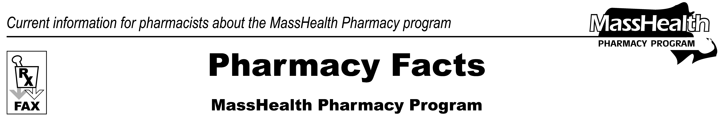
www.mass.gov/masshealth/pharmacy
Number 85
July 28, 2014
• Editor: Vic Vangel • Contributors: Paul Jeffrey, Kim Lenz, James Monahan, Nancy Schiff •
MHDL Update  Below are certain updates to the MassHealth Drug List (MHDL). See the MHDL for a complete listing of updates.  1. Additions  Effective August 4, 2014, the following newly marketed drugs have been added to the MassHealth Drug List.  Adasuve (loxapine oral inhalation powder)^{H}  Aerospan (flunisolide inhalation aerosol)  ALPROLIX (factor IX recombinant, Fc fusion protein)  Copaxone (glatiramer 40 mg) – PA  Farxiga (dapagliflozin) – PA  Fycompa (perampanel) – PA  Imbruvica (ibrutinib) – PA  Luzu (lliconazole) – PA  Noxafil (posaconazole delayed-release tablet) – PA  Otrexup (methotrexate subcutaneous injection) – PA  Tretten (factor XIII A-subunit recombinant)  Versacloz (clozapine suspension) – PA  VIMIZIM (elosulfase alfa) – PA  Zohydro ER (hydrocodone extended-release) – PA  2. Change in Prior Authorization Status  - Effective August 4, 2014, the following non-stimulant attention deficit hyperactivity disorder (ADHD) agent will no longer require prior authorization.  Strattera (atomoxetine)  - Effective August 4, 2014, the following lipid lowering agents will be covered without prior authorization within newly established quantity limits.  Lipitor # (atorvastatin 10 mg, 20 mg, 40 mg)  – PA > 45 units/month  Lipitor # (atorvastatin 80 mg)  – PA > 30 units/month  - Effective August 18, 2014, the following intranasal corticosteroid agents will require prior authorization regardless of age and quantity.  Nasacort AQ (triamcinolone nasal spray) – PA  Nasonex (mometasone nasal spray) – PA  Veramyst (fluticasone furoate nasal spray) – PA | 3. MassHealth Over-the-Counter Drug List  - Effective August 4, 2014, the following product will be added to the MassHealth Over-the-Counter Drug List as covered.  methylcellulose  - Effective August 4, 2014, the following product will be added to the MassHealth Over-the-Counter Drug List as covered within the quantity limit.  Nasacort Allergy 24HR (triamcinolone) < 1 inhaler/month  PA Prior authorization is required. The prescriber must obtain prior authorization for the drug in order for the pharmacy to receive payment. Note: Prior authorization applies to both the brand-name and the FDA “A”-rated generic equivalent of listed product.  # This designates a brand-name drug with FDA “A”-rated generic equivalents. Prior authorization is required for the brand, unless a particular form of that drug (for example, tablet, capsule, or liquid) does not have an FDA “A”-rated generic equivalent.  * The generic OTC and, if any, generic prescription versions of the drug are payable under MassHealth without prior authorization.  ̂ This drug is available through the health care professional who administers the drug. MassHealth does not pay for this drug to be dispensed through a retail pharmacy.  ^{H} This drug is available only in an inpatient hospital setting. MassHealth does not pay for this drug to be dispensed through the retail pharmacy or physician's office.
Please direct any questions or comments (or to be taken off of this fax distribution) to
Victor Moquin of Xerox at 617-423-9830.

