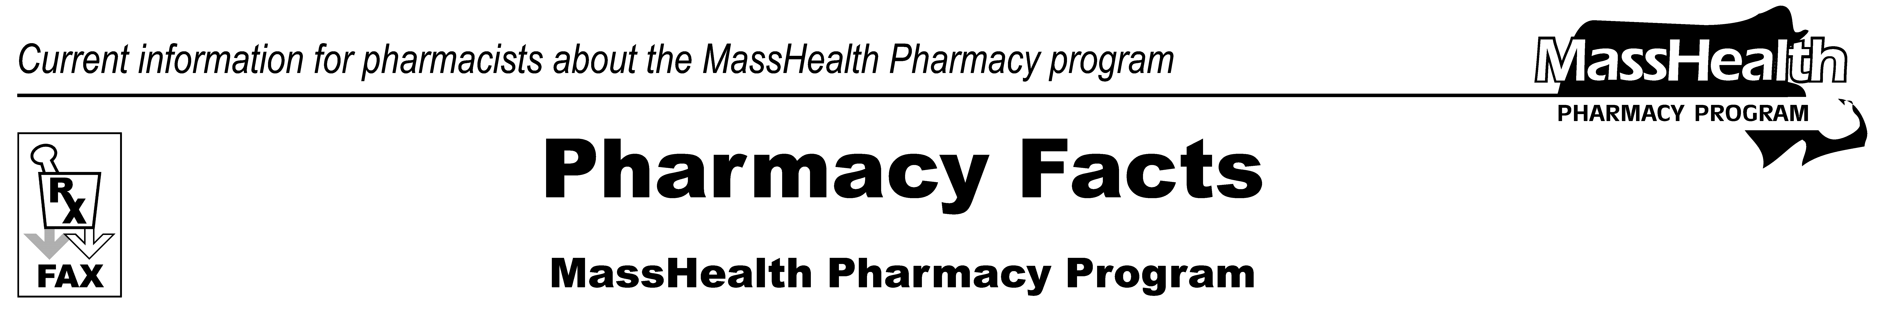
www.mass.gov/masshealth/pharmacy
Number 87
March 16, 2015
Page 1 of 2
• Editor: Vic Vangel • Contributors: Paul Jeffrey, Kim Lenz, James Monahan, Nancy Schiff •
MHDL Update  Below are certain updates to the MassHealth Drug List (MHDL). See the MHDL for a complete listing of updates.  1. Additions  Effective March 16, 2015, the following newly marketed drugs have been added to the MassHealth Drug List.  Beleodaq (belinostat) – PA  Bunavail (buprenorphine/naloxone buccal film) – PA  Dalvance (dalbavancin) – PA  ELOCTATE (factor VIII recombinant, Fc fusion protein)  Evzio (naloxone auto-injection) – PA  HyQvia (immune globulin subcutaneous injection, human/hyaluronidase human recombinant) – PA  Jardiance (empagliflozin) – PA  JUBLIA (efinaconazole) – PA  Kerydin (tavaborole) – PA  Northera (droxidopa) – PA  Plegridy (peginterferon beta-1a)  PURIXAN (mercaptopurine oral suspension) – PA  Rasuvo (methotrexate subcutaneous injection) – PA  Ryanodex (dantrolene injection suspension) ̂  SIVEXTRO (tedizolid injection) – PA  SIVEXTRO (tedizolid tablet) – PA  Spiriva Respimat (tiotropium inhalation solution) – PA > 1 inhaler/month  STRIVERDI (olodaterol) – PA  Triumeq (abacavir/dolutegravir/lamivudine)  Viekira Pak (ombitasvir/paritaprevir/ritonavir/dasabuvir) – PA  Xarelto (rivaroxaban starter pack) – PA  Zydelig (idelalisib) – PA  2. Change in Prior Authorization Status  - Effective March 16, 2015, the following antiretroviral agents no longer require prior authorization.  Edurant (rilpivirine)  Stribild (elvitegravir/cobicistat/emtricitabine/tenofovir)  - Effective March 16, 2015, the following oral antidiabetic agent no longer requires prior authorization.  Actos # (pioglitazone) | - Effective March 16, 2015, the following topical antifungal agent no longer requires prior authorization.  Penlac # (ciclopirox 8% nail lacquer)  - Effective March 16, 2015, the following topical antifungal agent no longer requires prior authorization within newly established age limits.  nystatin/triamcinolone cream, ointment – PA ≥ 17 years  - Effective March 16, 2015, the following topical vasodilator agent no longer requires prior authorization.  Rectiv (nitroglycerin 0.4% ointment)  - Effective March 16, 2015, the following urinary antispasmodic agent no longer requires prior authorization.  Detrol LA # (tolterodine extended-release 4 mg)  - Effective March 16, 2015, the following urinary antispasmodic agent is covered without prior authorization within newly established quantity limits.  Detrol LA # (tolterodine extended-release 2 mg) – PA > 30 units/month  - Effective March 30, 2015, the following iron product will require prior authorization.  INFeD (low molecular weight iron dextran) – PA  - Effective March 30, 2015, the following epinephrine auto-injection products will require prior authorization.  ADRENACLICK (epinephrine auto-injection) – PA  Auvi-Q (epinephrine auto-injection) – PA

3. Updated and New Pharmacy Initiatives

Pain Initiative
Effective March 30, 2015 the use of the following high dose short-acting opioid analgesic agents as monotherapy will require prior authorization:

codeine products > 360 mg/day
Dilaudid (hydromorphone) > 64 mg/day
morphine immediate-release > 240 mg/day
Opana (oxymorphone immediate-release) > 80 mg/day
oxycodone immediate-release > 160 mg/day

PA Prior authorization is required. The prescriber must obtain prior authorization for the drug in order for the pharmacy to receive payment. Note: Prior authorization applies to both the brand-name and the FDA “A”-rated generic equivalent of listed product.

# This designates a brand-name drug with FDA “A”-rated generic equivalents. Prior authorization is required for the brand, unless a particular form of that drug (for example, tablet, capsule, or liquid) does not have an FDA “A”-rated generic equivalent.

* The generic OTC and, if any, generic prescription versions of the drug are payable under MassHealth without prior authorization.

̂ This drug is available through the health care professional who administers the drug. MassHealth does not pay for this drug to be dispensed through a retail pharmacy.

^{H} This drug is available only in an inpatient hospital setting. MassHealth does not pay for this drug to be dispensed through the retail pharmacy or physician's office.
Please direct any questions or comments (or to be taken off of this fax distribution) to
Victor Moquin of Xerox at 617-423-9830.
Page 2 of 2
Pharmacy Facts, Number 87

