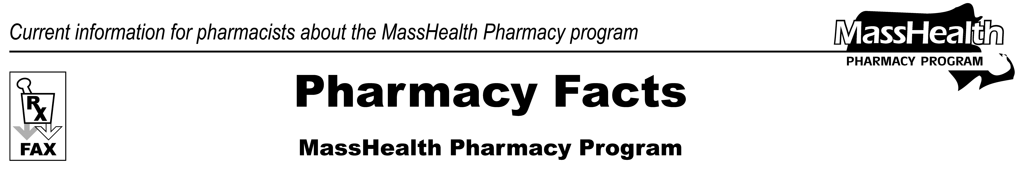
www.mass.gov/masshealth/pharmacy
Number 89
August 14, 2015
Page 1 of 2
• Editor: Vic Vangel • Contributors: Paul Jeffrey, Kim Lenz, James Monahan, Nancy Schiff •
Nasal Naloxone Rescue Kits  Background  The purpose of this edition of Pharmacy Facts is to inform pharmacies about Nasal Naloxone Rescue Kits and how to bill MassHealth for their distribution. Naloxone is an opioid receptor antagonist and is used as an antidote to opioid overdose. Naloxone reverses the effects of respiratory depression and central nervous system depression, such as sedation following heavy opioid use, thus decreasing the likelihood of death following an overdose. Naloxone may be administered intravenously, intramuscularly, or subcutaneously. Naloxone can also be administered intranasally using a nasal adaptor (also called an atomizer or mucosal atomization device). Individuals without medical backgrounds often prefer intranasal administration, as it does not require handling needles.  The Department of Public Health (DPH) has created a pamphlet that includes information about how to respond to an opioid overdose, and how to assemble the nasal adaptor.  This pamphlet can be found at  www.mass.gov/eohhs/docs/dph/quality/boards/pharmacy/naloxone-pamphlet.pdf.  Additional information on the Opioid Overdose Prevention and Reversal Project can be found at www.mass.gov/eohhs/docs/dph/substance-abuse/naloxone-info.pdf.  Pharmacy Standing Orders for Distributing Nasal Naloxone Rescue Kits  In Massachusetts, Nasal Naloxone Rescue Kits are available through standing order prescriptions in pharmacies, and through individual prescriptions.  A pharmacy standing order allows a pharmacy to distribute a Nasal Naloxone Rescue Kit to an  individual at risk of experiencing an opioid overdose or to a family member or friend of such an | individual without a prescription from that individual’s prescriber. A standing order for Nasal Naloxone Rescue Kits between a prescriber and pharmacy is permitted by the Drug Control Program at DPH and by the Board of Registration in Pharmacy. Standing orders must be signed by a physician licensed in Massachusetts, must be maintained on file, and must be readily retrievable at participating pharmacies. Pharmacies must file standing orders with the Board of Registration in Pharmacy via e-mail.  DPH has posted an example of a standing order for dispensing of naloxone at http://www.mass.gov/eohhs/gov/departments/dph/programs/hcq/dhpl/pharmacy/dispensing-of-naloxone-by-standing-order-.html.  The example standing order describes what to include in a Nasal Naloxone Rescue Kit as follows:  “Nasal Naloxone Rescue Kits contain the following, at a minimum:  - two 2 mL Luer-Jet-Lock syringes prefilled with naloxone (concentration: 1 mg/mL);  - two mucosal atomization devices; and  - patient information pamphlet with overdose prevention information and step-by-step instructions for overdose responses and naloxone administration.”  The “patient information pamphlet” referenced above is available at www.mass.gov/eohhs/docs/dph/quality/boards/pharmacy/naloxone-pamphlet.pdf.  Billing MassHealth for the Nasal Naloxone Rescue Kit  MassHealth will pay a pharmacy for a Nasal Naloxone Rescue Kit dispensed for a MassHealth member

Billing MassHealth for the Nasal Naloxone Rescue Kit (cont.)  under a standing order. MassHealth also pays for Nasal Naloxone Rescue Kits dispensed with a prescription for a MassHealth member by any pharmacy regardless of whether the pharmacy has a standing order for Nasal Naloxone Rescue Kits.  How to Dispense and Bill MassHealth for a Nasal Naloxone Rescue Kit  Please dispense:  Two 2mL prefilled Luer-Jet-Lock naloxone syringes (concentration 1 mg/mL)  PLUS  Two mucosal atomization devices (i.e. nasal adaptors)  PLUS  The DPH Naloxone Pamphlet  Please bill MassHealth for:  Two 2mL prefilled Luer-Jet-Lock naloxone syringes (concentration 1 mg/mL).  Dispensing pharmacists must attest via signature on the back of the prescription that two mucosal atomization devices (nasal adaptors) were dispensed with the naloxone syringes.  MassHealth will reimburse the pharmacy for the two naloxone syringes plus an additional $9.96 for the two nasal adaptors ($4.98 per adaptor). This $9.96 payment will be added to the naloxone claim payment.  Patient Counseling  When dispensing a Nasal Naloxone Rescue Kit, a pharmacist should counsel on appropriate use. In addition to directing the member to the pamphlet included in the Nasal Naloxone Rescue Kit, the pharmacist should advise the member as follows:  - Naloxone should only be used during an emergency and is an antidote for opioids only.  - After assembling the atomizer, half of the naloxone dose (1 mL) should be administered in each nostril. Naloxone can take up to  eight minutes to have an effect and will last  approximately 30 to 90 minutes. As most | opioids last longer than 30 to 90 minutes, the effects of naloxone may wear off before the effects of the opioids wear off and patients can go back into overdose.  - Do not administer naloxone if the solution appears discolored, cloudy, or contains solid particles.  - Remember to check the expiration date of this medication at regular intervals.  - The patient may experience symptoms of withdrawal. It is important to prevent additional opioid usage.
Please direct any questions or comments (or to be taken off of this fax distribution) to
Victor Moquin of Xerox at 617-423-9830.
Page 2 of 2
Pharmacy Facts, Number 89

