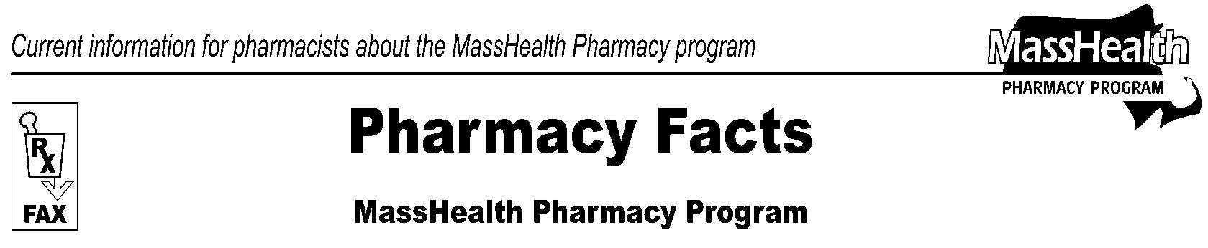
Page 1 of 2
Number 90
October 19, 2015
www.mass.gov/masshealth/pharmacy
• Editor: Vic Vangel • Contributors: Paul Jeffrey, Kim Lenz, James Monahan, Nancy Schiff •

MHDL Update

Below are certain updates to the MassHealth Drug List (MHDL). See the MHDL for a complete listing of updates.

- Additions

Effective October 13, 2015, the following newly marketed drugs have been added to the MassHealth Drug List.

Afrezza (insulin human inhalation powder) – PA
amphetamine sulfate – PA
Avycaz (ceftazidime/avibactam) – PA
Belsomra (suvorexant) – PA
BEXSERO (meningococcal group B vaccine)
bimatoprost 0.03% ophthalmic solution – PA
Cholbam (cholic acid) – PA
Cosentyx (secukinumab) – PA
CRESEMBA (isavuconazonium) – PA
duloxetine 40 mg – PA
IBRANCE (palbociclib) – PA
IXINITY (factor IX human recombinant)
Jadenu (deferasirox 90 mg, 180 mg, 360 mg)
LENVIMA (lenvatinib) – PA
levoleucovorin 175mg/17.5 mL injection – PA
Liletta (levonorgestrel-releasing intrauterine system 52 mg)
Movantik (naloxegol) – PA
Natesto (testosterone nasal gel) – PA
NUVESSA (metronidazole 1.3% vaginal gel) - PA
OMIDRIA (phenylephrine/ketorolac)^
Rytary (carbidopa/levodopa extended-release) – PA
Signifor LAR (pasireotide injectable suspension) – PA
Sotylize (sotalol solution) – PA
Toujeo (insulin glargine 300 units/mL prefilled syringe) – PA

- Change in Prior Authorization Status

- Effective October 13, 2015, the following dermatological agents will no longer require prior authorization.

Lac-Hydrin # (ammonium lactate)
LAClotion # (ammonium lactate)

- Effective October 13, 2015, the following ophthalmic anti-inflammatory agents will no longer require prior authorization.

Flarex (fluorometholone acetate)
prednisolone sodium phosphate ophthalmic solution

- Effective October 13, 2015, the following electrolyte agent will no longer require prior authorization.

Urocit-K # (potassium citrate 15 meq)

- Effective October 13, 2015, the following antihypertensives will no longer require prior authorization.

Avalide # (irbesartan/hydrochlorothiazide)
Avapro # (irbesartan)
Diovan # (valsartan)
Diovan HCT # (valsartan/hydrochlorothiazide)

- Effective October 26, 2015, the following headache therapy agents will require prior authorization for all ages and quantities.

butalbital 50 mg/acetaminophen 325 mg – PA
Fiorinal/Codeine (butalbital/aspirin/caffeine/codeine) – PA

- Effective October 26, 2015, the following antiviral agents will require prior authorization for exceeding the new quantity limits.

Relenza (zanamivir) – PA all quantities (June 1st to September 30th); PA < 5 years of age and > 20 inhalations/season (October 1st to May 31st)
Tamiflu (oseltamivir 30mg) – PA all quantities (June 1st to September 30th); PA > 20 capsules/season (October 1st to May 31st)
Tamiflu (oseltamivir 45 mg and 75 mg) – PA all quantities (June 1st to September 30th); PA > 10 capsules/season (October 1st to May 31st)
Tamiflu (oseltamivir 6 mg/mL suspension) – PA all quantities (June 1st to September 30th); PA > 180 mL/season (October 1st to May 31st)

- Effective October 26, 2015, the following kinase inhibitor will require prior authorization for all quantities.

Afinitor (everolimus) – PA

- Effective October 26, 2015, the following kinase inhibitors will require prior authorization.

Afinitor Disperz (everolimus tablets for oral suspension) – PA
Nexavar (sorafenib) – PA
Sutent (sunitinib) – PA

- Effective October 26, 2015, the following vaginal antibiotics will require prior authorization.

Cleocin Vaginal Ovule (clindamycin vaginal suppository) – PA
Clindesse (clindamycin vaginal cream) – PA

- Effective October 26, 2015, the following topical corticosteroids will require prior authorization.

amcinonide cream – PA
amcinonide ointment – PA
diflorasone cream – PA
diflorasone ointment – PA
Temovate (clobetasol propionate cream, ointment) – PA

- Effective October 26, 2015, the following hormone agent will require prior authorization.

Miacalcin (calcitonin salmon injection) – PA

- Effective October 26, 2015, the following antihypertensives will require prior authorization.

captopril – PA
captopril/hydrochlorothiazide – PA
Corgard (nadolol) – PA

PA Prior authorization is required. The prescriber must obtain prior authorization for the drug in order for the pharmacy to receive payment. Note: Prior authorization applies to both the brand-name and the FDA “A”-rated generic equivalent of listed product.

# This designates a brand-name drug with FDA “A”-rated generic equivalents. Prior authorization is required for the brand, unless a particular form of that drug (for example, tablet, capsule, or liquid) does not have an FDA “A”-rated generic equivalent.

* The generic OTC and, if any, generic prescription versions of the drug are payable under MassHealth without prior authorization.

̂ This drug is available through the health care professional who administers the drug. MassHealth does not pay for this drug to be dispensed through a retail pharmacy.

Please direct any questions or comments (or to be taken off of this fax distribution) to
Victor Moquin of Xerox at 617-423-9830.

