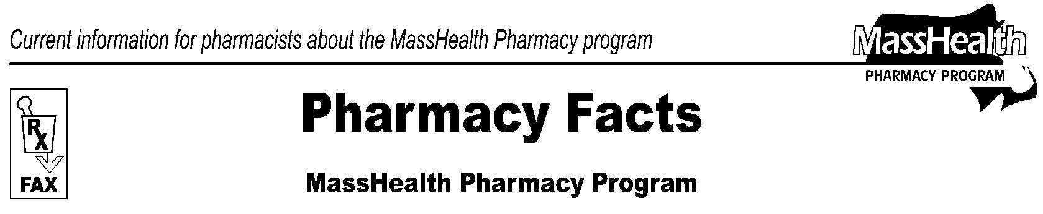
Page 1 of 2
Number 91
January 26, 2016
www.mass.gov/masshealth/pharmacy
• Editor: Vic Vangel • Contributors: Paul Jeffrey, Kim Lenz, James Monahan, Nancy Schiff •

MHDL Update
Below are certain updates to the MassHealth Drug List (MHDL). See the MHDL for a complete listing of updates.

- Additions

Effective February 8, 2016, the following newly marketed drugs have been added to the MassHealth Drug List.

Aptensio XR (methylphenidate extended-release) –
PA < 3 years and PA > 30 units/month
Asmanex HFA (mometasone inhalation aerosol)
Corlanor (ivabradine) – PA
Daklinza (daclatasvir) – PA
Duopa (carbidopa/levodopa enteral suspension) – PA
Entresto (sacubitril/valsartan) – PA
Farydak (panobinostat) – PA
Finacea (azelaic acid foam) – PA
Invega Trinza (paliperidone extended-release 3-month injection) – PA < 6 years and PA > 1 unit/3 months
Namzaric (memantine extended-release/donepezil) – PA
Natpara (parathyroid hormone) – PA
Opdivo (nivolumab) – PA
Orkambi (lumacaftor/ivacaftor) – PA
phenoxybenzamine – PA
Praluent (alirocumab) – PA
Proair Respiclick (albuterol inhalation powder) – PA
Repatha (evolocumab) – PA
Rexulti (brexpiprazole) – PA
Stiolto (tiotropium/olodaterol) – PA
Synjardy (empagliflozin/metformin) – PA
Technivie (ombitasvir/paritaprevir/ritonavir) – PA
Tivorbex (indomethacin 20 mg, 40 mg) – PA
Zarxio (filgrastim-sndz)
Zecuity (sumatriptan iontophoretic transdermal system) – PA
Zingo (lidocaine powder intradermal injection system) – PA

- Change in Prior Authorization Status

- Effective February 8, 2016, the following headache therapy agent will no longer require prior authorization within quantity limits.

Maxalt MLT # (rizatriptan orally disintegrating tablet) – PA > 18 units/month

- Effective February 8, 2016, the following leukotriene modifiers will no longer require prior authorization.

Singulair # (montelukast tablet, chewable tablet)

- Effective February 8, 2016, the following colony stimulating factor will no longer require prior authorization.

Neupogen (filgrastim)

- Effective February 8, 2016, the following opioid dependence agent will no longer require prior authorization within dose and duration of therapy limits.

Suboxone (buprenorphine/naloxone film ≤ 16 mg/day)
Suboxone (buprenorphine/naloxone film) –
PA > 180 days (> 16 mg/day and ≤ 24 mg/day)
Suboxone (buprenorphine/naloxone film) –
PA > 90 days (> 24 mg/day and ≤ 32 mg/day)
Suboxone (buprenorphine/naloxone film) –
PA > 32 mg/day

- Effective March 7, 2016, the following nonsteroidal anti-inflammatory agents will require prior authorization.

diflunisal – PA
fenoprofen 600 mg – PA
salsalate – PA

- Effective March 7, 2016, the following opioid analgesic will require prior authorization.

Buprenex (buprenorphine injection) – PA

- Effective March 7, 2016, the following topical antibiotic will require prior authorization.

Evoclin (clindamycin foam) – PA

- Effective March 7, 2016, the following antimalarial agent will require prior authorization.

Daraprim (pyrimethamine) – PA

- Effective March 7, 2016, the following opioid dependence agent will require prior authorization for all doses.

buprenorphine/naloxone tablet – PA

- Effective March 7, 2016, the following opioid analgesic agents will require prior authorization for all doses.

Dolophine (methadone oral) – PA
Methadose (methadone oral) – PA

- Effective March 7, 2016, the opioid analgesic agents will have updated high dose and/or quantity limit restrictions as described in Table 8: Opioids and Analgesics as well as the Pain Initiative. As a result, the following listings will change.

Astramorph-PF (morphine, injection) – PA > 120 mg/day
Dilaudid # (hydromorphone) – PA > 32 mg/day
Duragesic # (fentanyl 12, 25, 50 mcg/hr transdermal system) – PA > 50 mcg/hr and PA > 10 patches/month
Duragesic (fentanyl 75, 100 mcg/hr transdermal system) – PA
Duramorph (morphine, injection) – PA > 120 mg/day
hydrocodone/acetaminophen – PA > 80 mg/day
levorphanol tablet – PA > 4 mg/day
morphine immediate-release – PA > 120 mg/day
MS Contin # (morphine controlled-release tablet) – PA > 120 mg/day
oxycodone/acetaminophen – PA > 80 mg/day
oxycodone/aspirin – PA > 4 grams of aspirin/day
Percocet # (oxycodone/acetaminophen) –
PA > 80 mg/day
Roxicodone # (oxycodone immediate-release) –
PA > 80 mg/day
Vicoprofen # (hydrocodone 7.5 mg/ibuprofen) –
PA > 80 mg/day

PA – Prior authorization is required. The prescriber must obtain prior authorization for the drug in order for the pharmacy to receive payment. Note: Prior authorization applies to both the brand-name and the FDA “A”-rated generic equivalent of listed product.

# – This designates a brand-name drug with FDA
“A”-rated generic equivalents. Prior authorization is required for the brand, unless a particular form of that drug (for example, tablet, capsule, or liquid) does not have an FDA “A”-rated generic equivalent.

̂ – This drug is available through the health care professional who administers the drug. MassHealth does not pay for this drug to be dispensed through a retail pharmacy.

H – This drug is available only in an inpatient hospital setting. MassHealth does not pay for this drug to be dispensed through the retail pharmacy or physician's office.

