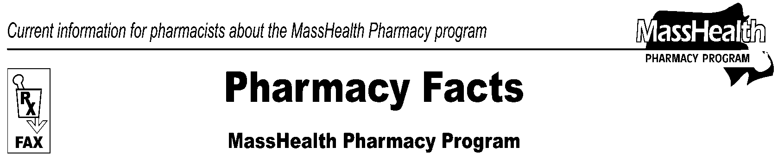
Page 1 of 2
Number 96
October 27, 2016
www.mass.gov/masshealth/pharmacy
• Editor: Vic Vangel • Contributors: Paul Jeffrey, Kim Lenz, James Monahan, Nancy Schiff •
MHDL Update  - Additions  Effective October 31, 2016, the following newly marketed drugs have been added to the MassHealth Drug List.  Afstyla (antihemophilic factor, recombinant, single chain)  Briviact (brivaracetam solution, tablet) – PA  butalbital 25 mg/acetaminophen 325 mg tablet – PA  Byvalson (nebivolol/valsartan) – PA  Cabometyx (cabozantinib tablet) – PA  Cinqair (reslizumab) – PA  Levo-T # (levothyroxine)  Nuplazid (pimavanserin) – PA  Ocaliva (obeticholic acid) – PA  Onzetra (sumatriptan nasal powder) – PA  Probuphine (buprenorphine implant)^ – PA  Qbrelis (lisinopril solution) – PA  Tecentriq (atezolizumab) – PA  Vaxchora (cholera vaccine, live, oral)1  Venclexta (venetoclax) – PA  Viekira XR (dasabuvir/ombitasvir/paritaprevir/ritonavir extended-release) – PA  Vonvendi (von willebrand factor, recombinant)  Xtampza (oxycodone extended-release capsule) – PA  Zembrace (sumatriptan injection) – PA  Zinbryta (daclizumab) – PA  - Change in Prior Authorization Status  - Effective October 31, 2016, the chewable tablet and oral suspension formulations of the following antiviral agent will no longer require prior authorization.  Isentress (raltegravir)  - Effective October 31, 2016, the following immunosuppressant will no longer require prior authorization.  Envarsus XR (tacrolimus extended-release tablet)  - Effective October 31, 2016, the following phosphate binding agents will no longer require prior authorization.  Auryxia (ferric citrate)  Fosrenol (lanthanum)  Velphoro (sucroferric oxyhydroxide) | Change in Prior Authorization Status, cont’d  - Effective October 31, 2016, the following antidepressant agents will no longer require prior authorization within age limits. Pediatric Behavioral Health Medication Initiative criteria will still apply. For additional information, please see the Pediatric Behavioral Health Medication Initiative documents found at www.mass.gov/druglist.  Cymbalta # (duloxetine 20 mg, 30 mg, 60 mg) – PA < 6 years  Prozac # (fluoxetine 40 mg capsule) – PA < 6 years  - Effective October 31, 2016, the following topical anesthetic agent will no longer require prior authorization within quantity limits.  Lidoderm # (lidocaine patch) – PA > 90 patches/mo.  - Effective October 31, 2016, the following lipid lowering agent will no longer require prior authorization within quantity limits.  Crestor # (rosuvastatin 5 mg, 10 mg, 20 mg) – PA > 45 units/mo.  Crestor # (rosuvastatin 40 mg) – PA > 30 units/mo.  - Effective October 31, 2016, the following non-stimulant Attention Deficit Hyperactivity Disorder (ADHD) agent will no longer require prior authorization within age limits. Pediatric Behavioral Health Medication Initiative criteria will still apply. For additional information, please see the Pediatric Behavioral Health Medication Initiative documents found at www.mass.gov/druglist.  Intuniv # (guanfacine extended-release) – PA < 3 years  - Effective October 31, 2016, the following proton pump inhibitor will no longer require prior authorization within quantity limits.  omeprazole 40 mg – PA > 60 units/mo.  - Effective October 31, 2016, the following H₂ antagonist will require prior authorization.  Pepcid (famotidine suspension) – PA  - Effective October 31, 2016, the following topical anesthetic agent will require prior authorization.  lidocaine ointment – PA

MHDL Update, cont’d  - MassHealth Supplemental Rebate/Preferred Drug List  Effective October 31, 2016, the following hepatitis antiviral combination agent will be added to the MassHealth Supplemental Rebate/Preferred Drug List.  Epclusa (sofosbuvir/velpatasvir) ^{PD} – PA  - Updated MassHealth Non-Drug Product List  Effective October 31, 2016, the following device has been added to the MassHealth Non-Drug Product List requiring prior authorization.  Gelsyn (hyaluronate) – PA  - MassHealth Brand Name Preferred over Generic Drug List  - Effective October 31, 2016, the following opioid agent will be added to the MassHealth Brand Name Preferred Over Generic Drug List.  Oxycontin (oxycodone extended-release tablet)^{BP} – PA  - Effective October 31, 2016, the following cerebral stimulant agent will be removed from the MassHealth Brand Name Preferred Over Generic Drug List.  Adderall XR (amphetamine salts extended-release) – PA < 3 years and PA > 60 units/mo. | - Corrections / Clarifications  The following drugs have been added to the MassHealth Drug List.  Dekas Essential (multivitamin) – PA  Dekas Plus (multivitamins/minerals/coenzyme Q10) – PA  Dekas Plus (multivitamins/minerals/folic acid/coenzyme Q10) – PA  Egrifta (tesamorelin) – PA  PA Prior authorization is required. The prescriber must obtain prior authorization for the drug in order for the pharmacy to receive payment. Note: Prior authorization applies to both the brand-name and the FDA “A”-rated generic equivalent of listed product.  # This designates a brand-name drug with FDA “A”-rated generic equivalents. Prior authorization is required for the brand, unless a particular form of that drug (for example, tablet, capsule, or liquid) does not have an FDA “A”-rated generic equivalent.  ^ This drug is available through the health care professional who administers the drug. MassHealth does not pay for this drug to be dispensed through a retail pharmacy.
Please direct any questions or comments (or to be taken off of this fax distribution) to
Victor Moquin of Xerox at 617-423-9830.
Pharmacy Facts, Number 96
Page 2 of 2

