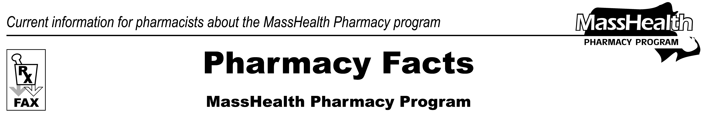
www.mass.gov/masshealth/pharmacy
Number 97
November 21, 2016
Page 1 of 1
• Editor: Vic Vangel • Contributors: Paul Jeffrey, Kim Lenz, James Monahan, Nancy Schiff •

MHDL Update
Below are certain updates to the MassHealth Drug List (MHDL). See the MHDL for a complete listing of updates.

MassHealth Brand Name Preferred Over Generic Drug List
Effective December 1, 2016, the following agents will be added to the MassHealth Brand Name Preferred Over Generic Drug List.
Epzicom (abacavir/lamivudine)
Seroquel XR (quetiapine extended-release 150 mg, 200 mg) – PA < 6 years or ≥ 18 years old and PA > 30 units/month
Seroquel XR (quetiapine extended-release 50 mg, 300 mg and 400 mg) – PA < 6 years or ≥ 18 years and PA > 60 units/month
PA Designation
The “PA” designation indicates that prior authorization is required.
The prescriber must obtain PA for the drug in order for the pharmacy to receive payment. Note: PA applies to both the brand name and the FDA “A”-rated generic equivalent of listed product.
Claims for the brand-name products listed above will be accepted before the December 1, 2016, date. Substitution of the generic equivalent will not be required.

Please direct any questions or comments (or to be taken off this fax distribution) to Victor Moquin of Xerox at 617-423-9830.

