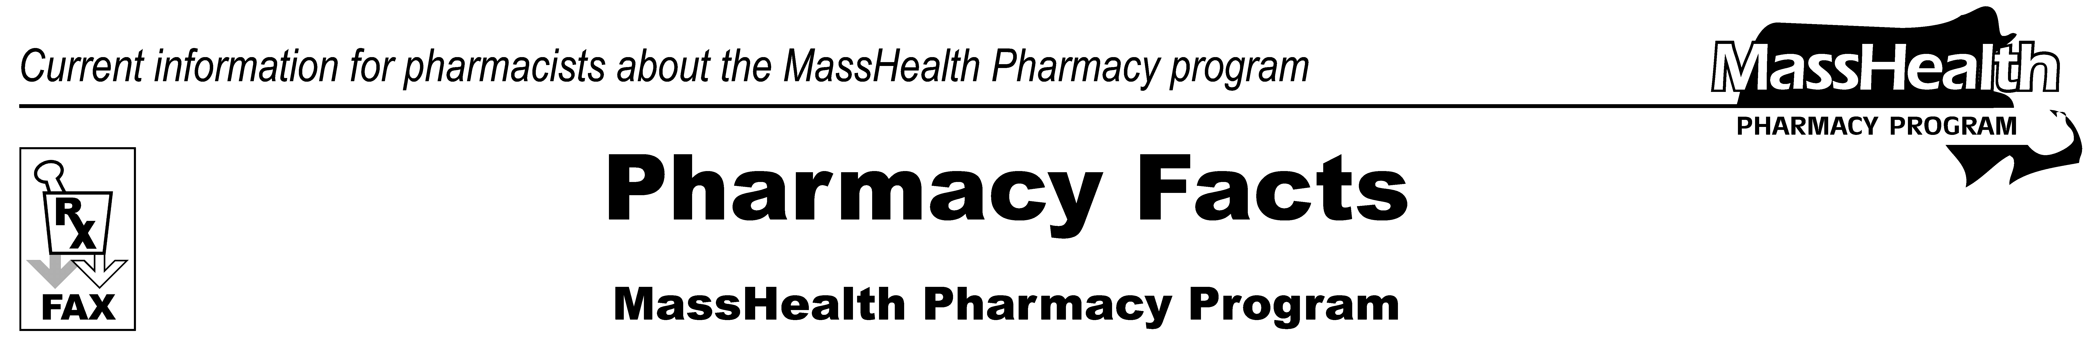
www.mass.gov/masshealth/pharmacy
Number 98
December 21, 2016
Page 1 of 2
• Editor: Vic Vangel • Contributors: Paul Jeffrey, Kim Lenz, James Monahan, Nancy Schiff •

MHDL Update
Below are some updates to the MassHealth Drug List (MHDL). For a complete update listing, see the MHDL.
Additions
Effective January 9, 2017, the following newly marketed drugs have been added to the MassHealth Drug List.
Bevespi (glycopyrrolate/formoterol) – PA
Cuvitru (immune globulin subcutaneous injection, human) – PA
Exondys 51 (eteplirsen) – PA
Gonitro (nitroglycerin sublingual powder) – PA
Invokamet XR (canagliflozin/metformin extended-release) – PA
Jentadueto XR (linagliptin/metformin extended-release) – PA
Kyleena (levonorgestrel-releasing intrauterine system 19.5 mg)
Otovel (ciprofloxacin/fluocinolone) – PA
Taytulla (ethinyl estradiol/norethindrone/ferrous fumarate)
Xiidra (lifitegrast) – PA
Zurampic (lesinurad) – PA
Change in Prior Authorization Status
Effective January 9, 2017, the following oral antidiabetic agents will no longer require prior authorization.
Glyset # (miglitol)
Prandin # (repaglinide)
Starlix # (nateglinide)
Effective January 9, 2017, the following antiemetic agents will require prior authorization with updated quantity limits.
Emend (aprepitant 125 mg powder for oral suspension) – PA > 6 units/28 days
Emend (aprepitant 40 mg and 125 mg capsule) – PA > 2 capsules/28 days
Emend (aprepitant 80 mg) – PA > 4 capsules/28 days
Effective January 9, 2017, the following antiemetic agent will require prior authorization when exceeding newly established quantity limits.
Emend (aprepitant trifold pack) – PA > 2 packs/28 days
Effective January 9, 2017, the following antiemetic agent will no longer require prior authorization.
Zofran ODT # (ondansetron orally disintegrating tablet 8 mg)
Effective January 9, 2017, the following opioid dependence agent will no longer be restricted to the health care professional who administers the drug.
Probuphine (buprenorphine implant) – PA
Effective January 9, 2017, the following antianxiety agent will require prior authorization for all ages.
meprobamate – PA
Effective January 9, 2017, the following urinary antispasmodic agents will require prior authorization for all strengths and quantities.
Enablex (darifenacin) – PA
Toviaz (fesoterodine) – PA
Effective January 9, 2017, the following anti-anginal agents will require prior authorization.
Nitrolingual (nitroglycerin lingual spray) – PA
Nitromist (nitroglycerin lingual aerosol) – PA
MassHealth Brand Name Preferred Over Generic Drug List
Effective January 9, 2017, the following antiretroviral agents will be added to the MassHealth Brand Name Preferred Over Generic Drug List.
Kaletra (lopinavir/ritonavir) ^{BP}
Norvir (ritonavir) ^{BP}
Effective January 9, 2017, the following antiviral agent will be added to the MassHealth Brand Name Preferred over Generic Drug List.
Tamiflu (oseltamivir 30mg) ^{BP} – PA all quantities (June 1 to September 30); PA > 20 capsules/season (October 1 to May 31)
Tamiflu (oseltamivir 45 mg and 75 mg) ^{BP} – PA all quantities (June 1 to September 30); PA > 10 capsules/season (October 1 to May 31)
Tamiflu (oseltamivir 6 mg/mL suspension) ^{BP} – PA all quantities (June 1 to September 30); PA > 180 mL/season (October 1 to May 31)
Effective January 9, 2017, the following lipid- lowering agent will be added to the MassHealth Brand Name Preferred over Generic Drug List.
Zetia (ezetimobe) ^{BP} – PA
Effective January 9, 2017, the following antiviral agent will be removed from the MassHealth Brand Name Preferred Over Generic Drug List.
Baraclude # (entecavir tablet) – PA > 30 units/month
Legend
PA Prior authorization is required. The prescriber must obtain prior authorization for the drug in order for the pharmacy to receive payment. Note: Prior authorization applies to both the brand-name and the FDA “A”-rated generic equivalent of listed product.
# This designates a brand-name drug with FDA “A”-rated generic equivalents. Prior authorization is required for the brand, unless a particular form of that drug (for example, tablet, capsule, or liquid) does not have an FDA “A”-rated generic equivalent.
̂ This drug is available through the health care professional who administers the drug. MassHealth does not pay for this drug to be dispensed through a retail pharmacy.

Please direct any questions or comments (or to be taken off this fax distribution) to Victor Moquin of Xerox at 617-423-9830.

