Number 99
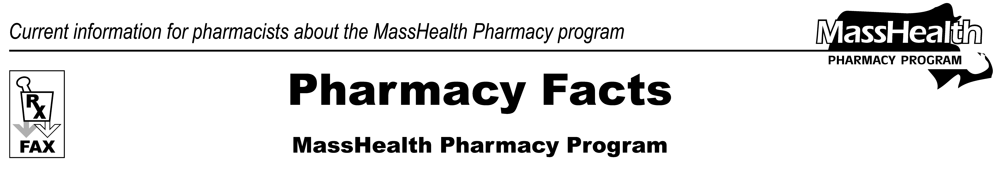

February 1, 2017

www.mass.gov/masshealth/pharmacy
- Editor: Vic Vangel • Contributors: Paul Jeffrey, Kim Lenz, James Monahan, Nancy Schiff •

Notice of Listening Session on Proposed Updates to Pharmacy Rates
The MassHealth Pharmacy Program will hold a public listening session on Friday, February 10, from 1:00 to 2:30 PM in the 1st Floor Conference Room at 100 Hancock Street, Quincy, 02171. The purpose of this session is to hear comments from interested stakeholders on proposed changes to the agency’s reimbursement methodology for prescribed drugs, necessary to comply with recent changes to federal law. The agency anticipates implementing these changes via regulatory amendments with an effective date of April 1, 2017.
During the session, staff from the Pharmacy Program will describe and invite feedback on key components of the proposed methodology, including definitions of actual acquisition cost (AAC) and professional dispensing fee, and related concepts. There will not be a conference call number. Please RSVP by e-mail no later than Monday, February 6, to Vic Vangel at vic.vangel@state.ma.us for purposes of gauging attendance.
Thank you.

Please direct any questions or comments (or to be taken off of this fax distribution) to
Victor Moquin of Xerox at 617-423-9830.

