Number 142 March 20, 2020
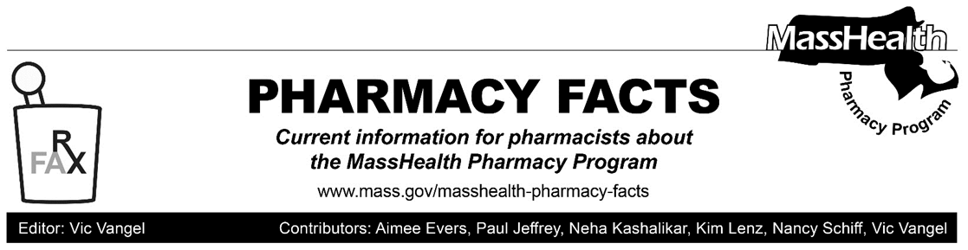
Additional Updates Related to Coronavirus Disease 2019 (COVID-19)—Effective Immediately

In response to the coronavirus disease (COVID-19) outbreak, MassHealth is:
- allowing additional exceptions to the 30-day supply limitation described at 130 CMR 406.411(D) for behavioral health medications and schedule IV benzodiazepines and hypnotics;
- removing prior authorization (PA) requirements for certain drugs;
- extending existing PAs that are due to expire for 60 days;
- allowing for clozapine refills if current lab results cannot be obtained; and
- allowing for emergency overrides if a claim is rejected for lack of PA.

In addition, to promote social distancing and maintain contactless transactions, pharmacies may not require signatures from MassHealth members and Health Safety Net patients and are encouraged to offer curbside pickup, courier home delivery, or delivery by mail or other similar parcel delivery. Finally, this Pharmacy Facts includes information relevant to pharmacies that provide durable medical equipment (DME).

These policy changes are intended to allow greater flexibility in providing patient care to MassHealth members who may be affected by the outbreak. For further information about MassHealth coverage and reimbursement policy for services related to COVID-19, please review All Provider Bulletin 289 (ALL-289), Pharmacy Facts #141, and LTSS Provider Information: Updates Related to the Coronavirus Disease 2019 (COVID-19) (Durable Medical Equipment Providers). Please also visit the MassHealth COVID-19 provider website as MassHealth continues to issue new guidance. As with ALL-289, the policies described in this Pharmacy Facts are effective immediately (except as noted below) and will remain effective for the duration of the state of emergency declared via Executive Order No. 591.

The procedures described in the bulletin apply to all pharmacy claims processed through the Pharmacy Online Processing System (POPS), including claims for the Health Safety Net (HSN) program.

Waiver of Signature Requirements

Pharmacies should take all necessary steps to allow patients to maintain proper social distancing and minimize contact with objects touched by other individuals. In particular, and notwithstanding any MassHealth policies to the contrary (including policies or requirements of MassHealth managed care entities or their contracted pharmacy benefit managers), pharmacies may not require a signature from a MassHealth member or HSN patient upon prescription drug pickup or delivery. In addition, pharmacies are encouraged and allowed to provide prescription drugs to MassHealth members and HSN patients via curbside pickup, courier home delivery, or delivery by mail or other similar parcel delivery.​ If a signature is otherwise required, the pharmacy may document the waiver of signature by signing the delivery slip or prescription with the phrase, “Signature not required related to COVID-19.”

Days’ Supply Limitations

MassHealth is expanding the drug classes where up to a 90-day supply may be dispensed. In addition to the drug classes described in Pharmacy Facts #141, and notwithstanding the requirements of 130 CMR 406.411(D)(1): Days’ Supply Limitation, pharmacies may dispense up to a 90-day supply of behavioral health medications and schedule IV benzodiazepines and hypnotics in quantities up to a 90-day supply, if requested by a MassHealth member or HSN patient or a prescriber as long as sufficient quantity remains on the prescription to support the quantity being filled.

We remind pharmacies that if, based on a pharmacist’s professional judgement, a pharmacy believes that dispensing up to a 90-day supply of any drug not generally subject to this policy would be in the best interest of a MassHealth member or HSN patient, it may call the MassHealth Drug Utilization Review (DUR) program at (800) 745-7318 to request an override.

Removal of PA Requirements for Certain Drugs

MassHealth is temporarily removing PA requirements for the following drugs and drug classes.

- Aminoglycoside Agents—Inhaled
- Antibiotics—Oral and Injectable
- Antifungals—Oral and Injectable
- Respiratory Agents—Oral and Inhaled
- Sublocade

Accordingly, and notwithstanding any contrary requirements in the MassHealth Drug List, prescribers do not have to obtain PA for those drugs; and pharmacies should fill and dispense these prescriptions without any PA requirement.

Extension of Existing PAs

MassHealth is working to identify and extend PAs that are due to expire in the coming weeks. MassHealth anticipates that, where appropriate, these existing PAs will be extended for up to another 60 days from the date of expiration. Notwithstanding this initiative, pharmacies should continue to outreach to prescribers in the event a new PA is required

Clozapine Refills if Current Lab Results Cannot Be Obtained

Pharmacies may refill clozapine prescriptions for MassHealth members and HSN patients if current lab results cannot be obtained, provided that the pharmacist has consulted with the prescriber, and that such a refill is clinically appropriate in the pharmacist’s professional judgment. The pharmacist must document all pertinent details in the patient’s records.

Emergency Overrides

Consistent with 130 CMR 406.411(B) and to ensure that MassHealth members and HSN patients do not experience gaps in therapy, pharmacists may utilize an emergency override if a claim for a medication is rejected due to lack of PA. MassHealth will pay the pharmacy for at least a 72-hour, nonrefillable supply of the drug dispensed under these circumstances. To obtain an emergency override, pharmacists should contact the Drug Utilization Review Program at (800) 745-7318 during normal business hours. If outside business hours, pharmacies may submit an emergency override claim with a value of “03” for Level of Service (field 418). After the prescription is adjudicated, the pharmacy should remove the “03” from the level of service field before the next fill.
Albuterol Inhalers

MassHealth is temporarily removing the requirement to use brand name ProAir when dispensing an albuterol inhaler. Claims for both branded ProAir inhalers and generic equivalents will be accepted. When dispensing either drug, the pharmacy should enter a DAW code of “0.”

Early Refills

As described in Pharmacy Facts #141, MassHealth reminds pharmacies that it is allowing early refills of existing prescriptions for drugs as long as at least one refill remains on the prescription. If a pharmacy receives a denial for an early refill, the pharmacy should place a “13” in the Submission Clarification field (NCPDP field 420-DK) to override the denial. If, based on a pharmacist’s professional judgment, a pharmacy believes that an early refill would be necessary for a member, it may call the MassHealth Drug Utilization Review (DUR) program at (800) 745-7318 to request an override if an early refill denial occurs after using this outlined procedure.

For Pharmacies That Provide Durable Medical Equipment (DME)

PA Extensions
If a DME provider (including a pharmacy with a DME specialty) is unable to complete the required paperwork for the continuation of an existing PA due to COVID-19-related reasons, the provider must submit an extension request to the MassHealth Long Term Services and Supports (LTSS) Provider Portal (https://www.masshealthltss.com) before the end date of the existing PA. Such extension requests must have the following note in the comments field: “COVID-19.” Extension requests related to COVID-19 will be approved for periods up to 90 days.

Days’ Supply Limitations for DME
Notwithstanding those sections of the DME and Oxygen Payment and Coverage Guideline Tool that prohibit DME providers from delivering more than a 30-day supply of covered medical supplies to a MassHealth member, those providers may deliver up to a 90-day supply of those medical supplies upon the member’s request. Providers must clearly document in the member's chart and when submitting claims that the provider delivered an increased supply due to “COVID-19.” Providers must also include, in the member’s chart and with the claims, the dates of service (DOS) and time period the delivery will encompass.

Member or Member's Designee Signature on Delivery Ticket
Notwithstanding the requirements of 130 CMR 409.419(A), DME providers should not ask the member or the member’s designee to sign a delivery slip at the time that the provider delivers DME supplies or equipment to the member’s home. Providers must document the following on the delivery slip, “Signature not required related to COVID-19.”

Face-to-Face Requirement
In accordance with 42 CFR 440.70(f)(6), MassHealth will permit physicians and other qualified non-physician practitioners, as appropriate, to conduct any face-to-face encounter required by 42 CFR 440.70 via telehealth (including telephone and live video) in accordance with the standards set forth in All Provider Bulletin 289. DME providers must (1) verify that the physician or qualified non-physician practitioner performed the encounter; and (2) include documentation of that encounter in the member's records.

