COMMONWEALTH OF IVIASSACHUSETTS

SUFFOLK COUNTY BOARD OF REGISTRATION IN PHARMACY

In the Matter of ) PharmaHealth Specialty, Inc. ) Registration No. DS89728 ) Expires December 31, 2015 )
PHA-2014-0204

CONSENT AGREEMENT FOR PROBATION

The Massachusetts Board of Registration in Pharmacy ("Board") and the PharmaHealth Specialty, Inc. ("Licensee" or "Pharmacy"), DS89728, 132 Alden Road, Fairhaven, Massachusetts, do hereby stipulate and agree that the following information shall be entered into and become a permanent part of the Pharmacy's record maintained by the Board:

1. The Pharmacy acknowledges that the Board opened a complaint against its Massachusetts pharmacy license related to the conduct set forth in Paragraph 2, identified as Docket No. PHA-2014-0204. 1

- The Board and the Pharmacy acknowledge and agree to the following facts:

  - From at least January 2013 to January 2014, Pharmacy delivered controlled substances to prescribers' offices, in violation of M.G.L. c. 94C, § 9. The medications delivered to the prescribers' offices were not necessary for the immediate and proper treatment of patients until it was possible for the patients to have their prescriptions filled in a pharmacy.

  - In or about 2014, the Pharmacy provided pre-printed referral forms that included the name of the Pharmacy to prescribers, in violation of 247 CMR 9.01(13).

  - The foregoing facts warrant disciplinary action by the Board under M.G.L. c. 112, §§42A and 61, and 247 CMR 10.3(1)(a) and (x).

1 The term "license” applies to both a current license and the right to renew an expired
license.

PharmaHcalth Specialty, Inc.
Ds89728
PHA-2014 -0204

- The Pharmacy agrees that its registration shall be placed on PROBATION for one (1) year ("Probationary Period"), commencing with the date on which the Board signs this Agreement ("Effective Date").

- During the Probationary Period, the Pharmacy further agrees that it shall comply in all material respects with all laws and regulations governing the practice of pharmacy and the United States Pharmacopeia.

- The Pharmacy further agrees that it shall submit documentation within 90 days of the Effective Date demonstrating the following:

  - The Manager of Record read and reviewed M.G.L. c. 94C;

  - The Pharmacy implemented policies and procedures pertaining to compliance with M.G.L. c. 94C;

  - The Pharmacy implemented a policy and procedure pertaining to the use of pre-printed prescriptions forms and 247 CMR 9.01(13); and

  - The Pharmacy removed signage indicating that it will deliver controlled substances to prescribers' offices.

- The Board agrees that in return for the Pharmacy's execution and successful compliance with the requirements of this Agreement it will not prosecute the Complaint.

- If the Pharmacy has complied to the Board's satisfaction with all the requirements contained in this Agreement, the Probationary Period will terminate one (1) year after the Effective Date upon written notice to the Pharmacy from the Board. 2

- If the Pharmacy does not materially comply with each requirement of this Agreement, or if the Board opens a Subsequent Complaint 3 during the Probationary Period, the Pharmacy agrees to the following:

2 In all instances where this Agreement specifies written notice to the Pharmacy from the Board, such notice shall be sent to the Pharmacy's address of record.
3 The term "Subsequent Complaint" applies to a complaint opened after the Effective Date
concerning acts, omissions, or events occurring after the Effective Date, which (l) alleges that the Pharmacy engaged in conduct that violates Board statutes or regulations, and (2) is substantiated by evidence, as determined following the complaint investigation during which the Pharmacy shall have an opportunity to respond.
PharmaHealth Specialty, Inc.
DS89728
PHA·2014 ·0204

- The Board may upon written notice to the Pharmacy, as warranted to protect the public health, safety, or welfare:

- EXTEND the Probationary Period; and/or

ii. MODIFY the Probation Agreement requirements; and/or

iii. IMMEDIATELY SUSPEND the Pharmacy's registration.

- If the Board suspends the Pharmacy's registration pursuant to Paragraph 7(a)(iii), the suspension shall remain in effect until:

- the Board provides the Pharmacy written notice that the Probationary Period is to be resumed and under what terms; or

ii. the Board and the Pharmacy sign a subsequent agreement; or

iii. the Board issues a written final decision and order following adjudication of the allegations (1) of noncompliance with this Agreement, and/ or (2) contained in the Subsequent Complaint.

- The Pharmacy agrees that if the Board suspends its registration in accordance with Paragraph 7, it will immediately return its current Massachusetts registration to the Board, by hand or certified mail The Pharmacy further agrees that upon said suspension, they will no longer be authorized to operate as a pharmacy in the Commonwealth of Massachusetts and shall not in any way represent itself as a pharmacy until such time as the Board reinstates registration or right to renew such registration.

- The Pharmacy understands that it has a right to formal adjudicatory hearing concerning the Complaint and that during said adjudication it would possess the right to confront and cross-examine witnesses, to call witnesses, to present evidence, to testify on its own behalf, to contest the allegations, to present oral argument, to appeal to the courts, and all other rights as set forth in the Massachusetts Administrative Procedures Act, M.G.L. c. 30A, and the Standard Adjudicatory Rules of Practice and Procedure, 801 CMR 1.01 et seq. The Pharmacy further understands that by executing this Agreement it is knowingly and voluntarily waiving its right to a formal adjudication of the Complaints.
PharmaHealth Specialty, Inc. DS89728
PHA-2014-0204
Page 3 of 4

11. The Pharmacy acknowledges that it has been represented by legal counsel in connection with the Complaint and this Agreement.

- The Pharmacy acknowledges that after the Effective Date, the Agreement constitutes a public record of disciplinary action by the Board. The Board may forward a copy of this Agreement to other licensing boards, law enforcement entities, and other individuals or entities as required or permitted by law.

- The individual signing this Agreement certifies that he/she is authorized to enter into this Agreement on behalf of the Pharmacy, and that he/she has read this Agreement.

- The Pharmacy understands and agrees that entering into this Agreement is a voluntary and final act and not subject to reconsideration, appeal or judicial review.
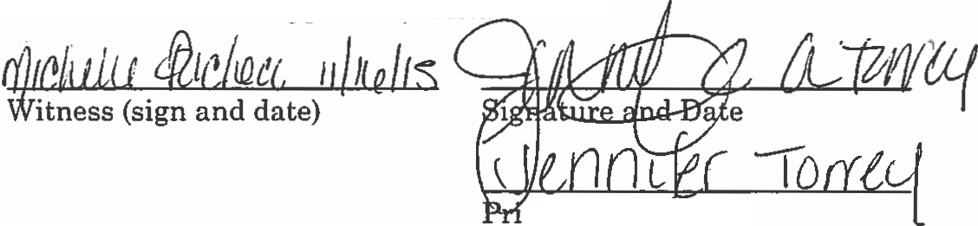

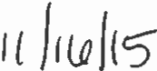

Int Name
PharmaHealth Specialty, Inc.

David Sencabaugh, R.Ph
Executive Director
Board of Registration in Pharmacy

12-7-2015
Effective Date of Probation Agreement

Fully Signed Agreement Sent to Registrant on 12/7/15 by
Certified Mail No. 7015 1660 0001 1911 0410

PharmaHealth Specialty, Inc.
DS89728
PHA·20l4·0204

Page 4 of 4

