

Modernizing the Public Health Data Warehouse: Tracking Public Health Trends
2021

Legislative Mandate

The following report is issued pursuant to Chapter 111 Section 237 of the General Laws, which states:
Section 237. The commissioner shall collect, record and analyze data, and shall assemble and maintain data systems, necessary to analyze population health trends. The commissioner shall give priority to analyzing fatal and nonfatal opiate overdoses. The commissioner may identify and determine additional priorities for the reduction of morbidity and mortality.
Notwithstanding section 74 of chapter 6, sections 16 to 16Y, inclusive, of chapter 6A, chapter 12C, chapter 19A, chapter 46, chapter 94C, chapters 111 to 111O, inclusive, chapter 112, chapter 118E, chapter 119, chapter 120, chapter 123, and chapter 123B, the center for health information analysis and any office or agency within the executive branch shall provide, upon request from the commissioner, information necessary to conduct the analysis required by this section if the provision of such information is otherwise consistent with federal and state law. The commissioner may request from any office or agency within the judicial branch, and any such office or agency may provide, information necessary to conduct this analysis required by this section if the provision of such information is otherwise consistent with federal and state law.
The commissioner shall develop policies and procedures for the governance of such data and data systems, which shall include provisions for confidentiality and security. Information or data provided or accessed under this section shall be confidential, shall not be used to identify any individual and shall be used solely for the conduct of analysis pursuant to this section. Such information or data shall not be considered a public record, shall be exempt from disclosure under section 10 of chapter 66 and shall not be subject to subpoena or discovery or admissible as evidence in any action of any kind in any court or before any other tribunal, board, agency or person. All resulting reports shall provide data in an aggregate and de-identified format.
The commissioner shall, not less than biennially, prepare and submit a report on priority public health trends. The report shall be publicly available and shall be filed with clerks of the senate and the house of representatives, the house and senate chairs of the joint committee on mental health, substance use and recovery, the house and senate chairs of the joint committee on public health and the house and senate chairs of the joint committee on health care financing.
The commissioner may promulgate regulations to implement this section.

Introduction
The Massachusetts Department of Public Health (DPH) submits this report to the legislature to provide an update on its activities to bring timely, multi-sector data into the Public Health Data warehouse (PHD) under Section 237 and transition to more sustainable, powerful, and secure computing platforms to create efficiencies and maximize privacy protections for the PHD over time. Unlike previous legislative reports that strictly provided health outcome data on a public health issue, the focus of this report is the status of innovative changes to the PHD and the benefits that will accrue to the Commonwealth with analysis on several priority topics to be conducted in the coming year.
The initial focus of the PHD, and its legislative reports, was the study of fatal and non-fatal opioid overdoses as authorized by Chapter 55. By 2016, after several PHD opioid reports, DPH successfully demonstrated that data could be pooled and analyzed from multiple sources to inform complex policy decisions; the legislature authorized DPH to use the PHD for analysis of other population health trends. From 2019 to 2022, DPH has expanded the PHD to include new data assets and more recent years of data. These actions have enriched the PHD’s utility for analysis of substance addictions (more broadly), maternal child health, COVID-19, and other emerging and persistent inequitable health outcomes among Massachusetts residents. This report explains the new potential of the PHD to assist DPH and other decision-makers in understanding and addressing health inequities experienced by DPH priority populations. The report highlights two recent case studies of findings generated using the PHD – one related to opioid use trends and another related to stimulant use trends – and how these findings are influencing programmatic and policy decisions to improve health outcomes.

Executive Summary
Massachusetts is a national leader in access to timely, linked, multi-year state datasets to enable analyses of public health priorities and trends. Few states have a robust data warehouse project that can conduct complex analyses of 34 distinct datasets drawing from health care to social service programs to inform policy and programs. In December 2017, Section 237 of Chapter 111 permanently reauthorized the Public Health Data Warehouse (PHD) in recognition of the important public health information provided by the linked datasets. This report provides an update on the progress of modernizing and enhancing the PHD to ensure the state has needed information on the health of Massachusetts residents and health inequities. The report includes two vignettes exemplifying the value of the PHD to understanding opioid use at the beginning of the COVID-19 pandemic and the potential of the PHD to track emerging trends, such as the increase in overdoses deaths resulting from the combined use of stimulants and opioids. The Massachusetts Department of Public Health (DPH) believes the updated PHD will help Massachusetts address not only the opioid epidemic but also assist in monitoring COVID-19, inequities in maternal and child health outcomes, and other complex public health trends impacting DPH’s priority populations.
As the opioid epidemic and the COVID-19 pandemic illustrate, public health challenges can be complex, rapidly evolving, and multifactorial. The updated PHD (referred to as PHD 2.0) has expanded capacity to meet current and future needs to analyze these complex interactions to provide a nuanced picture to decision-makers that can assist them with strategic decisions on policy and programming. From 2019 - 2022, DPH has worked with its state partner data owners to add additional datasets and expand the variables available for analysis. DPH has also increased the computing power of the PHD, created robust analytic plans, and supported a public-private partnership to identify and answer key questions to inform public health responses and policymaking. Analysis of public health priorities using the enhanced PHD began in earnest in 2022, however, results of these analyses are not yet available at the time of this report.
With enhanced computing power and additional datasets, the PHD will continue to be an important resource as Massachusetts looks to address its public health priorities and disease prevention.

Addressing the Opioid Crisis: History of the PHD
The PHD was established through a series of laws, starting in 2014 and culminating in 2018, with enactment of Section 237 of Chapter 111, which reduced barriers to data sharing, data linkage, and data analysis of important public health trends. Chapter 284 of the Acts of 2014 was enacted to promote gun violence prevention and included data provisions. Recognizing that the state needed enhanced ability to conduct in-depth complex data analysis for understanding complicated public health challenges, it mandated that DPH develop a plan for “a data warehouse linking relevant private and public data systems,” compliant with all state and federal laws governing confidentiality of data. DPH’s plan focused on creating accessible, secure, and timely linked data that supported public health program planning and evaluation, as well as research and collaboration with external partners, without the sharing of the original datasets.

Chapter 55 of the Acts of 2015, passed by the legislature and signed by Governor Baker, focused on addressing the growing opioid crisis and laid the foundation for the PHD, acting on the recommendations resulting from Chapter 284. At that time, Massachusetts had seen a notable increase in opioid overdose deaths, with the number of deaths tripling between 2010 and 2015. Figure 1 (below) shows this alarming increase in opioid-related overdose deaths. Chapter 55 provided the legal basis for cross-agency collaboration and data sharing to facilitate in-depth analysis of the opioid crisis. It required that the Secretary of the Executive Office of Health and Human Services (EOHSS), in collaboration with DPH, examine data related to opioid overdose deaths and answer seven specific public health questions about fatal opioid overdoses. DPH determined that these questions could only be answered by linking 10 datasets from five state agencies in the PHD. This demonstration data project uncovered many hurdles to complex analyses, including differing legal requirements for each dataset, variable structures and quality of data, and information technology challenges. In the span of one year (2016), DPH navigated these hurdles and developed the PHD to have a strong, linked-data foundation that prioritized privacy and security of data.

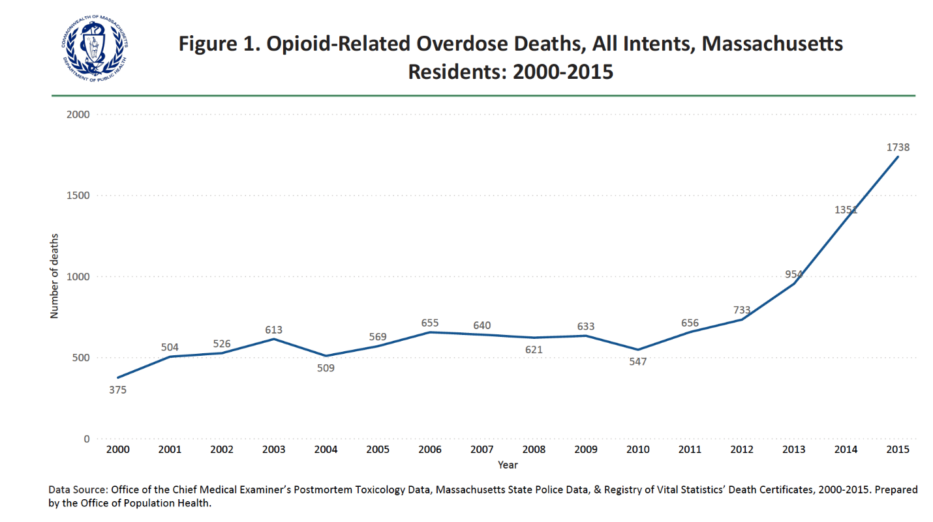

This collaborative effort resulted in an opioid overdose report that answered the seven questions posed by the legislature, along with four additional questions which arose during data analysis. This report was submitted to the legislature in 2016 along with a data brief and a data visualization report.,, The legislature reauthorized the PHD in 2016 in Chapter 133 of the Acts of 2016 that required analysis of fatal and, for the first time, non-fatal opioid-related overdoses to guide policy development and programmatic decision-making in the Commonwealth. This resulted in a 2018 legislative report and a data brief.,

The Chapter 55 and PHD analyses of the opioid epidemic had direct policy impact, informing how DPH targeted public health efforts to high-need areas; the opioid overdose death rate then declined from 2016 – 2019. Figure 2 shows the leveling off and slight decrease in overdose deaths that occurred in Massachusetts during this time. Important findings from these analyses include:
- Estimates of the rate of opioid use disorder (OUD) in Massachusetts were nearly four times higher than national estimates and two times higher than what past surveillance methods would have found for the state.
- In addition, the ability to track individuals across data systems made it possible to the determine that non-fatal opioid overdoses were increasing and nearly 10% of non-fatal overdoses were followed by a fatal overdose within two years, influencing public health programming to intervene earlier and more often with individuals who had experienced non-fatal overdoses.
These two examples demonstrate how in-depth PHD findings can directly influence public health action and result in decreased morbidity and mortality.

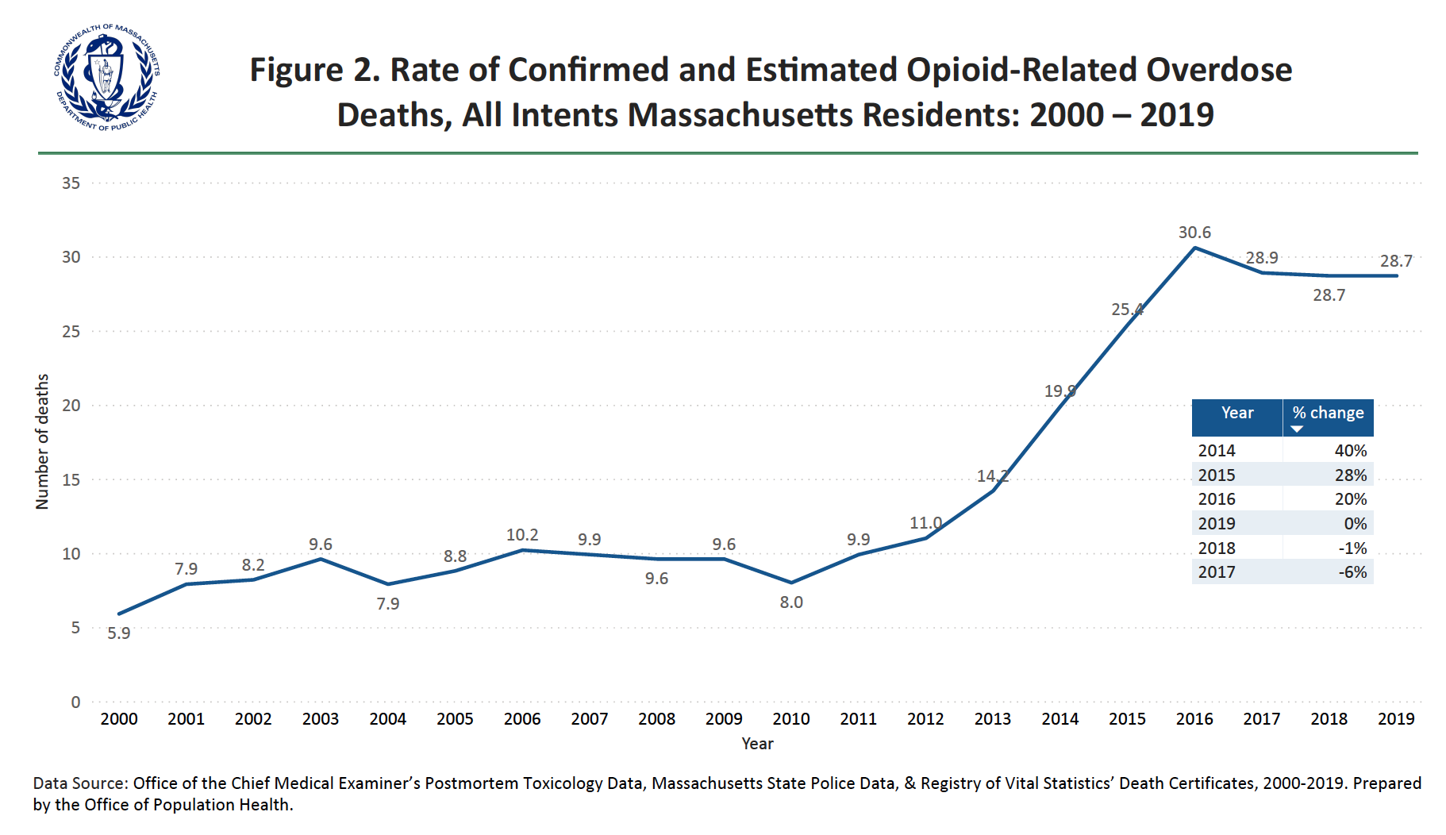

In December 2017, Section 237 of Chapter 111 permanently reauthorized the PHD., Section 237 requires the Commissioner to “collect, record and analyze data, and … assemble and maintain data systems, necessary to analyze population health trends.” It has enabled DPH to link 29 datasets from more than 20 governmental administrative data systems, including data from social factors that influence health (known as the social determinants of health), such as affordable housing data and Supplemental Nutrition Assistance Program (SNAP) data. The Department’s work under the authority in Section 237 has solidified the use of the PHD to analyze public health trends and helped expand the PHD to include new data assets and more recent years of data. These actions have enriched the PHD’s utility for analysis of substance addictions (more broadly than opioid use disorder), maternal child health, COVID-19, and other emerging and persistent inequitable health outcomes among Massachusetts residents. This report will describe the multiple approaches DPH has taken to strengthen this valuable linked, multi-sector data system under its Section 237 authority.

As the opioid crisis and the COVID-19 pandemic have demonstrated, good data has the potential to change the course of disease through informing improved public health programming and policy. This report describes DPH efforts to prepare for the current and future public health needs of the Commonwealth through the modernization of the PHD and similar data initiatives.

Managing the PHD
The PHD is managed by DPH’s Office of Population Health (OPH). DPH created OPH in 2017 to accelerate the use of data and advanced analytics to identify inequities in health outcomes, risk factors, and the social determinants of health and to communicate and disseminate these findings. OPH’s mission is to develop and use data-driven approaches to address health inequities in the Commonwealth and to inform policies, programs, and investments of decision-makers and stakeholders using a social determinants of health and racial equity framework.
The PHD is essential to fulfilling both the mission of OPH and vision and mission of DPH. The PHD enables OPH to conduct complex analyses that consider the root causes of health for populations that have endured structural inequities, by bringing together and linking health and social data. OPH endeavors to embody DPH’s vision and mission, as represented in the DPH House. Figure 3 below depicts the vision, mission and focus of DPH using the “DPH House” visual.
What Is Population Health?
Population health is the study of the health of whole populations and groups of individuals within that population. It looks at health outcomes, access to the factors that determine health (known as the social determinants of health or SDoH), and the policies and interventions that affect both.
- David Kindig, MD, PhD and Greg Stoddart, PhD
Figure 3: DPH House

To accomplish its mission, OPH has four divisions and supports cross-agency work within the Department. The four divisions are:
- Special Analytics Projects (where the PHD is located)
- Office of Data Management and Outcomes Assessment (implements the Behavioral Risk Factor Surveillance System, Youth Health Survey, and the Massachusetts Cancer Registry and manages DPH’s access to Center for Health Information and Analysis’ (CHIA’s) Massachusetts Acute Hospital Case Mix Database)
- Registry of Vital Records and Statistics (collects and manages birth and death data as part of the overall registry operations)
- Office of Health Equity
OPH strives to find innovative ways of using, combining, and visualizing data to draw a more complete and informative picture of public health needs and inequities in the Commonwealth. The PHD was developed to address gaps in information about one pressing public health issue – the opioid crisis – but became the foundation for a model that can be applied to many different public health issues and will continue to evolve over time to address emerging needs.

Creating a Data Warehouse for the Future: PHD 2.0
The Public Health Data Warehouse (PHD) provides access to timely, linkable, longitudinal data from across state government to enable analysis of trends related to public health priorities. The PHD is a nationally recognized innovation, proven as an effective tool for accelerating data analysis and dissemination of actionable information to guide the Commonwealth’s response to the priority public health needs. From 2019 to 2022, DPH, through the Division of Special Analytic Projects in OPH, has updated and modernized the PHD. This section explains the goal in updating the PHD, the process required to modernize it, and the potential of the PHD 2.0 for understanding important public health issues in the Commonwealth.

The Goals of PHD 2.0
The goals of the PHD 2.0 are to identify and add new data sources to continue to improve the understanding of trends in public health from a health equity perspective and to disseminate actionable information for policy and programmatic decision-making. To accomplish these goals, DPH has focused on having a data warehouse that has strong analytic efficiency, sufficient detail to respond to varying public health priorities, with longitudinal data to analyze trends over time, and the capacity to add additional datasets as needed.
Under Section 237, the Commissioner of Public Health has the authority to identify public health topics for PHD analysis, in addition to the mandated study of fatal and non-fatal opiate overdoses. Last year, the Commissioner identified COVID-19 and maternal and child health (MCH) as additional public health priority areas for PHD study, with particular analysis of maternal morbidity and mortality and disparities in maternal and child health outcomes. Figure 5 below demonstrates the stark disparities by race and ethnicity found for severe maternal morbidity in Massachusetts and shows the data that prompted this designation.

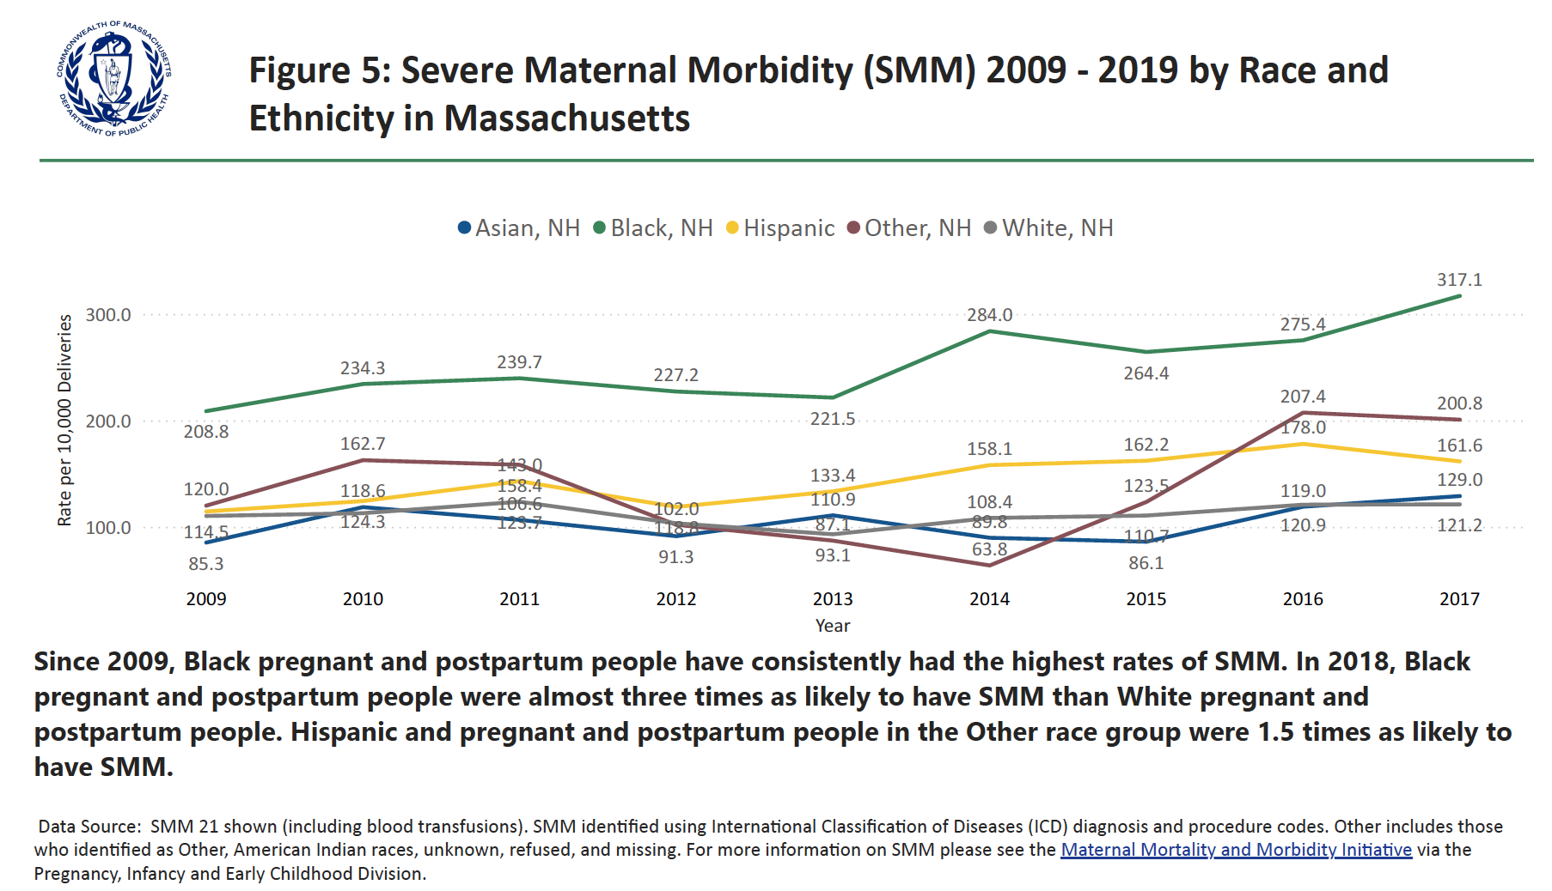
Figure 4: Severe Maternal Morbidity (SMM) 2009 – 2019 by Race and
Ethnicity in Massachusetts

Once a public health topic is defined, DPH convenes an interdepartmental working group to develop an analytic agenda, including specific questions that DPH will use the PHD to answer. DPH engages partners to refine the questions and conduct analyses. The internal PHD governance group developed guiding principles and a set of questions to guide its analysis, which aim to ensure PHD data is secure, data privacy is maintained, and the research is grounded in equity and ethics. These guiding principles are used by PHD staff in maintaining the PHD and developing analysis plans:
- DPH will value inter-agency collaboration and commit to incorporating the principles of community-engaged research;
- DPH will strive for a well-structured, transparent, and comprehensive Governance to support the operational needs of the PHD;
- DPH will review and modify its Governance as needed to address emergent needs, preserve the spirit of the PHD program, and be inclusive;
- DPH will use only the minimum necessary amount of data to accomplish specific analyses; and
- All PHD work products will be conducted on the behalf of DPH and the residents of the Commonwealth.

In addition, OPH develops research-based questions to focus the PHD analysis on the populations most at risk and on achieving actionable data. The answers to these questions form the basis of the PHD analysis plan. These questions are:
- For this public health issue, what puts people at risk?
- Who are the high-risk groups for this issue and what more do we need to know about them?
- What can we learn by stratifying results by race, ethnicity, housing status (homelessness), poverty, substance use disorder (SUD) status, and residence?
- What is the evidence base for impacting change on this issue?
- What are we already doing to impact change and what could be done better with better data?
- What new evidence-based interventions could we implement with our known high-risk groups that would improve health outcomes?

PHD 2.0 Data Structure
PHD 2.0 has increased data capacity and strong privacy and security protections. Overall, the PHD now has 34 datasets, including 16 coming from outside agencies. In addition to the 15 datasets that the PHD previously included when focusing specifically on opioid overdoses, OPH added datasets that related to maternal and child health, focused on substance use and infectious diseases, and addressed the social determinants of health. In early 2023, OPH will begin the process to add COVID-19 data. In addition, DPH added more years for most of the datasets to allow analysis of multi-year trends. Now most datasets span the years 2011 – 2020 or beyond. Lastly, instead of having data summarized to the individual-level as it was in PHD 1.0, PHD 2.0 includes an entry for every encounter with a data system (for example, every inpatient hospital visit has a unique entry). This makes the data more flexible for analytic questions, allowing the PHD to better respond to new priority topic areas as they are identified.

To build PHD 2.0, the Division of Special Analytic Projects (SAP) -- the lead team within OPH responsible for operating the PHD -- recreated data linkages and restructured datasets to increase analytic efficiency and include more detail. The new data linkage in PHD 2.0 builds on existing PHD security measures to protect data:
- First, most datasets are linked at the individual level to the All Payers Claims Database (APCD), which serves as the spine for linking individual information across datasets. Figure 6 provides a visual of the role of the APCD in PHD 2.0 and the multiple datasets that are part of the PHD 2.0.
- Second, to create the linkage, SAP uses six personal identifiers: first name, last name, date of birth, gender, social security number, and zip code of residence.
- After each dataset is linked, the personal identifiers (except for the zip codes and gender) are dropped to protect the information.
- Lastly, dates of service included in some datasets, such as hospitalization data, are masked so that this information is retained for analytic purposes while still maintaining the privacy of the data.

This linkage process was developed with the Center for Health Information and Analysis’ (CHIA) support; it is only through their work developing the Master Patient Index (which assigns a single unique surrogate key to each person, regardless of how many different insurance carriers have submitted data about the person) that the development of the APCD spine was possible. Additionally, CHIA has been a strong technical partner to DPH on the PHD since the establishment of Chapter 55, providing technical assistance on the use of their health datasets, input on analyses, and partnering on trouble-shooting technical challenges. DPH acknowledges the necessity of CHIA’s partnership, which is directly linked to past, current, and future success of PHD.

Figure 5: PHD 2.0 Structure
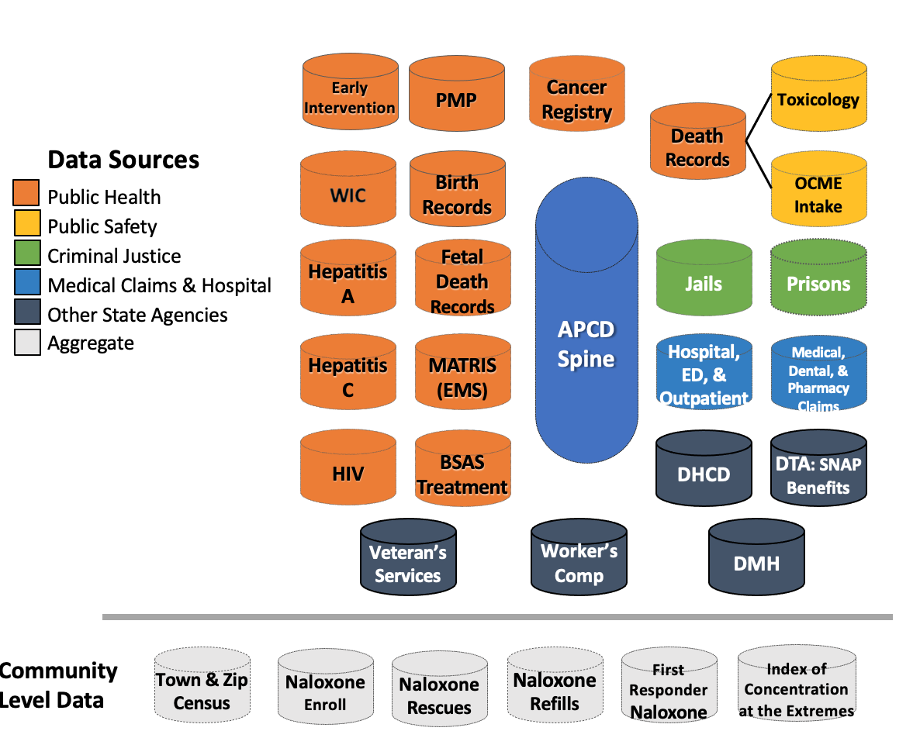

Collaboration with Other State Agencies
DPH works closely with data providers to understand the datasets they are contributing, develop agreements about the use of the data, and solicit input on potential research questions of interest to the agency. The SAP team communicates with each group sharing data to understand what information they have available, how to interpret the information, and the pertinent limitations surrounding the data. Additionally, SAP maintains contact with the submitting organizations to ensure their data is utilized and interpreted correctly. This involves (1) allowing the data-submitting agencies to review any analytic plans proposed by external partners that would utilize the agency’s data and (2) providing the opportunity to review all products produced using the agency’s data, such as publications or conference presentations. Figure 6 lists all the state agencies that have contributed data to the PHD 2.0.

Figure 6: Datasets, State Agency Partners, and Current Years of Data Available for PHD 2.0
Datasets |  |  | State Agency | Years of data available
INDIVUDAL LEVEL DATA |  | Acute Care Hospital Discharge Data (Case Mix) | CHIA | 2011-2020
INDIVUDAL LEVEL DATA |  | All Payer Claims Database | CHIA | 2014-2020
INDIVUDAL LEVEL DATA |  | Bureau of Family Health and Nutrition: Early Intervention | DPH | 2011-2017
INDIVUDAL LEVEL DATA |  | Bureau of Family Health and Nutrition: WIC Program | DPH | 2011-2020
INDIVUDAL LEVEL DATA |  | Bureau of Infectious Diseases and Laboratory Sciences: Hepatitis A Surveillance Data | DPH | 2011-2020
INDIVUDAL LEVEL DATA |  | Bureau of Infectious Diseases and Laboratory Sciences: Hepatitis C Surveillance Data | DPH | 2011-2020
INDIVUDAL LEVEL DATA |  | Bureau of Infectious Diseases and Laboratory Sciences: HIV Surveillance Data | DPH | 2013-2020
INDIVUDAL LEVEL DATA |  | Bureau of Substance Addiction Services Treatment Data | DPH | 2011-2019
INDIVUDAL LEVEL DATA |  | Department of Housing and Community Development: Emergency Assistance Program Data | DHCD | 2010-2020
INDIVUDAL LEVEL DATA |  | Department of Industrial Accidents: Workers Compensation | DIA | 2011-2020
INDIVUDAL LEVEL DATA |  | Department of Mental Health: Treatment Data | DMH | 2011-2020
INDIVUDAL LEVEL DATA |  | Department of Corrections: Prison Data | DOC | 2011-2020
INDIVUDAL LEVEL DATA |  | Department of Transitional Assistance: SNAP Benefits Data | DTA | 2011-2020
INDIVUDAL LEVEL DATA |  | Department of Veterans' Services Benefits Data | DVS | 2011-2020
INDIVUDAL LEVEL DATA |  | Essex County Jail Data | MSA | 2011-2020
INDIVUDAL LEVEL DATA |  | Hampden County Jail Data | MSA | 2011-2020
INDIVUDAL LEVEL DATA |  | Hampshire County Jail Data | MSA | 2011-2020
INDIVUDAL LEVEL DATA |  | Franklin County Jail Data | MSA | 2011-2020
INDIVUDAL LEVEL DATA |  | Massachusetts Cancer Registry: Cancer Incidence Data | DPH | 2011-2018
INDIVUDAL LEVEL DATA |  | Middlesex County Jail Data | MSA | 2011-2020
INDIVUDAL LEVEL DATA |  | Office of the Chief Medical Examiner: Circumstances of Death Data | OCME | 2014-2020
INDIVUDAL LEVEL DATA |  | Office of the Chief Medical Examiner: Postmortem Toxicology Data | OCME | 2014-2020
INDIVUDAL LEVEL DATA |  | Office of Emergency Medical Services: Massachusetts Ambulance Trip Record Information System | DPH | 2013-2020
INDIVUDAL LEVEL DATA |  | Prescription Monitoring Program | DPH | 2011-2020
INDIVUDAL LEVEL DATA |  | Registry of Vital Records and Statistics Dataset: Birth Certificates | DPH | 2011-2020
INDIVUDAL LEVEL DATA |  | Registry of Vital Records and Statistics Dataset: Death Certificates | DPH | 2011-2020
INDIVUDAL LEVEL DATA |  | Registry of Vital Records and Statistics Dataset: Fetal Death Certificates | DPH | 2011-2020
COMMUNITY LEVEL DATA |  | High Intensity Drug Trafficking Areas Drug Seizure Data | HIDTA | 2019-2021
COMMUNITY LEVEL DATA |  | Index of Concentration at the Extremes Measures (spatial social polarization metric) | ACS (US Census) | 2014-2018
COMMUNITY LEVEL DATA |  | Overdose Education and Naloxone Distribution Program: First Responder Naloxone Data | DPH | 2011-2020
COMMUNITY LEVEL DATA |  | Overdose Education and Naloxone Distribution Program: Naloxone Enrollments | DPH | 2011-2020
COMMUNITY LEVEL DATA |  | Overdose Education and Naloxone Distribution Program: Naloxone Refills | DPH | 2011-2020
COMMUNITY LEVEL DATA |  | Overdose Education and Naloxone Distribution Program: Naloxone Rescues | DPH | 2011-2020
COMMUNITY LEVEL DATA |  | UMASS Donahue Institute and American Community Survey: Population Estimates | ACS; UMass | 2011-2019
From 2019 to 2020, the DPH Office of the General Counsel worked closely with DPH programs and other agencies to design a data use agreement for PHD (PHD DUA) participation that reflects the required terms, conditions and assurances for data protection and security for each dataset and variable. Based on DPH’s experience under Chapter 55, it was important that the PHD DUA also incorporate a level of flexibility not afforded under prior PHD DUAs. First, DPH wanted to offer other state agencies and programs a mechanism for indicating conditions under which their data would or would not be used in different analyses. Second, DPH wanted a mechanism for adding or modifying data in the PHD with a notification process, versus requiring the execution of a new agreement each time a data change was made. DPH and its PHD collaborators worked closely over many months to develop and execute this new flexible PHD DUA model, which satisfies the data protection and security needs of each individual agency while also reducing administrative burden.
DPH solicits research ideas from submitting organizations to find out if they have a topic or question of interest that fits within the parameters of the PHD. By utilizing the linked datasets, the partner organization often gains new insights into their own data that they did not have when viewing it alone. By utilizing state agency partners as subject matter experts, DPH learns about pertinent policy questions that, if answered, could help further the mission and work of the agency, or support cross-agency initiatives.

Increasing PHD 2.0 Computing Capacity
SAP has significantly expanded the computing power of the PHD to enable it to analyze more complex data quickly and securely. As the PHD 2.0 contains more datasets, and as those datasets are more robust than previous versions, SAP has had to expand the computing environment to one that has the power and capacity to do complex analyses of large datasets. Technically, this upgrade means that SAP migrated the PHD from a cloud-based system with limited capacity to a more secure cloud-based system with significant processing and storage space. For example, this upgrade will allow SAP to add more datasets like COVID-19 data, link that data to social determinants of health data, and analyze the linked data, stratified by priority population characteristics like race, ethnicity, and industry/occupation.
In the past, SAP was limited in the type of analysis it could conduct, as they only had access to limited datasets. In addition, the data environment didn’t allow for quick analysis. The new PHD will allow SAP to analyze multiple factors more quickly, especially social determinants of health by priority populations, that are connected to public health outcomes.
The new computing environment has strong security protections and safety precautions. It is HIPAA-complaint, encrypted at rest (on the hard drive) and in flight (when it is moving across the network), and stores the datasets separately from one another at rest. Data come together only for the analysis and then are split apart again. The computing environment can be configured to allow storing and processing of data with different compliance needs.

Collaboration with Researchers and Consumers to Ensure a Strong Equity Focus
Public and private partners, from academia and other fields, can provide important insights into trends in priority public health topics, as they have additional expertise and perspectives to add to PHD analyses. In the spring of 2021, DPH provided an opportunity, through a competitive Notice of Opportunity (NOO) process, for a limited number of external parties to use the PHD to assist the Department with analysis of population health trends for substance use, especially among DPH’s priority populations (as listed in Figure 4). DPH requested applicants propose analyses designed to reduce morbidity and mortality and to reduce health disparities resulting from racial inequities, to inform current state policy and programs on substance use. While DPH’s priority populations are the focus of the current NOO, DPH anticipates that future partnership possibilities will support identification of additional populations at disproportionate risk for negative outcomes related to substance use.
In June 2021, SAP convened a review team for selecting qualified applications to add to the PHD analysis. The team is comprised of staff from the OPH, relevant subject matter experts from across DPH, representatives from state agencies whose data are being requested, and community representatives with lived experience of substance use. SAP developed rigorous review criteria, including requiring a demonstration of community engaged approaches before determining which project to prioritize for PHD analysis. Fifteen projects were ultimately approved under this NOO process.

Analytic Plans for Opioids and Maternal and Child Health
From 2019 - 2022, SAP has worked with internal cross-bureau working groups to establish analytic plans for analysis of the opioid epidemic and the crisis of racial inequities in maternal and child health. The expanded datasets and computing power of PHD 2.0 will allow DPH to undertake complex analyses that look at a host of social and environmental factors that may contribute to these health issues. SAP and its external partners will continue to conduct these analyses to inform public health programming and policy.

Opioids
To develop the list of analytic priorities and critical questions regarding opioids, SAP worked with several internal working groups comprised of subject matter experts identified by DPH Bureau Directors and OPH staff. SAP trained the working groups on the new capacity of PHD 2.0 to inform their decision-making. The working groups developed analytic topics and questions and then sorted them to select the priorities and questions that (1) could be answered using PHD and (2) that were actionable. The working groups prioritized analyses that have the potential to reduce opioid morbidity and mortality and reduce disparities in opioid outcomes resulting from health and racial inequities through informed policy and programmatic decisions. Then, the selection of topics and questions were reviewed and approved by the Commissioner of Public Health.

Maternal and child health (mCH)
As allowed by Section 237, the Commissioner may identify and determine additional priorities for the reduction of morbidity and mortality. In 2018, the Commissioner of Public Health directed OPH to generate new, actionable information to help Massachusetts address inequities in maternal and child health (MCH) outcomes, especially among people of color and other populations impacted by social factors. Maternal and child health outcomes are often cited as an important marker of racial and ethnic inequities, as these outcomes can be determined by a variety of structural factors such as access to quality health care, housing, and income., Nationally, Black, American Indian, and Alaska Native (AI/AN) women are two to three times more likely to die from preventable pregnancy-related causes than White women, and these deaths are increasing. The United States has the highest maternal mortality rate among developed countries, demonstrating the impact of social factors on this outcome.
What is maternal and child health and why is it a priority public health issue?
Maternal and child health (MCH) covers the health of mothers, infants, children, and adolescents. While health outcomes for women, infants, and children in Massachusetts are better compared to the national average, significant racial, ethnic, and socioeconomic disparities persist. For example, infant mortality in Massachusetts is 1.5 -2 times higher for Black and Hispanic infants than White infants.
Given that Massachusetts devotes substantial resources to protecting and improving the health of these populations by offering nearly 50 programs and services targeted at pregnant women, infants, and children, more complex analyses can help focus those resources on the factors that most impact disparities in outcomes.
SAP led a Department workgroup in 2018 to identify MCH datasets to be included in the PHD (e.g. the Nutrition Program for Women, Infants, & Children (WIC) and Early Intervention (EI)) and to design research questions of interest to DPH’s Maternal and Child Health Block Grant (Title V) initiatives and other MCH efforts in Massachusetts. The workgroup proposed, and the Commissioner of Public Health accepted, an initial focus on three MCH topics: (1) maternal morbidity and mortality, (2) preterm birth and infant mortality, and (3) adolescent health and wellness.

Timeline to Start Analysis with PHD 2.0
SAP began analysis of PHD 2.0 in 2022. Staff reassignments during the COVID-19 pandemic resulted in delays securing data use agreements and accessing datasets. The PHD currently has 34 datasets, 27 of which are linkable at the individual level, as well as seven community-level datasets which will enable SAP to provide in-depth analyses of priority topics. The datasets included are found in Figure 6 with the years of data available.

Case Studies on the PHD’s Potential to Inform Public Health
The next two vignettes demonstrate the PHD’s potential to inform decision-making on important public health topics. One case study demonstrates the effectiveness of the PHD 1.0 and how it influenced regular DPH opioid surveillance reporting. The second case study provides an early glimpse of the types of analyses that are possible with PHD 2.0 and shares recent data on opioid and stimulant use. With the PHD, DPH has a strong data tool to understand and communicate about the public health challenges facing Massachusetts residents in the coming years.

Opioids Surveillance
Early use of the PHD helped DPH identify important characteristics of opioid use disorder (OUD) and opioid-related overdose deaths that informed public policy and programming. In addition, this more nuanced understanding of the risk factors and impacts of the disease informed DPH’s ongoing opioid surveillance strategy for producing more timely reports. Continued opioid surveillance has identified a concerning upward trend of opioid-related deaths during the COVID-19 pandemic; PHD analyses will help DPH identify any new or changing variables in this trend.
Early PHD analysis in 2015 enabled DPH to have a richer understanding of opioid use in Massachusetts. While PHD analysis can be more time-intensive and data updates are more delayed than other public health surveillance methods because of the number of datasets involved, it can provide a more complete and detailed picture of the issue. Once key contributors to a public health issue are identified in the PHD, regular surveillance can provide more rapid reports for continued monitoring. Because the PHD linked multiple datasets, DPH was able to identify more populations at risk for opioid-related overdose deaths than possible with typical surveillance methods. Important findings from the PHD, covering data from 2011 – 2015, include:
- There were more people experiencing homelessness in Massachusetts than previous estimates suggested (estimate rose from 1% of the population to 4% after PHD analysis).
- After controlling for several behavioral health diagnoses, chronic medical conditions, demographic characteristics, and engagement with state agencies, those experiencing homelessness where 64% more likely to have a fatal opioid overdose and nearly 6 times more likely to experience a non-fatal overdose.
- The risk of fatal opioid-related overdose was six times higher for persons diagnosed with a serious mental illness (“SMI;” includes mood disorders, schizophrenia, and other psychotic disorders) and three times higher for those diagnosed with depression.
- Compared to the rest of the adult population, the opioid-related overdose death rate was 120 times higher for persons recently released from prisons and jails. Nearly one of every 11 opioid-related overdose deaths were to persons with histories of incarceration in Massachusetts jails and prisons.
- The highest risk of opioid-related overdoses for postpartum people occurred 7-12 months after delivery.

These findings resulted in policy changes and changes in typical public health surveillance approaches. For example, understanding the risk of opioid overdose among incarcerated individuals helped support Massachusetts Medication Assisted Treatment (MAT) programs in Massachusetts Sheriffs’ House of Corrections, such as the Five Sheriff Massachusetts MAT program, which provided an evidence-based structure shown to help individuals achieve long-term recovery. In addition, previous attempts to link opioid-related emergency medical services (EMS) incidents to hospital-treated opioid overdoses in the PHD grappled with the broad definition of opioid-related EMS events (i.e. any event where 911 was called and an opioid was involved). As not all opioid-related EMS incidents are overdoses, it is not surprising that they would not be identified as overdoses in hospital records. Starting with the November 2020 rapid opioid report, SAP divided opioid-related incidents into five severity categories: (1) dead on arrival (of opioid overdose), (2) acute opioid overdose, (3) opioid intoxicated, (4) opioid withdrawal, and (5) other, opioid-related incident. All opioid-related incidents are sorted into one of the five categories. All opioid-related incidents present a burden to the EMS system and are potential points of contact to connect patients to further care; therefore, SAP continues to collect and report on all of them. However, each of the five severity categories has unique clinical presentations and this breakdown allows for a deeper understanding of the opioid epidemic in MA and therefore facilitates a more targeted response. In PHD 2.0, these five severity categories are also present in EMS data. Researchers can utilize these refined categories to filter to those opioid-related EMS incidents that are of interest to their analysis; the linkage between EMS-treated opioid overdoses and hospital-treated opioid overdoses are more precise.

The PHD will be instrumental in understanding opioid use and related deaths in the coming years. As discussed earlier, the opioid epidemic in Massachusetts is ongoing and, despite a leveling off of the opioid-related death rate after years of focused efforts, the COVID-19 pandemic may have impacted opioid-overdose rates, causing a recent increase, especially among Hispanic and Black non-Hispanic men. Based on preliminary data, the national opioid-overdose rate rose 32% from 2019 to 2020. While Massachusetts did not experience such a drastic increase, the opioid overdose rate did increase 5% from 2019 to 2020. The 2020 opioid-related death rate is 30.2 per 100,000, close to the 2016 peak of 30.6 per 100,000 residents, as shown in Figure 7 below.

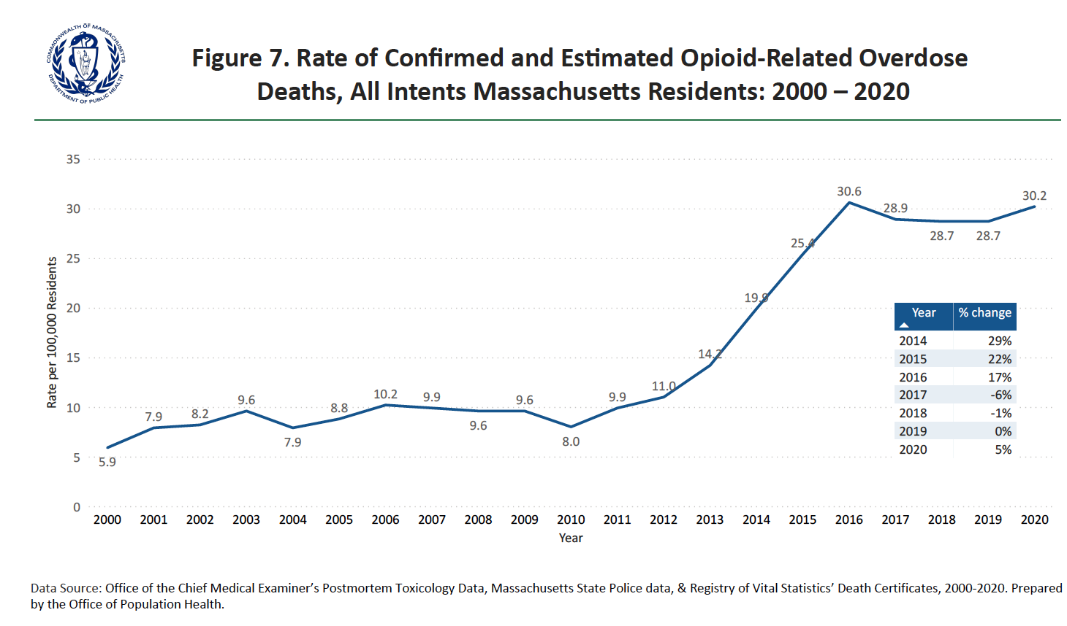
Furthermore, while opioid-related deaths continue to be mostly among men 25-44 years old, these demographics are shifting; communities of color are impacted by opioid-related overdose more today than in the past. In 2020, Hispanic males had the highest opioid overdose death rate among all demographics, while Black non-Hispanic males had the largest increase in their opioid overdose death rate between 2019 and 2020. In the coming years, DPH will focus on using the PHD 2.0 to better understand the shifting demographics of opioid-related deaths and their social determinants to inform policy, programs, and on-going public health surveillance.

Stimulants Surveillance
Early use of PHD 2.0 by DPH highlights an important connection between stimulant use and opioid-related overdose deaths and demonstrates the potential for PHD 2.0 to provide complex analysis of public health challenges. The presence of cocaine in opioid-related overdose deaths in Massachusetts increased 44% from 2014 to 2020. Stimulants are increasingly present in Massachusetts toxicology screens for opioid-related overdose deaths. In 2020, cocaine was present in 42% of post-mortem toxicology screens and amphetamines were present in 6%; these data are consistent with nationwide trends, showing a rise in stimulant-involved overdoses in the northeast.,, Multi-substance use is a growing issue in addiction treatment, and this complex interplay of substances will continue to present a challenge to Massachusetts. Utilizing PHD 2.0 will assist in understanding its complexity and which populations are most impacted.
Stimulant use disorder can be hard to identify in data. It appears less often in medical and treatment records because of the more limited treatment options that currently exist for stimulant use disorder when compared to other conditions, such as opioid use disorder. However, with PHD 2.0, linked datasets provided a fuller picture of stimulant use in Massachusetts. The PHD 2.0 is able to link together the following data points:
- Diagnoses codes for stimulant use disorder found in All Payer Claims Database (APCD) Medical claims and Center for Health Information and Analysis’ (CHIA’s) Case mix inpatient, outpatient, and observation claims
- The indication that stimulants are a substance of use among Bureau of Substance Addiction Services (BSAS)-licensed addiction treatment programs
- The underlying cause of death or a contributing cause of death coded as stimulant-related, or toxicology results indicating a stimulant, in death records
- Among those with confirmed HIV virus infection, people who report crack, cocaine, or methamphetamine use in the last 12 months
- Indication of problematic stimulant use as either the cause of an emergency medical service (EMS) call or that the patient has a history of stimulant misuse, in EMS data
- Prescription stimulants data from the Prescription Monitoring Program (PMP)

In 2021, DPH conducted a preliminary analysis looking only at death records and toxicology reports. Between 2014-2019, 41% of opioid overdose deaths also had a stimulant involved (Figure 8).

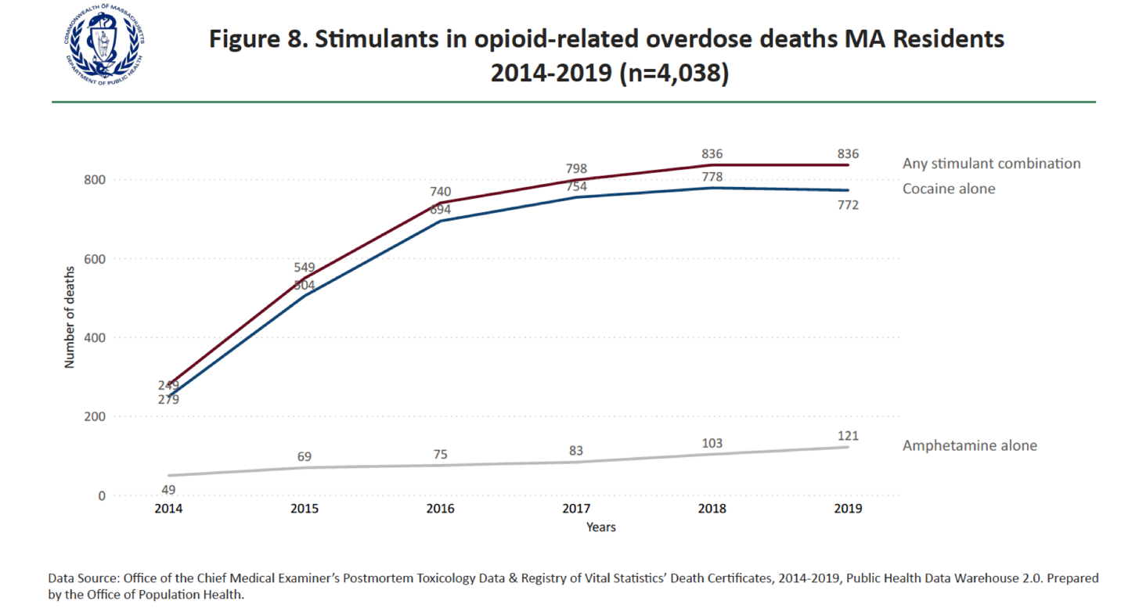

Persons older than 24 years, non-Hispanic Black, Hispanic, and American Indian Alaskan Native non-Hispanic residents, and persons recently experiencing homelessness were more likely than their counterparts to die with opioids and stimulants present upon toxicology analysis. While the frequency of opioids-only overdose deaths had stabilized, the number of deaths with opioids plus stimulants present increased 305% (279 in 2014 to 832 in 2019) as shown in Figure 9. Deaths with stimulants alone increased only slightly, from 20 in 2014 to 26 in 2019.

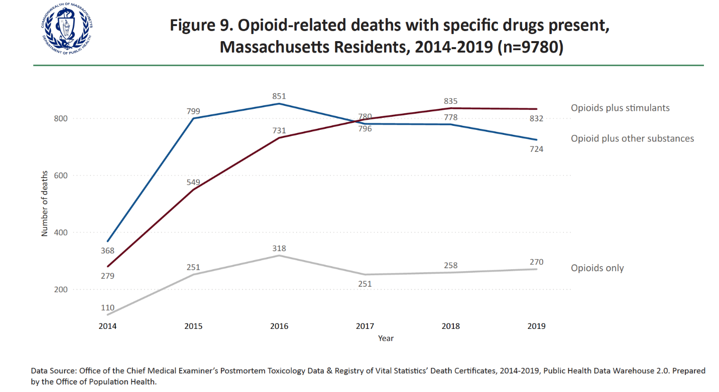
Males comprised 73% of all polysubstance overdose deaths and females comprised 27%. Among prescription opioids (Rx) combinations, the proportion of female decedents increased: in heroin and stimulant overdoses, females comprised 41.4%; in fentanyl, prescriptions and stimulant overdoses, females comprised 37.1%; in heroin, prescription, and stimulant overdoses, females comprised 36.4%. Additionally, females accounted for 42.8% of the overdose deaths with stimulants alone.
These early findings raise specific policy questions for SAP. In particular, it would be of interest to evaluate stimulant prescribing to understand if there is a link between risky stimulant prescribing to certain outcomes, including: risk of psychosis, overdose (stimulant, opioid, all drug), risk of opioid overdose among those co-prescribed stimulants and opioids, and to explore its prescribing among one or more of the Department’s priority populations. In addition, it would be important to try to estimate the prevalence of stimulant misuse and/or use disorder by year in Massachusetts stratified by the Department’s priority populations. These early findings demonstrate the new potential of PHD 2.0 to understand the complexity of substance use in Massachusetts and lead the way for further analysis of Massachusetts’ complex and ever-evolving addiction and overdose crisis.

Summary
The PHD 2.0 offers Massachusetts an important opportunity to better understand complicated public health problems using a multi-sector perspective that is especially beneficial for understanding systems and structural drivers of poor health outcomes. The addition of datasets containing information on social factors will allow DPH to analyze the connection between the social determinants of health and health inequities and will inform future programming and policy decisions. With the enhanced computing power and additional datasets and additional years of longitudinal data, the PHD will be an important resource as Massachusetts looks to address its public health priorities and disease prevention.

APPENDICES

Links to Reports and Websites

Public Health Data Warehouse Legislative Reports
Massachusetts Department of Public Health. (2016, September). An Assessment of Opioid- Related Deaths in Massachusetts (2013 – 2014). https://www.mass.gov/doc/chapter-55-2016-legislative-report-0/download.
Massachusetts Department of Public Health. (2017, August). An Assessment of Fatal and Nonfatal Opioid Overdoses in Massachusetts (2011 – 2015). https://www.mass.gov/doc/phd-2017-legislative-report-0/download.
Massachusetts Department of Public Health. (2019, November). Impact of the Opioid Epidemic on High Risk Populations and Maternal Health: Results from the Public Health Data Warehouse. https://www.mass.gov/doc/phd-2019-legislative-report-0/download.
Peer Reviewed Publications
Massachusetts Department of Public Health. Peer Reviewed Publications Utilizing the Massachusetts Chapter 55/Public Health Data Warehouse (PHD) Data Version Updated: 04/13/2021 https://www.mass.gov/doc/peer-reviewed-publications-041321-0/download.
DPH Websites
Public Health Data Warehouse. https://www.mass.gov/public-health-data-warehouse-phd.
Current Opioid Statistics. https://www.mass.gov/lists/current-opioid-statistics.

Acronyms
ACS: American Community Survey
AI/AN: American Indian, and Alaska Native
APCD: All Payers Claims Database
BSAS: Bureau of Substance Addiction Services, Massachusetts Department of Public Health
CHIA: Center for Health Information and Analysis
COVID-19: coronavirus disease of 2019
DHCD: Massachusetts Department of Housing and Community Development
DIA: Department of Industrial Accidents
DMH: Massachusetts Department of Mental Health
DPH: Massachusetts Department of Public Health
DTA: Massachusetts Department of Transitional Assistance
DUA: data use agreement
DVS: Massachusetts Department of Veterans' Services
EI: Early Intervention
EMS: emergency medical service
EOHSS: Executive Office of Health and Human Services
HIV: human immunodeficiency virus
MADOC: Massachusetts Department of Corrections
MAT: medication assisted treatment
MCH: maternal and child health
MSA: Massachusetts Sheriffs’ Association
NOO: Notice of Opportunity
OCME: Office of Chief Medical Examiner
OEMS: Office of Emergency Medical Services
OEND: Overdose Education and Naloxone Distribution
OPH: Office of Population Health
OUD: opioid use disorder
PHD: Public Health Data warehouse
PMP: Prescription Monitoring Program
SAP: Division of Special Analytic Projects, OPH
SMI: serious mental illness
SNAP: Supplemental Nutrition Assistance Program
SUD: substance use disorder
UMASS: University of Massachusetts
WIC: Special Supplemental Nutrition Program for Women, Infants, and Children Program

Endnotes

An Act Relative to the Reduction of Gun Violence, Chapter 248, Section 102 (2014). https://malegislature.gov/laws/sessionlaws/acts/2014/chapter284.
Massachusetts Department of Public Health. (2015, March). Feasibility Proposal and Implementation Plan for a Public Health Data Warehouse. Report SD.1980. https://malegislature.gov/Bills/189/Senate/SD1980.
An Act Requiring Certain Reports for Opiate Overdose, Chapter 55 (2015). https://malegislature.gov/Laws/SessionLaws/Acts/2015/Chapter55.
Massachusetts Department of Public Health. (2021, May). Data Brief: Opioid-Related Overdose Deaths Among Massachusetts Residents. Mass.gov. https://www.mass.gov/doc/opioid-related-overdose-deaths-among-ma-residents-may-2021/download.
The law tasked the state Secretary of Health and Human Services, in collaboration with the Massachusetts Department of Public Health (MDPH), with conducting the analysis to address seven specific concerns: 1. Instances of multiple provider episodes, meaning a single patient having access to opiate prescriptions from more than one provider; 2. Instances of poly-substance access, meaning a patient having simultaneous prescriptions for an opiate and a benzodiazepine, or for an opiate and another drug that may enhance the effects or risks of drug abuse or overdose; 3. The overall opiate prescription history of individuals, including whether the individuals had access to legal prescriptions for opiate drugs at the time of their deaths; 4. Whether the individuals had previously undergone voluntary or involuntary treatment for substance addiction or behavioral health; 5. Whether the individuals had attempted to enter but were denied access to treatment for substance addiction or behavioral health; 6. Whether the individuals had received past treatment for a substance overdose; 7. Whether any individuals had been previously detained or incarcerated and, if so, whether the individuals had received treatment during the detention or incarceration.
Massachusetts Department of Public Health. (2016, September 15). An Assessment of Opioid- Related Deaths in Massachusetts (2013 – 2014). Mass.gov. https://www.mass.gov/doc/chapter-55-2016-legislative-report-0/download.
Massachusetts Department of Public Health. (2016, September). Data Brief: Opioid-Related Overdose Deaths Among Massachusetts Residents (2013 – 2014). Mass.gov. https://www.mass.gov/files/documents/2017/08/31/chapter-55-opioid-overdose-study-data-brief-9-15-2016.pdf.
Massachusetts Department of Public Health. (2016, September). The Massachusetts Opioid Epidemic: a data visualization of findings from the Chapter 55 report. Mass.gov. https://chapter55.digital.mass.gov.
An Act Making Appropriations for the Fiscal Year 2017 for the Maintenance of the Departments, Boards, Commissions, Institutions and Certain Activities of the Commonwealth, for Interest, Sinking Fund and Serial Bond Requirements and for Certain Permanent Improvements, Chapter 133 (2016). https://malegislature.gov/Laws/SessionLaws/Acts/2016/Chapter133.
Massachusetts Department of Public Health. (2017, August 16). An Assessment of Fatal and Nonfatal Opioid Overdoses in Massachusetts (2011 – 2015). Mass.gov. https://www.mass.gov/files/documents/2017/08/31/legislative-report-chapter-55-aug-2017.pdf.
Massachusetts Department of Public Health. (2017, August). Data Brief: An Assessment of Opioid-Related Overdoses in Massachusetts 2011-2015. Mass.gov. https://www.mass.gov/files/documents/2017/08/31/data-brief-chapter-55-aug-2017.pdf.
Unfortunately, the upward trend of opioid-related overdose deaths restarted with the pandemic. Massachusetts Department of Public Health. (2021, May). Data Brief: Opioid-Related Overdose Deaths Among Massachusetts Residents. Mass.gov. https://www.mass.gov/doc/opioid-related-overdose-deaths-among-ma-residents-may-2021/download.
Bharel, M., Bernson, D., Averbach, A. (2020, August 19). Using Data to Guide Action in Response to the Public Health Crisis of Opioid Overdoses. NEJM Catalyst: Innovations in Care Delivery, Vol. 1 (No. 5), 1 – 18. DOI: 10.1056/CAT.19.1118.
Bharel, M., Bernson, D., Averbach, A. (2020, August 19). Using Data to Guide Action in Response to the Public Health Crisis of Opioid Overdoses. NEJM Catalyst: Innovations in Care Delivery, Vol. 1 (No. 5), 1 – 18. DOI: 10.1056/CAT.19.1118.
Outside Section 48, FY2018 Budget Summary. (2017, December). https://budget.digital.mass.gov/bb/gaa/fy2018/os_18/h48.htm.
111 M.G.L. § 237. https://malegislature.gov/Laws/GeneralLaws/PartI/TitleXVI/Chapter111/Section237.
111 M.G.L. § 237. https://malegislature.gov/Laws/GeneralLaws/PartI/TitleXVI/Chapter111/Section237.
Center for Health Information and Analysis. CHIA’s New MA APCD Master Patient Index. https://www.chiamass.gov/assets/docs/p/apcd/Overview-of-New-MA-APCD-Master-Patient-Index.pdf.
Previously, PHD was hosted on MITC Cloud and used SAS software for analysis. Now it is now hosted on Amazon Web Services (AWS) and is using SAS Enterprise.
Singh, G.K. (2010). Maternal Mortality in the United States, 1935-2007: Substantial Racial/Ethnic, Socioeconomic, and Geographic Disparities Persist. A 75th Anniversary Publication. Health Resources and Services Administration, Maternal and Child Health Bureau. https://www.hrsa.gov/sites/default/files/ourstories/mchb75th/mchb75maternalmortality.pdf.
Artiga, S., Pham, O., Orgera, K., Ranji, U. (2020, Nov. 10). Racial Disparities in Maternal and Infant Health: An Overview. Kaiser Family Foundation. https://www.kff.org/report-section/racial-disparities-in-maternal-and-infant-health-an-overview-issue-brief/.
C Petersen, E.E., Davism N.L., Goodman, D., Cox, S., Syverson, C., Seed, K., Shapiro-Mendoza, C., Callaghan, W.M., Barfield, W. (2019, Sept. 6). Racial/Ethnic Disparities in Pregnancy-Related Deaths — United States, 2007–2016. MMWR Morb Mortal Wkly Rep, 68, 762–765. https://www.cdc.gov/mmwr/volumes/68/wr/mm6835a3.htm?s_cid=mm6835a3_w.
Tikkanen, R., Gunja, M.Z., FitzGerald, M., Zephyrin, L. (2020, Nov. 18). Maternal Mortality and Maternity Care in the United States Compared to 10 Other Developed Countries. The Commonwealth Fund. https://www.commonwealthfund.org/publications/issue-briefs/2020/nov/maternal-mortality-maternity-care-us-compared-10-countries.
Massachusetts Department of Public Health. (2019, November). Impact of the Opioid Epidemic on High Risk Populations and Maternal Health: Results from the Public Health Data Warehouse. https://www.mass.gov/doc/phd-2019-legislative-report-0/download.
Massachusetts Department of Public Health. (2017, August 16). An Assessment of Fatal and Nonfatal Opioid Overdoses in Massachusetts (2011 – 2015). Mass.gov. https://www.mass.gov/files/documents/2017/08/31/legislative-report-chapter-55-aug-2017.pdf.
Massachusetts Department of Public Health. (2017, August 16). An Assessment of Fatal and Nonfatal Opioid Overdoses in Massachusetts (2011 – 2015). Mass.gov. https://www.mass.gov/files/documents/2017/08/31/legislative-report-chapter-55-aug-2017.pdf.
Massachusetts Department of Public Health. (2019, November). Impact of the Opioid Epidemic on High Risk Populations and Maternal Health: Results from the Public Health Data Warehouse. https://www.mass.gov/doc/phd-2019-legislative-report-0/download.
Middlesex Sherriff’s Office. (2019, September 6). Sheriffs announce launch of landmark medication assisted treatment (MAT) pilot program. https://www.middlesexsheriff.org/press-releases/news/sheriffs-announce-launch-landmark-medication-assisted-treatment-mat-pilot.
Massachusetts Department of Public Health. (2021, May). Opioid-Related Overdose Deaths, All Intents, MA Residents – Demographic Data Highlights. Mass.gov. https://www.mass.gov/doc/opioid-related-overdose-deaths-demographics-may-2021/download.
Massachusetts Department of Public Health. (2021, May). Data Brief: Opioid-Related Overdose Deaths Among Massachusetts Residents. Mass.gov. https://www.mass.gov/doc/opioid-related-overdose-deaths-among-ma-residents-may-2021/download.
Massachusetts Department of Public Health. (2021, May). Data Brief: Opioid-Related Overdose Deaths Among Massachusetts Residents. Mass.gov. https://www.mass.gov/doc/opioid-related-overdose-deaths-among-ma-residents-may-2021/download.
Massachusetts Department of Public Health. (2021, May). Opioid-Related Overdose Deaths, All Intents, MA Residents – Demographic Data Highlights. Mass.gov. https://www.mass.gov/doc/opioid-related-overdose-deaths-demographics-may-2021/download.
Office of the Chief Medical Examiner’s Postmortem Toxicology Data & Registry of Vital Statistics’ Death Certificates. 2014-2019. Public Health Data Warehouse 2.0. Prepared by the Office of Population Health.
Massachusetts Department of Public Health. (2021, May). Data Brief: Opioid-Related Overdose Deaths Among Massachusetts Residents. Mass.gov. https://www.mass.gov/doc/opioid-related-overdose-deaths-among-ma-residents-may-2021/download.
Mattson C.L., Tanz L.J., Quinn K., Kariisa M., Patel P., Davis N.L. (2021, February 21). Trends and Geographic Patterns in Drug and Synthetic Opioid Overdose Deaths — United States, 2013–2019. MMWR Morb Mortal Wkly Rep 2021;70:202–207. DOI: http://dx.doi.org/10.15585/mmwr.mm7006a4.
Hedegaard, H., Miniño, A.M., and Warner, M. (2021, April). Co-involvement of Opioids in Drug Overdose Deaths Involving Cocaine and Psychostimulants. NCHS Data Brief. 406. https://www.cdc.gov/nchs/products/databriefs/db406.htm.
Massachusetts Department of Public Health. (2021, May). Data Brief: Opioid-Related Overdose Deaths Among Massachusetts Residents. Mass.gov. https://www.mass.gov/doc/opioid-related-overdose-deaths-among-ma-residents-may-2021/download.

