INDOOR AIR QUALITY ASSESSMENT

Phinehas S. Newton Library
19 On the Common
Royalston, MA

Prepared by:
Massachusetts Department of Public Health
Bureau of Environmental Health
Indoor Air Quality Program
May 2021

Background
Building: | Phinehas S. Newton Library (PSNL)
Address: | 19 On the Common, Royalston, MA
Requested by: | Katherine Morris, Director
Reason for Request: | General indoor air quality (IAQ) concerns
Date of Assessment: | October 29, 2020
Massachusetts Department of Public Health/Bureau of Environmental Health (MDPH/BEH) Staff Conducting Assessment: | Michael Feeney, Director, IAQ Program
Building Description: | The PSNL is a red brick building originally constructed in 1913. The interior includes a main floor and basement used for storage.
Building Population: | Approximately 3 staff work in the building. Members of the public visit daily.
Windows: | Openable

Methods
Please refer to the IAQ Manual for methods, sampling procedures, and interpretation of results (MDPH, 2015).

IAQ Testing Results
The following is a summary of indoor air testing results (Table 1).
- Carbon dioxide levels were below the MDPH guideline of 800 parts per million (ppm) in all occupied areas assessed. Please note discussion regarding furnace exhaust vent.
- Temperature was below the recommended range of 70°F to 78°F.
- Relative humidity was within or close to the recommended range of 40 to 60% in all areas assessed.
- Carbon monoxide levels were non-detectable (ND) in all indoor areas assessed.
- Fine particulate matter (PM2.5) concentrations measured were below the National Ambient Air Quality Standard (NAAQS) level of 35 μg/m³ in all areas assessed.

Ventilation
The PSNL does not have a mechanical heating, ventilating and air-conditioning (HVAC) system. Opening windows provides fresh air. Heat is provided by radiators that exist in all areas of the building. Please note that windows were open during this assessment.

Microbial/Moisture Concerns
The building was assessed during a rainstorm. Water was seen leaking from the rear gutter of the building, which was wetting the exterior wall of the building (Picture 1). If chronically exposed to leaking water in this manner, damage to brick and mortar may occur.
Of note are conditions noted in the basement. Part of the basement formerly occupied by the Royalston Police Department (RPD) was finished with an undeterminable interior wall material, which may be gypsum wallboard (GW) (Picture 2). In the corner of the room is a sump pump. The presence of a sump pump indicates that the basement likely becomes repeatedly flooded. In addition, a sump pump is a source of water vapor that can wet both building components and stored materials. A sump pump opening may also be a source of mold as well as provide a means for other below grades pollutants (such as radon gas) to enter the building’s interior. The wall space between the interior wall and foundation in this area could not be observed, therefore it could not be determined if this wall space was insulated.
A stain was noted on the floor, which PSNL staff identified as a soft drink spill. The use of GW in below grade space is not recommend since it is highly susceptible to mold growth from exposure to water as a liquid or vapor. Since the PSNL does not have a mechanical ventilation system, there is no means to condition the air in this space to reduce humidity, which can be particularly critical during extended periods of hot, humid weather. In addition, since the PSNL was constructed in 1910, the floor and foundation walls of the basement are likely uninsulated and therefore would be the same temperature of the ground around/beneath the building. In this circumstance, the basement walls and floor are likely to become moistened with condensation during hot, humid weather.
Materials that can support mold growth if moistened were observed to be stored directly on the cement floor, which as discussed can be subject to condensation. The uninsulated walls would serve as a thermal bridge, which would lower the floor’s temperature below the dew point, resulting in condensation moistening any materials stored. This process would occur during hot, humid weather. Storing of materials that is prone to mold growth if moistened should be avoided in this area during high relative humidity conditions.
The building has a number of shrubberies that are in close proximity to the foundation/exterior walls (Picture 3). Shrubbery in this configuration can result in extended water exposure to exterior surfaces, which may result in damage to exterior walls. Shrubbery also prevents exterior walls from drying by sunlight.

Other Conditions
Carbon dioxide sampling was conducted in the space above the duct connecting the furnace to the chimney (Table 1), which produced a measurement indicating breaches in the duct. When fuel is combusted, a number of products are produced, including carbon dioxide. Other products of combustion including; carbon monoxide, water vapor, particulates and other pollutants may also be released. IAQ staff could not locate any carbon monoxide detectors in the building.

CONCLUSIONS/RECOMMENDATIONS
Indoor air testing did not denote any unusual conditions in occupied space that could have an effect on IAQ at the time of this assessment. As noted by PSNL staff, the furnace room door is closed during business hours, and IAQ staff did not detect combustion odors outside this area.
Based on the observations made during the visit, the following recommendations are made:

Ventilation

- Consider installing carbon monoxide detectors on each floor of the building.
- Seal all seams and holes in the vent connecting the furnace to the chimney.
- Install weather-stripping and a door sweep on the furnace room door to render this
opening as airtight as feasible when this door is closed.

Water Damage

- Consider removing stored materials capable of supporting mold growth from the
basement floor. Such materials may include cardboard, soft plastic, paper and other
porous materials. Materials should be stored in a manner that will limit the
accumulation of condensation during hot, humid weather. Ensure that materials
susceptible to mold-growth are not directly stored on the basement floor or exterior
foundation walls.
- Consideration should be given as to the necessity of a sump pump in the basement.
Given that water penetration into this location is likely melting snow or rainwater from the gutter, improving drainage around the outside of the building may eliminate the need for the sump pump. If a sump pump is necessary for the building, consider installing a removable yet airtight commercially available sump cover.
- Extend downspouts at least 5 feet away from foundation walls. Reestablish the slope
of the ground in contact with the foundation with a water-resistant material (example
clay), that has sufficient slope to direct water runoff away from the foundation. In
general, a slope of 1 foot of height and feet of length of a water-resistant ground
covering is recommended.
- If repair of downspouts and improving drainage eliminates basement flooding,
consider abandoning the sump pump by sealing the cement floor.
- During extended periods of hot, humid weather, use of dehumidifiers in the basement
should be considered. Please note that dehumidifiers should be configured to drain
condensation outside the building or to an interior drain. If dehumidifiers cannot be
drained in this manner, ensure they are properly emptied, cleaned/ maintained as per
the manufacturer’s recommendations.
- Given the presence of the sump pump in the former Police area, it is recommended
that porous wall materials installed over the foundation be removed in a manner
consistent with guidelines of the US EPA document, Mold Remediation in Schools
and Commercial Buildings. Mold Remediation in Schools and Commercial Buildings Guide: Chapter 1 | Mold | US EPA
- Relocate shrubbery to a distance at least 5 feet from foundation walls.
- Refer to resource manual and other related IAQ documents located on the MDPH’s
website for further building-wide evaluations and advice on maintaining public
buildings. These documents are available at: http://mass.gov/dph/iaq.

References
MDPH. 2015. Massachusetts Department of Public Health. Indoor Air Quality Manual: Chapters I-III. Available at: http://www.mass.gov/eohhs/gov/departments/dph/programs/environmental-health/exposure-topics/iaq/iaq-manual/.

Picture 1
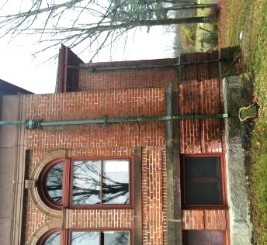
Water exposure to north exterior wall, likely from leaking roof gutter
Note that the location of the downspout terminus is roughly above the corner of the basement sump pump in Picture 2

Picture 2
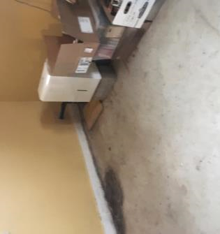
Interior wall installed over foundation wall, formerly occupied by Royalston Police Department, Note sump pump opening (arrow) and dehumidifier
Picture 3
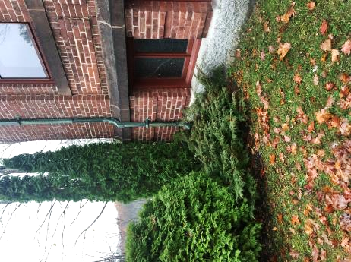
Shrubbery in contact/close proximity to exterior walls of PSNL

Location | Carbon  Dioxide  (ppm) | Carbon Monoxide  (ppm) | Temp  (°F) | Relative  Humidity  (%) | PM2.5  (µg/m³) | Occupants  in Room | Windows  Openable | Ventilation |  | Remarks
 |  |  |  |  |  |  |  | Supply | Exhaust
Background (outdoors) | 376 | 2 | 47 | 50 | 2
Front desk/book stack | 476 | ND | 59 | 62 | 1 | 0 | N | N | N
Children’s section | 484 | ND | 66 | 51 | 1 | 0 | Y | N | N | Fireplace
Side stack | 515 | ND | 66 | 51 | 1 | 1 | Y | N | N
Books on tape | 555 | ND | 65 | 51 | 1 | 0 | Y | N | N
Restroom | 475 | ND | 66 | 52 | 1 | 0 | Y | N | N
Basement-former Police area | 438 | ND | 62 | 56 | 1 | 0 | Y | N | N | Materials stored on floor, stain on floor, wall material (possible GW) installed over foundation walls
Furnace room | 499 | ND | 62 | 57 | 1 | 0 | N | N | N | Materials stored on floor
Furnace room, above furnace vent duct | 908 | ND | 62 | 57 | 2 | 0 | N | N | N | Materials stored on floor
Oil tank room | 491 | ND | 62 | 57 | 3 | 0 | N | N | N | Materials stored on floor

