Commonwealth of Massachusetts
Executive Office of Health and Human Services

Office of Medicaid
600 Washington Street

Boston, MA 02111
www.mass.gov/masshealth

MASSHEALTH
TRANSMITTAL LETTER PHM-52
May 2005

TO: Pharmacies Participating in MassHealth
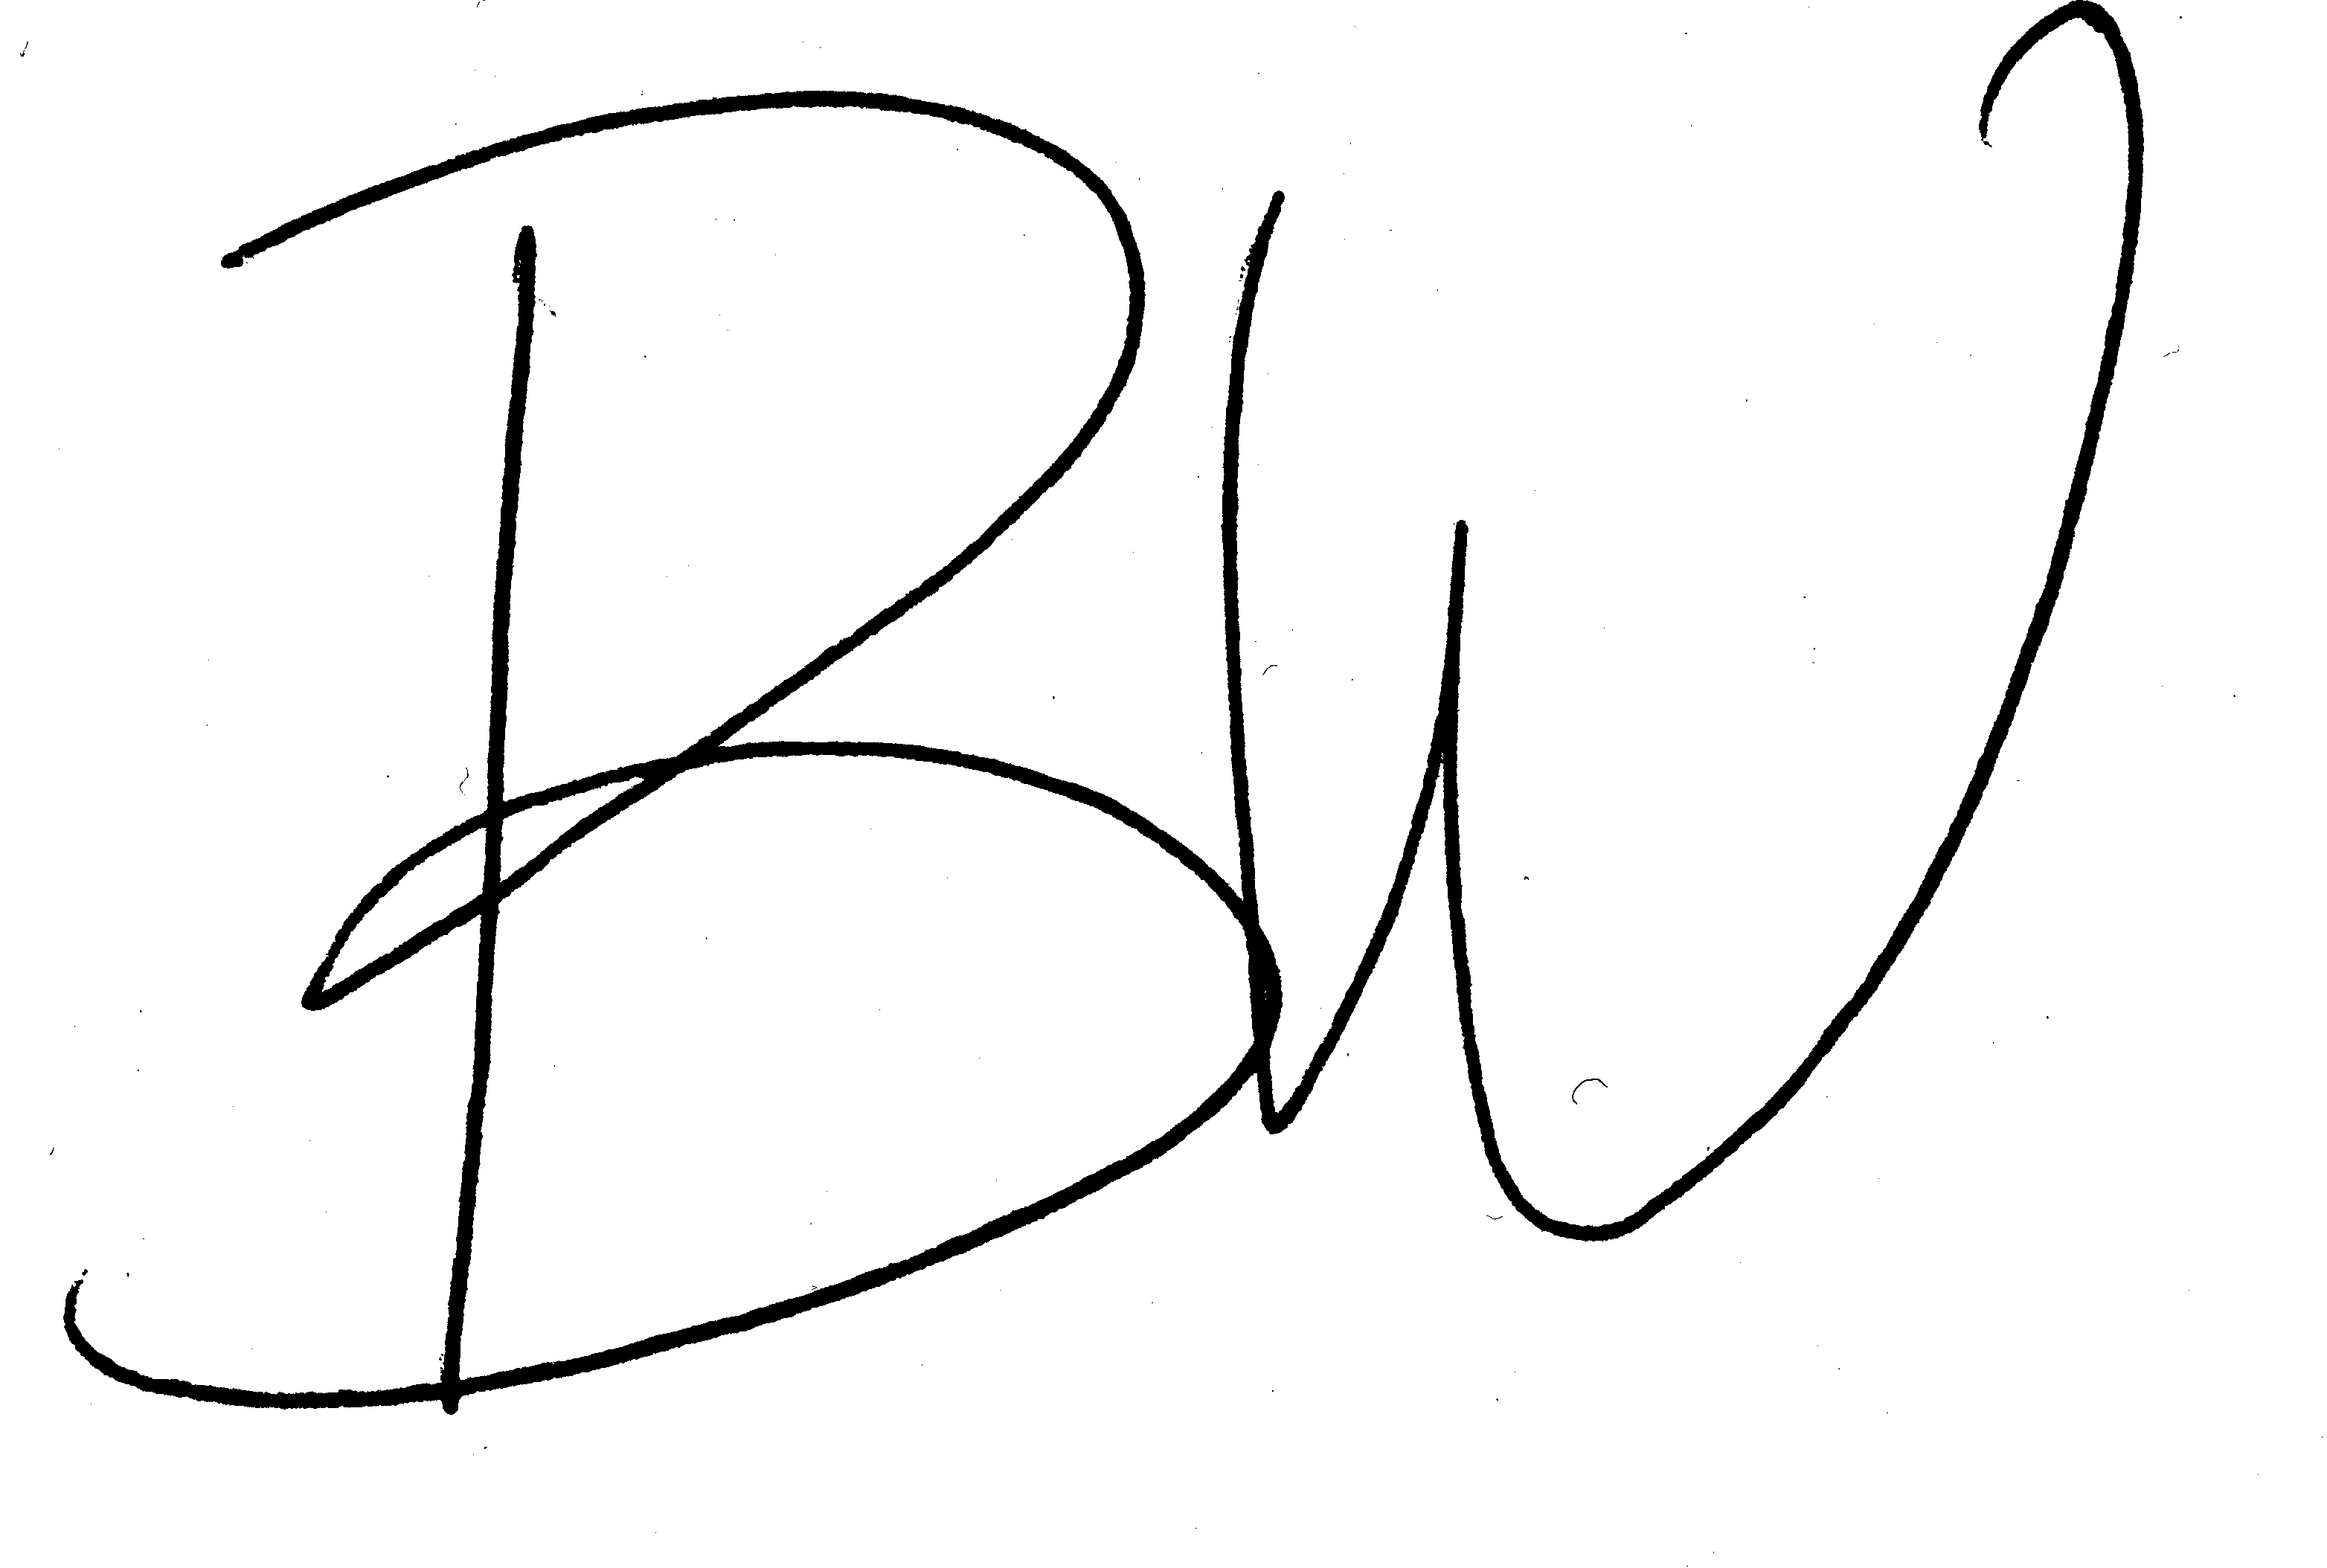
FROM: Beth Waldman, Medicaid Director

RE: Pharmacy Manual (Revision to Service Limitations)

This letter transmits revisions to the pharmacy regulations about topical acne products. The revision removes language about service limitations for topical acne products. Service limitations to this type of drug therapy will be in the MassHealth Drug List.

The revisions also clarify service limitations and exclusions.

These regulations are effective May 15, 2005.

NEW MATERIAL
(The pages listed here contain new or revised language.)

Pharmacy Manual

Pages 4-9 and 4-10

OBSOLETE MATERIAL
(The pages listed here are no longer in effect.)

Pharmacy Manual

Pages 4-9 and 4-10 — transmitted by Transmittal Letter PHM-51

